STATE PURCHASING DIVISION
OF THE
GENERAL SERVICES DEPARTMENT
AND
CORRECTIONS DEPARTMENT

REQUEST FOR PROPOSALS (RFP)

Offender Management System Replacement Project


RFP#
17-770-2500-5317

Issue Date: July 18, 2016

Due Date: September 9, 2016

I. INTRODUCTION 1
A. PURPOSE OF THIS REQUEST FOR PROPOSALS 1
B. BACKGROUND INFORMATION 1
C. SCOPE OF PROCUREMENT 1
D. PROCUREMENT MANAGER 2
E. DEFINITION OF TERMINOLOGY 3
F. PROCUREMENT LIBRARY 9
II. CONDITIONS GOVERNING THE PROCUREMENT 10
A. SEQUENCE OF EVENTS 10
B. EXPLANATION OF EVENTS 10
1. Issuance of RFP 11
2. Acknowledgement of Receipt 11
3. Pre-Proposal Conference 11
4. Deadline to Submit Written Questions 11
5. Response to Written Questions 12
6. Submission of Proposal 12
7. Proposal Evaluation 12
8. Selection of Finalists 12
9. Best and Final Offers 13
10. Oral Presentations and Demonstrations 13
11. Finalize Contractual Agreements 13
12. Contract Awards 13
13. Protest Deadline 14
C. GENERAL REQUIREMENTS 14
1. Acceptance of Conditions Governing the Procurement 14
2. Incurring Cost 14
3. Prime Contractor Responsibility 14
4. Subcontractors/Consent 15
5. Amended Proposals 15
6. Offeror’s Rights to Withdraw Proposal 15
7. Proposal Offer Firm 15
8. Disclosure of Proposal Contents 15
9. No Obligation 16
10. Termination 16
11. Sufficient Appropriation 16
12. Legal Review 16
13. Governing Law 16
14. Basis for Proposal 17
15. Contract Terms and Conditions 17
16. Offeror’s Terms and Conditions 17
17. Contract Deviations 18
18. Offeror Qualifications 18
19. Right to Waive Minor Irregularities 18
20. Change in Contractor Representatives 18
21. Notice of Penalties 18
22. Agency Rights 18
23. Right to Publish 18
24. Ownership of Proposals 19
25. Confidentiality 19
26. Electronic Mail Address Required 19
27. Use of Electronic Versions of this RFP 19
28. New Mexico Employees Health Coverage 19
29. Campaign Contribution Disclosure Form 20
30. Letter of Transmittal 20
31. Pay Equity Reporting Requirements 21
32. Disclosure Regarding Responsibility 21
33. New Mexico Preferences 23
III. RESPONSE FORMAT AND ORGANIZATION 24
A. Number and Format of Responses 24
B. Number of Copies 24
1. Hard Copy Responses 24
C. PROPOSAL FORMAT 25
Proposal Content and Organization 25
1. Technical Proposal (Binder 1): 25
IV. SPECIFICATIONS 27
A. DETAILED SCOPE OF WORK 27
1. Initial Project Planning and Gap Analysis (Post-Award) 28
2. OMS Implementation 31
3. Ongoing Maintenance and Support (Post-implementation) 43
B. TECHNICAL SPECIFICATIONS 46
1. Organizational Experience 46
2. Organizational References 50
3. Oral Presentation and Product Demonstration 50
4. Mandatory Specification 50
C. BUSINESS SPECIFICATIONS 51
1. Financial Stability 51
2. Performance Surety Bond 51
3. Letter of Transmittal Form 52
4. Campaign Contribution Disclosure Form 52
5. Cost 52
6. Resident Business or Resident Veterans Preference 53
V. EVALUATION 54
A. EVALUATION POINT SUMMARY 54
B. EVALUATION FACTORS 55
1. B.1 Organizational Experience 55
2. B.2 Organizational References 55
3. B.3 Oral Presentation and Product Demonstration 55
4. B.4 Mandatory Specifications 55
5. C.1 Financial Stability 56
6. C.2 Performance Surety Bond 56
7. C.3 Letter of Transmittal 56
8. C.4 Campaign Contribution Disclosure Form 56
9. C.5 Cost 56
10. C.6 New Mexico Preferences 56
C. EVALUATION PROCESS 57
APPENDIX A: REQUEST FOR PROPOSAL 58
APPENDIX B: Campaign Contribution Disclosure Form 59
APPENDIX C: SAMPLE CONTRACT 62
APPENDIX D: COST RESPONSE FORM 90
A. Cost Proposal Form 90
B. Implementation Costs and Narrative 95
C. Rate Card 100
APPENDIX E: Letter of Transmittal Form 102
APPENDIX F: ORGANIZATIONAL REFERENCE QUESTIONNAIRE 103
APPENDIX G: RESIDENT VETERANS CERTIFICATION 106
APPENDIX H: “TO-BE” BUSINESS PROCESS SUMMARIES and HIGH-LEVEL DIAGRAMS 107
APPENDIX I: OMS REQUIREMENTS MATRIX 166
APPENDIX J: REPORTS LIST 167
APPENDIX K: INTERFACE LIST 175
APPENDIX L: DATA COVERSION 182
Appendix M: Bidder Questions Form 255

I. INTRODUCTION

PURPOSE OF THIS REQUEST FOR PROPOSALS

The purpose of this Request for Proposal (RFP) is to solicit sealed proposals to establish a contract through competitive negotiations for the procurement of a Commercial-off-the-shelf (COTS) Offender Management System (OMS).

BACKGROUND INFORMATION

The New Mexico Corrections Department (NMCD) has made the reduction of recidivism (the rate of return of an inmate after release) by 10% over the next three years its top priority. The current client-server OMS is end-of-life, end-of-support, and needs to be replaced in order to support the changing business processes to accomplish this and other agency goals.

The new OMS must use new technology and design standards to streamline and improve business processes for end users who manage and supervise offenders. The Agency’s direction to accomplish this is to purchase a COTS web system using current technologies. The complete OMS will have at least 17 unique modules as necessary components to manage inmates and offenders through the correctional system and will provide much-needed new functionality to support and improve the business process.

Providing one seamless web-based system for the management of inmates and offenders supports the state government initiatives related to reducing the cost of government operations, improving customer service, and increasing public safety. The ability to manage the application online, instead of pushing out updates to over a thousand computers, will greatly reduce support and maintenance costs.

Please see the NMCD website for more information at http://www.cd.nm.gov/.

SCOPE OF PROCUREMENT

The primary scope of this procurement is to replace the current OMS. The current system has two components: the Criminal Management Information System (CMIS) and a newer, web-based Offender Management Program (OMP), which is used for programmatic management for offenders and a booking intake module. The NMCD envisions that both systems will be replaced by the procurement of a new OMS. Any satellite systems that have been developed at the department level will be replaced as well.
Through this procurement, the NMCD seeks to reduce the use of paper via the implementation of automated workflow processes and to enhance the NMCD’s ability to interact with other internal and external systems, using standard protocols. The NMCD is seeking a fully integrated OMS that eliminates the need for duplicate entry of data, decreases data entry errors, and increases the ability to collaborate across the Department. The new OMS should allow the NMCD to define and measure their business operations through a series of metrics and reporting.
The implementation of a new OMS will impact stakeholders, including the Adult Prisons Division (APD), Probation and Parole Division (PPD), central office operations, offenders, citizens, and external stakeholders, such as program service Offerors and volunteers.
The following objectives describe the technical scope of this procurement. The procurement of a COTS OMS will:
- Replace and discontinue the use of the legacy OMS
- Collapse development and maintenance overhead due to multiple disparate systems
- Provide the technical components and platform to allow application mobility
- Migrate existing data and data structures from Informix to an SQL data format
- Store data in compliance with National Information Exchange Model (NIEM)-Justice standards for information exchanges
- Provide the ability for the new OMS application to be database independent
- Ensure that the technical aspects and capabilities of the new OMS are “service oriented to the business need”
- Replicate production data to a separate environment for the purpose of disaster recovery, reporting, statistical analysis, and business intelligence efforts
- Ensure that NMCD IT staff gain sufficient experience and knowledge to implement the OMS and to maintain the OMS independently after implementation
- Document the new OMS thoroughly, from both a functional and technical perspective, prior to implementation, and ensure that a process exists for future updates and maintenance of the documentation
- Create a virtual server environment for high availability, increased reliability, redundancy, and streamlined administration of the OMS

PROCUREMENT MANAGER

- NMCD has assigned a procurement manager to be responsible for the conduct of this procurement. The procurement manager’s name, address, telephone number, and e-mail address are listed below:
Name: Ms. Kathleen Branchal, Deputy Bureau Chief
Address: 4337 NM HIway 14
Santa Fe, NM 87508
Telephone: (505)-827-8673
Fax (505) 827-8634
Email: Kathleen.branchal2@state.nm.us

- All deliveries of responses via express carrier must be addressed as follows:
Name: Ms. Kathleen Branchal, Deputy Bureau Chief
Reference RFP Name: Offender Management System (OMS) Replacement Project

Address: NM Corrections Department
4337 State Rd. 14
Santa Fe, NM 87508

- Any inquiries or requests regarding this procurement should be submitted, in writing, to the procurement manager. Offerors may contact ONLY the procurement manager regarding this procurement. Other state employees or Evaluation Committee members do not have the authority to respond on behalf of the SPD. Protests of the solicitation or award must be delivered by mail to the protest manager. As a protest manager has been named in this RFP, pursuant to NMSA 1978, § 13-1-172, ONLY protests delivered directly to the protest manager in writing and in a timely fashion will be considered to have been submitted properly and in accordance with statute, rule, and this RFP. Emailed protests will not be considered as properly submitted, nor will protests delivered to the procurement manager be considered properly submitted.

DEFINITION OF TERMINOLOGY

This section contains definitions of terms used throughout this procurement document, including appropriate abbreviations:

“Addendum” or “Addenda” means an addition or deletion to, a material change in, or general interest explanation of a solicitation document.

“Ad-hoc Report” means a report produced one time to answer a single business question, not a standard report.

“Agency” means the SPD of the General Services Department or that State Agency sponsoring the procurement action.

“APD” means the Adult Prisons Division.

“Authorized Purchaser” means an individual authorized by a Participating Entity to place orders against this contract.

“Award” means the final execution of the contract document.

“Business Hours” means 8:00 a.m. through 5:00 p.m. Mountain Standard or Mountain Daylight Time, whichever is in effect on the date given.

“CJIS” means the Criminal Justice Information Services, the largest division of the FBI.

“Close of Business” means 5:00 p.m. Mountain Standard or Daylight Time, whichever is in use at that time.

“CMIS” means the Criminal Management Information System, the current legacy OMS for the NMCD.

“CMMI” means Capability Maturity Model Integration, a process improvement training and appraisal program and service administered and marketed by Carnegie Mellon University and required by many DoD and U.S. Government contracts, especially in software development.

“Confidential” means confidential financial information concerning an Offeror’s organization and data that qualifies as a trade secret in accordance with the Uniform Trade Secrets Act NMSA 1978 57-3-A-1 to 57-3A-7. See NMAC 1.4.1.45. As one example, no information that could be obtained from a source outside this request for proposals can be considered confidential information.

"Configuration" means using native tools in the OMS to design or adapt it for the purposes of changing its behavior or features, without the need to use programming languages to accommodate the behavior or features. (Note: This term should not be confused with the term “Configuration Management (CM).” Please see the definition of Configuration Management below.)

“Configuration Management” is a process for planning and principles for installation, configuration, implementation, and maintenance of software and software environments, including the following non-comprehensive list of activities: Software promotion, release, back-out, Change management, audit, and capacity management.

“Contract" means any agreement for the procurement of items of tangible personal property, services, or construction.

“Contractor" means any business having a contract with a state agency or local public body.

“COTS” means Commercial-off-the-Shelf, a term used to describe software or hardware products that are ready-made and available for sale to the general public.

“CTA” means Corrections Technology Association, a public, nonprofit network of professionals actively involved in leveraging technology in the field of Corrections.

"Customization" means that a feature or extension or modification of the OMS software requires custom coding. Software customizations typically involve building desired functionality from scratch, using a programming language.

“DA” means District Attorney.

“Deliverable” means any measurable, tangible, verifiable outcome, result, or item that shall be produced to complete a project or part of a project and to receive payment. A Deliverable may be composed of one or more interrelated project Work Products.

“Desirable” means the terms “may,” “can,” “should,” “preferably,” or “prefers” identify a desirable or discretionary item or factor.

“Determination" means the written documentation of a decision of a procurement officer, including findings of fact required to support a decision. A determination becomes part of the procurement file to which it pertains.

“Documentation” means training materials, manuals, handbooks, maintenance libraries, and other publications supplied with software or supplied in connection with services.
“DoIT” means the New Mexico Department of Information Technology, which has project oversight authority and is responsible for operating all communications-related items and the State’s Data Center, located at 715 Alta Vista, in Santa Fe. DolT has the responsibility to review all solicitations involving any form of information technology for technical sufficiency.

“Effective Date” means the date on which the resulting contract is fully approved and executed in accordance with applicable laws, rules, regulations, and/or policy.

“Electronic Signature (or eSignature)” means a term used to cover the spectrum of signatures provided in electronic form, including but not limited to digital signature, images of signatures, and encrypted signatures.

“Electronic Version/Copy” means a digital form consisting of text, images, or both, readable on computers or other electronic devices that includes all content that the Original and Hard Copy proposals contain. The digital form may be submitted using a compact disc (cd) or USB flash drive. The electronic version/copy can NOT be emailed.

“ETL” means Extract Transform Load which refers to a process in database usage and especially in data warehousing that: Extracts data from homogeneous or heterogeneous data sources. Transforms the data for storing it in the proper format or structure for the purposes of querying and analysis.

“Evaluation Committee" means a body appointed to perform the evaluation of an Offerors’ proposals.

“Evaluation Committee Report" means a report prepared by the procurement manager and the Evaluation Committee for contract award. It will contain written determinations resulting from the procurement.

“Finalist” means an Offeror who meets all the mandatory specifications of this RFP and whose score on evaluation factors is sufficiently high enough to merit further consideration by the Evaluation Committee.

“GAAP” means an acronym for Generally Accepted Accounting Principles.

“GRA” means Global Reference Architecture, designed as an information-sharing architecture to meet the needs of government at all levels, and fulfill the need for improved collaboration across communities.

“Hourly Rate” means the proposed fully loaded maximum hourly rates that include travel, per diem, fringe benefits, and any overhead costs for contractor personnel, as well as subcontractor personnel, if appropriate.

“Invitation to Bid or ITB” means all documents, including those attached or incorporated by reference, used for soliciting closed-bid proposals. The Agency may publish one or more related ITBs subsequent to the completion of this RFI process.

“IT” means Information Technology.

“Mandatory" – the terms "must," "shall," "will," "is required," or "are required" identify a mandatory item or factor. Failure to meet a mandatory item or factor will result in the rejection of the Offeror’s proposal.

“Minor Technical Irregularities” means anything in the proposal that does not affect the price quality and quantity or any other mandatory requirement.

“Multiple Source Award" means an award of an indefinite quantity contract for one or more similar services, items of tangible personal property, or construction to more than one Offeror.

“NIEM” means National Information Exchange Model, a community-driven, standards-based approach to exchanging information.

“NMAC” means New Mexico Administrative Code.

“NMCD” means New Mexico Corrections Department.

“Offeror" is any person, corporation, or partnership who chooses to submit a proposal.

“Offender Management Services” is a merger of the NMCD Records and Classification Bureaus establishing an Office following the best practices of inmate management in Corrections. The purpose of the Office of Offender Management Services is public safety.

“OMS” means Offender Management System, a electronic system for managing all offenders.

“PMO” means Project Management Office, a group or department within a business, agency, or enterprise that defines and maintains standards for project management within the organization. The PMO strives to standardize and introduce economies of repetition in the execution of projects.

“PPD” means Probation and Parole Division.

“Price Agreement” means a definite quantity contract or indefinite quantity contract, which requires the contractor to furnish items of tangible personal property, services, or construction to a state agency or a local public body, which issues a purchase order, if the purchase order is within the quantity limitations of the contract, if any.

“Probation Violation” means the court process that occurs when a person, previously ordered to serve a term of probation with conditions, violates one or more of the conditions of probation, and the PPD Officer files a petition with the court requesting that all or part of the probation be modified or revoked.

“Procurement Manager” means any person or designee authorized by a state agency or local public body to enter into or administer contracts and make written determinations with respect thereto.

“Procuring Agency" means all State of New Mexico agencies, commissions, institutions, political subdivisions and local public bodies allowed by law to entertain procurements.

“Product Environment” means a setting where software and other products are put into operation for their intended uses by end users.

“Project” means a temporary process undertaken to solve a well-defined goal or objective, with clearly defined start and end times, a set of clearly defined tasks, and a budget. The project terminates once the project scope is achieved and project acceptance is given by the project executive sponsor.

“Proposal” means a response to a Request for Proposals.

“Real-time” means a term often used to distinguish reporting, depicting, or reacting to events at the same rate and sometimes at the same time as they unfold, rather than compressing a depiction or delaying a report or action.

“Recidivism” means a person’s relapse into criminal or other chargeable offense behavior after the person receives sanctions or undergoes interventions for a previous crime; recidivism is often measured by re-arrest, re-charge, or new convictions.

“Redacted” means a version/copy of the proposal with the information considered confidential as defined by NMAC 1.4.1.45 and defined herein and outlined in Section II.C.8 of this RFP as blacked out BUT NOT omitted or removed.

“Request for Proposals (RFP)" means all documents, including those attached or incorporated by reference, used for soliciting proposals.

“Responsible Offeror" means an Offeror who submits a responsive proposal and who has furnished, when required, information and data to prove that his financial resources, production or service facilities, personnel, service reputation, and experience are adequate to make satisfactory delivery of the services or items of tangible personal property described in the proposal.

“Responsive Offer" means an offer which conforms in all material respects to the requirements set forth in the request for proposals. Material respects of a request for proposals include, but are not limited to price, quality, quantity, or delivery requirements.

“RTM” means an acronym for Requirements Traceability Matrix. A document used to check if current project requirements are being met.

“Sealed” means, in terms of a non-electronic submission, that the proposal is enclosed in a package which is completely fastened in such a way that nothing can be added or removed. Open packages submitted will not be accepted, except for packages that may have been damaged by the delivery service itself. The State reserves the right, however, to accept or reject packages where there may have been damage done by the delivery service itself. Whether a package has been damaged by the delivery service or left unfastened and should or should not be accepted is a determination to be made by the procurement manager. By submitting a proposal, the Offeror agrees to and concurs with this process and accepts the determination of the procurement manager in such cases.

“Services” means professional services conducted by the Offeror to deliver requested OMS functionality (e.g., project management, system configuration and customization, training, and testing).

“SPD” means State Purchasing Division of the New Mexico State General Services Department.

“Staff" means any individual who is a full-time, part-time, or an independently contracted employee with the Offerors’ company.

“Stakeholder” means any person, group, or agency that interacts with the corrections system.

“State (the State)” means the State of New Mexico.

“State Agency” means any department, commission, council, board, committee, institution, legislative body, agency, government corporation, educational institution or official of the executive, legislative or judicial branch of the government of this state. “State agency” includes the purchasing division of the general services department and the state purchasing agent but does not include local public bodies.

“State Purchasing Agent” means the director of the purchasing division of the general services department.

“Statement of Concurrence” means an affirmative statement from the Offeror to the required specification agreeing to comply and concur with the stated requirement(s). This statement shall be included in Offerors proposal (e.g., “We concur,” “Understands and Complies,” “Comply,” “Will Comply if Applicable,” etc.).

“T&M” means an acronym for Time and Material.

“TAP” means an acronym for Transition and Accountability Plan.

“Unredacted” means a version/copy of the proposal containing all complete information, including any that the Offeror would otherwise consider confidential, such as copy for use only for the purposes of evaluation.

“VINE” means an acronym for Victim Identification and Notification Everyday

“Work Products” means the documented results of the Scope of Work activities. One or more work products collectively form a deliverable.

“Written” means typewritten on standard 8 ½ x 11 inch paper. Larger paper is permissible for charts, spreadsheets, etc.

PROCUREMENT LIBRARY
A procurement library has been established. Offerors are encouraged to review the material contained in the Procurement Library by selecting the link provided in the electronic version of this document through your own internet connection or by contacting the procurement manager and scheduling an appointment.

Link: http://cd.nm.gov/admin/rfp/COTS_Offender_Management_System/cotsOmsRfp.html

II. CONDITIONS GOVERNING THE PROCUREMENT

This section of the RFP contains the schedule, description and conditions governing the procurement.

SEQUENCE OF EVENTS

The Procurement Manager will make every effort to adhere to the following schedule:

Action | Responsible Party | Due Dates Sample Time Frames | Location
1. Issue RFP | NMCD | 7/18/2016
2. Acknowledgement Form | NMCD | 8/2/16
3. Pre-Proposal Conference | NMCD | 8/4/2016 | NMCD
4. Deadline to submit  Questions | Potential Offerors | 8/12/2016 by 5pm Mountain Standard Time/Daylight Time
5. Response to Written  Questions | Procurement Manager | 8/19/2016
6. Submission of Proposal | Potential Offerors | 9/9/2016 3pm  Mountain Standard Time/Daylight Time
7. Proposal Evaluation | Evaluation Committee | 9/9/2016 – 10/6/2016
8. Selection of Finalists | Evaluation Committee | 10/7/2016
9. Oral Presentation(s) and Demonstration(s) | Finalist Offerors | 10/24/2016 – 11/3/2016 | NMCD
10. Open Cost Proposals | Finalist Offerors | 11/4/2016
11. Contract Negotiations | NMCD / Finalist Offeror | 11/14/2016 – 1/31/2017
12. Contract Awards | NMCD / Finalist Offeror | 1/31/2017
13. Protest Deadline | SPD | +15 days

EXPLANATION OF EVENTS

The following paragraphs describe the activities listed in the sequence of events shown in Section II. A., above.

Issuance of RFP

This RFP is being issued by the New Mexico Corrections Department on July 18, 2016.

Acknowledgement of Receipt

Potential Offerors should hand deliver, return by facsimile or send via registered or certified mail, the "Acknowledgement of Receipt of Request for Proposals Form" that accompanies this document, Appendix A, to have their organization placed on the procurement distribution list. The form should be signed by an authorized representative of the organization, dated, and returned to the Procurement Manager by 3:00 pm MST or MDT on July 24, 2016.

The procurement distribution list will be used for the distribution of written responses to questions. Failure to return the Acknowledgement of Receipt form (Appendix D) shall constitute a presumption of receipt and rejection of the RFP, and the potential Offeror’s organization name shall not appear on the distribution list.

Pre-Proposal Conference

A pre-proposal conference will be held as indicated in the listed sequence of events shown in Section II. A., in the NMCD Auditorium located at 4337 NM Highway 14, Santa Fe, NM 87508. Teleconference attendance will be available by calling 1-888-850-4523, passcode 840353. Potential Offeror(s) are encouraged to submit written questions in advance of the conference to the Procurement Manager (see Section I, Paragraph D). The identity of the organization submitting the question(s) will not be revealed. Additional written questions may be submitted at the conference. All written questions will be addressed in writing on the date listed in the Sequence of Events. A public log will be kept of the names of potential Offeror(s) that attended the pre-proposal conference.

Attendance at the pre-proposal conference is highly recommended, but not a prerequisite for submission of a proposal.

Deadline to Submit Written Questions

Potential Offerors may submit questions, by email only, to the Procurement Manager as to the intent of or clarify elements of this RFP until 5pm Mountain Standard Time/Daylight Time as indicated in the sequence of events shown in Section II. A. All emailed questions must be addressed to the Procurement Manager as declared in Section I, Paragraph D. Questions shall be clearly labeled and shall cite the Section(s) in the RFP or other document which form the basis of the question. Please use the questions template found in Appendix M for submission of questions.

Response to Written Questions

Written responses to written questions will be distributed as indicated in the sequence of events to all potential Offerors whose organization name appears on the procurement distribution list. An e-mail copy will be sent to all Offeror’s that provide Acknowledgement of Receipt Forms described in II.B.2 before the deadline. Written responses will be posted to: http://cd.nm.gov/admin/rfp/COTS_Offender_Management_System/cotsOmsRfp.html

Submission of Proposal

ALL OFFEROR PROPOSALS MUST BE RECEIVED FOR REVIEW AND EVALUATION BY THE PROCUREMENT MANAGER OR DESIGNEE NO LATER THAN 3:00 PM MOUNTAIN STANDARD TIME/DAYLIGHT TIME ON September 9, 2016. Proposals received after this deadline will not be accepted. The date and time of receipt will be recorded on each proposal.

Proposals must be addressed and delivered to the Procurement Manager at the address listed in Section I, Paragraph D2. Proposals must be sealed and labeled on the outside of the package to clearly indicate that they are in response to the Offender Management System (OMS) Replacement Project. Proposals submitted by facsimile, or electronic means will not be accepted.

A public log will be kept of the names of all Offeror organizations that submitted proposals. Pursuant to NMSA 1978, § 13-1-116, the contents of proposals shall not be disclosed to competing potential Offerors during the negotiation process. The negotiation process is deemed to be in effect until the contract is awarded pursuant to this Request for Proposals. Awarded in this context means the final required state agency signature on the contract(s) resulting from the procurement has been obtained.

Proposal Evaluation

An Evaluation Committee will perform the evaluation of proposals. This process will take place as indicated in the listed in the sequence of events shown in Section II. A., depending upon the number of proposals received. During this time, the Procurement Manager may initiate discussions with Offerors who submit responsive or potentially responsive proposals for the purpose of clarifying aspects of the proposals. However, proposals may be accepted and evaluated without such discussion. Discussions SHALL NOT be initiated by the Offerors.

Selection of Finalists

The Evaluation Committee will select and the Procurement Manager will notify the finalist Offerors as per the sequence of events shown in Section II. A., or as soon as possible. A schedule for the oral presentation and demonstration will be determined at this time. The NMCD will ensure that the selection process accords equal opportunity and appropriate consideration to all who are capable of meeting the specifications. The goals of the evaluation process are to ensure fairness and objectivity in review of the proposals and to ensure that the contract is awarded to the Offeror whose proposal best satisfies the criteria of the RFP at a reasonable/competitive cost.

Best and Final Offers

Finalist Offerors may be asked to submit revisions to their proposals for the purpose of obtaining best and final offers by the date specified as listed in the sequence of events shown in Section II. A, or as soon as possible. Best and final offers may also be clarified and amended at finalist Offeror’s oral presentation and demonstration.

Oral Presentations and Demonstrations

Finalist Offerors may be required to conduct an oral presentation and product demonstration at a location to be determined as listed in the sequence of events shown in Section II. A., or as soon as possible. If selected as a finalist, Offerors agree to provide the Evaluation Committee the opportunity to interview proposed staff members identified by the Evaluation Committee and receive a demonstration of the proposed OMS, at the option of the Agency. The Evaluation Committee may request a finalist to provide an oral presentation of the proposal and demonstration of the OMS as an opportunity for the Evaluation Committee to ask questions and seek clarifications.

Whether or not oral presentations and demonstrations will be held is at the discretion of the Evaluation Committee.

Finalize Contractual Agreements

Any contractual agreement(s) resulting from this RFP will be finalized with the most advantageous Offeror(s) as listed in the sequence of events shown in Section II. A., or as soon thereafter as possible. This date is subject to change at the discretion of the State Purchasing Division or relevant Agency Procurement office. In the event mutually agreeable terms cannot be reached with the apparent most advantageous Offeror in the time specified, the State reserves the right to finalize a contractual agreement with the next most advantageous Offeror(s) without undertaking a new procurement process.

Contract Awards

After review of the Evaluation Committee Report and the signed contractual agreement, the Agency Procurement office will award as stated in Section II. A., Sequence of Events or as soon as possible thereafter. This date is subject to change at the discretion of the State Purchasing Division or relevant Agency Procurement office.

The contract shall be awarded to the Offeror (or Offerors) whose proposals are most advantageous to the NMCD, taking into consideration the evaluation factors set forth in this RFP. The most advantageous proposal may or may not have received the most points. The award is subject to appropriate Department and State approval.

Protest Deadline

Any protest by an Offeror must be timely and in conformance with NMSA 1978, § 13-1-172 and applicable procurement regulations. As a Protest Manager has been named in this Request for Proposals, pursuant to NMSA 1978, § 13-1-172, ONLY protests delivered directly to the Protest Manager in writing and in a timely fashion will be considered to have been submitted properly and in accordance with statute rule and this Request for Proposals. The 15 calendar day protest period shall begin on the day following the award of contracts and will end at 5:00 pm Mountain Standard Time/Daylight Time on the 15th day. Protests must be written and must include the name and address of the protestor and the request for proposal number. It must also contain a statement of the grounds for protest including appropriate supporting exhibits and it must specify the ruling requested from the party listed below. The protest must be delivered to:

Lori Vigil, Protest Manager
4337 NM Highway 14
Santa Fe, New Mexico 87508

Protests received after the deadline will not be accepted.

GENERAL REQUIREMENTS
All procurement activities will be conducted in accordance with section 1.4.1 of the New Mexico Administrative Code.

Acceptance of Conditions Governing the Procurement

Potential Offerors must indicate their acceptance of the conditions governing the procurement in their letter of transmittal. Submission of a proposal constitutes acceptance of the evaluation factors contained in Section V of this RFP.

Incurring Cost

Any cost incurred by the potential Offeror in preparation, transmittal, and/or presentation of any proposal or material submitted in response to this RFP shall be borne solely by the Offeror. Any cost incurred by the Offeror for set up and demonstration of the proposed equipment and/or system shall be borne solely by the Offeror.

Prime Contractor Responsibility

Any contractual agreement that may result from this RFP shall specify that the prime contractor is solely responsible for fulfillment of all requirements of the contractual agreement with a state agency which may derive from this RFP. The state agency entering into a contractual agreement with a vendor will make payments to only the prime contractor.

Subcontractors/Consent

The use of subcontractors is allowed. The prime contractor shall be wholly responsible for the performance of the contractual agreement whether or not subcontractors are used. Additionally, the prime contractor must receive approval, in writing, from the agency awarding any resultant contract, before any subcontractor is used during the term of this agreement.

Amended Proposals

An Offeror may submit an amended proposal before the deadline for receipt of proposals. Such amended proposals must be complete replacements for a previously submitted proposal and must be clearly identified as such in the transmittal letter. The Agency personnel will not merge, collate, or assemble proposal materials.

Offeror’s Rights to Withdraw Proposal

Offerors will be allowed to withdraw their proposals at any time prior to the deadline for receipt of proposals. The Offeror must submit a written withdrawal request addressed to the Procurement Manager and signed by the Offeror’s duly authorized representative.

The approval or denial of withdrawal requests received after the deadline for receipt of the proposals is governed by the applicable procurement regulations.

Proposal Offer Firm

Responses to this RFP, including proposal prices for services, will be considered firm until such time that the contract is considered executed.

Disclosure of Proposal Contents

- Proposals will be kept confidential until negotiations and the award are completed by the Agency. At that time, all proposals and documents pertaining to the proposals will be open to the public, except for material that is clearly marked proprietary or confidential. The Procurement Manager will not disclose or make public any pages of a proposal on which the potential Offeror has stamped or imprinted "proprietary" or "confidential" subject to the following requirements:
- Proprietary or confidential data shall be readily separable from the proposal in order to facilitate eventual public inspection of the non-confidential portion of the proposal.
- Confidential data is restricted to:
- Confidential financial information concerning the Offeror’s organization and;
- Data that qualifies as a trade secret in accordance with the Uniform Trade Secrets Act, NMSA 1978 § 57-3A-1 to 57-3A-7.
- PLEASE NOTE: The price of products offered or the cost of services proposed shall not be designated as proprietary or confidential information.

If a request is received for disclosure of data for which an Offeror has made a written request for confidentiality, the State Purchasing Division or the Agency shall examine the Offeror’s request and make a written determination that specifies which portions of the proposal should be disclosed. Unless the Offeror takes legal action to prevent the disclosure, the proposal will be disclosed. The proposal shall be open to public inspection subject to any continuing prohibition on the disclosure of confidential data.

No Obligation

This RFP in no manner obligates the State of New Mexico or any of its Agencies to the use of any Offeror’s services until a valid written contract is awarded and approved by appropriate authorities.

Termination

This RFP may be canceled at any time and any and all proposals may be rejected in whole or in part when the agency determines such action to be in the best interest of the State of New Mexico.

Sufficient Appropriation

Any contract awarded as a result of this RFP process may be terminated if sufficient appropriations or authorizations do not exist. Such terminations will be effected by sending written notice to the contractor. The Agency’s decision as to whether sufficient appropriations and authorizations are available will be accepted by the contractor as final.

Legal Review

The Agency requires that all Offerors agree to be bound by the General Requirements contained in this RFP. Any Offeror’s concerns must be promptly submitted in writing to the attention of the Procurement Manager.

Governing Law

This RFP and any agreement with an Offeror which may result from this procurement shall be governed by the laws of the State of New Mexico.

Basis for Proposal

Only information supplied, in writing, by the Agency through the Procurement Manager or in this RFP should be used as the basis for the preparation of Offeror proposals.

Contract Terms and Conditions

The contract between an agency and a contractor will follow the format specified by the Agency and contain the terms and conditions set forth in the Sample Contract Appendix F. However, the contracting agency reserves the right to negotiate provisions in addition to those contained in this RFP (Sample Contract) with any Offeror. The contents of this RFP, as revised and/or supplemented, and the successful Offeror’s proposal will be incorporated into and become part of any resultant contract.

The Agency discourages exceptions from the contract terms and conditions as set forth in the RFP Sample Contract. Such exceptions may cause a proposal to be rejected as nonresponsive when, in the sole judgment of the Agency (and its Evaluation Committee), the proposal appears to be conditioned on the exception, or correction of what is deemed to be a deficiency, or an unacceptable exception is proposed which would require a substantial proposal rewrite to correct.

Should an Offeror object to any of the terms and conditions, as set forth in the RFP Sample Contract (Appendix C), strongly enough to propose alternate terms and conditions in spite of the above, the Offeror must propose specific alternative language. The Agency may or may not accept the alternative language. General references to the Offeror’s terms and conditions or attempts at complete substitutions of the Sample Contract are not acceptable to the Agency and will result in disqualification of the Offeror’s proposal.

Offerors must provide a brief discussion of the purpose and impact, if any, of each proposed change followed by the specific proposed alternate wording.

If an Offeror fails to propose any alternate terms and conditions during the procurement process (the RFP process prior to selection as successful Offeror), no proposed alternate terms and conditions will be considered later during the negotiation process. Failure to propose alternate terms and conditions during the procurement process (the RFP process prior to selection as successful Offeror) constitutes an explicit agreement by the Offeror that the contractual terms and conditions contained herein are accepted by the Offeror.

Offeror’s Terms and Conditions

Offerors must submit with the proposal, a complete set of any additional terms and conditions they expect to have included in a contract negotiated with the Agency. Please see Section II.C.15 for contract requirements.

Contract Deviations

Any additional terms and conditions, which may be the subject of negotiation (such terms and conditions having been proposed during the RFP process prior to selection as successful Offeror), will be discussed only between the Agency and the Offeror selected and shall not be deemed an opportunity to amend the Offeror’s proposal.

Offeror Qualifications

The Evaluation Committee may make such investigations as necessary to determine the ability of the potential Offeror to adhere to the requirements specified within this RFP. The Evaluation Committee will reject the proposal of any potential Offeror who is not a Responsible Offeror or fails to submit a responsive offer as defined in NMSA 1978, § 13-1-83 and 13-1-85.

Right to Waive Minor Irregularities

The Evaluation Committee reserves the right to waive minor irregularities. The Evaluation Committee also reserves the right to waive mandatory requirements provided that all of the otherwise responsive proposals failed to meet the same mandatory requirements, and the failure to do so does not otherwise materially affect the procurement. This right is at the sole discretion of the Evaluation Committee.

Change in Contractor Representatives

The Agency reserves the right to require a change in contractor representatives if the assigned representative(s) is (are) not, in the opinion of the Agency, adequately meeting the needs of the Agency.

Notice of Penalties

The Procurement Code, NMSA 1978, § 13-1-28 through 13-1-199, imposes civil, misdemeanor, and felony criminal penalties for its violation. In addition, the New Mexico criminal statutes impose felony penalties for bribes, gratuities, and kickbacks.

Agency Rights

The Agency in agreement with the Evaluation Committee reserves the right to accept all or a portion of a potential Offeror’s proposal.

Right to Publish

Throughout the duration of this procurement process and contract term, Offerors and contractors must secure from the agency written approval prior to the release of any information that pertains to the potential work or activities covered by this procurement and/or agency contracts deriving from this procurement. Failure to adhere to this requirement may result in disqualification of the Offeror’s proposal or removal from the contract.

Ownership of Proposals

All documents submitted in response to the RFP shall become property of the State of New Mexico.

Confidentiality

Any confidential information provided to, or developed by, the contractor in the performance of the contract resulting from this RFP shall be kept confidential and shall not be made available to any individual or organization by the contractor without the prior written approval of the Agency.

The Contractor(s) agrees to protect the confidentiality of all confidential information and not to publish or disclose such information to any third party without the procuring Agency's written permission.

Electronic Mail Address Required

A large part of the communication regarding this procurement will be conducted by electronic mail (e-mail). Offeror must have a valid e-mail address to receive this correspondence.

Use of Electronic Versions of this RFP

This RFP is being made available by electronic means. In the event of conflict between a version of the RFP in the Offeror’s possession and the version maintained by the agency, the Offeror acknowledges that the version maintained by the agency shall govern.

New Mexico Employees Health Coverage

- If the Offeror has, or grows to, six (6) or more employees who work, or who are expected to work, an average of at least 20 hours per week, over a six (6) month period during the term of the contract, Offeror must agree to have in place, and agree to maintain for the term of the contract, health insurance for those employees if the expected annual value in the aggregate of any and all contracts between Contractor and the State exceed $250,000 dollars.

- Offeror must agree to maintain a record of the number of employees who have (a) accepted health insurance; (b) decline health insurance due to other health insurance coverage already in place; or (c) decline health insurance for other reasons. These records are subject to review and audit by a representative of the state.

- Offeror must agree to advise all employees of the availability of State publicly financed health care coverage programs by providing each employee with, as a minimum, the following web site link to additional information http://www.insurenewmexico.state.nm.us/.

- For Indefinite Quantity, Indefinite Delivery contracts (price agreements without specific limitations on quantity and providing for an indeterminate number of orders to be placed against it); these requirements shall apply the first day of the second month after the Offeror reports combined sales (from state and, if applicable, from local public bodies if from a state price agreement) of $250,000.

Campaign Contribution Disclosure Form

Offeror must complete, sign, and return the Campaign Contribution Disclosure Form, APPENDIX B, as a part of their proposal. This requirement applies regardless whether a covered contribution was made or not made for the positions of Governor and Lieutenant Governor or other identified official. Failure to complete and return the signed unaltered form will result in disqualification.

Letter of Transmittal

Offeror’s proposal must be accompanied by the Letter of Transmittal Form located in APPENDIX E which must be completed and signed by an individual person authorized to obligate the company. The letter of transmittal MUST:

- Identify the submitting business entity.
- Identify the name, title, telephone, and e-mail address of the person authorized by the Offeror organization to contractually obligate the business entity providing the Offer.
- Identify the name, title, telephone, and e-mail address of the person authorized to negotiate the contract on behalf of the organization (if different than (2) above).
- Identify the names, titles, telephone, and e-mail addresses of persons to be contacted for clarification/questions regarding proposal content.
- Identify sub-contractors (if any) anticipated to be utilized in the performance of any resultant contract award.
- Describe the relationship with any other entity which will be used in the performance of this awarded contract.
- Identify the following with a check mark and signature where required:
  - Explicitly indicate acceptance of the Conditions Governing the Procurement stated in Section II. C.1;
  - Explicitly indicate acceptance of Section V of this RFP;
  - Acknowledge receipt of any and all amendments to this RFP.
- Be signed by the person identified in #2 above.

Pay Equity Reporting Requirements

- If the Offeror has ten (10) or more employees OR eight (8) or more employees in the same job classification, Offeror must complete and submit the required reporting form (PE10-249) if they are awarded a contract. Out-of-state Contractors that have no facilities and no employees working in New Mexico are exempt if the contract is directly with the out-of-state contractor and fulfilled directly by the out-of-state contractor, and not passed through a local vendor.

- For contracts that extend beyond one (1) calendar year, or are extended beyond one (1) calendar year, Offeror must also agree to complete and submit the required form annually within thirty (30) calendar days of the annual bid or proposal submittal anniversary date and, if more than 180 days has elapsed since submittal of the last report, at the completion of the contract.

- Should Offeror not meet the size requirement for reporting at contract award but subsequently grows such that they meet or exceed the size requirement for reporting, Offeror must agree to provide the required report within ninety (90) calendar days of meeting or exceeding the size requirement.

- Offeror must also agree to levy these reporting requirements on any subcontractor(s) performing more than 10% of the dollar value of this contract if said subcontractor(s) meets, or grows to meet, the stated employee size thresholds during the term of the contract. Offeror must further agree that, should one or more subcontractor(s) not meet the size requirement for reporting at contract award but subsequently grows such that they meet or exceed the size requirement for reporting, offer will submit the required report, for each such subcontractor, within ninety (90) calendar days of that subcontractor meeting or exceeding the size requirement.

Disclosure Regarding Responsibility

- Any prospective Contractor and any of its Principals who enter into a contract greater than sixty thousand dollars ($60,000.00) with any state agency or local public body for professional services, tangible personal property, services, or construction agrees to disclose whether the Contractor, or any principal of the Contractor’s company:
- Is presently debarred, suspended, proposed for debarment, or declared ineligible for award of contract by any federal entity, state agency or local public body;

- Has within a three-year period preceding this offer, been convicted in a criminal matter or had a civil judgment rendered against them for:
- The commission of fraud or a criminal offense in connection with obtaining, attempting to obtain, or performing a public (federal, state or local) contract or subcontract;
- Violation of Federal or state antitrust statutes related to the submission of offers; or
- The commission in any federal or state jurisdiction of embezzlement, theft, forgery, bribery, falsification or destruction of records, making false statements, tax evasion, violation of Federal criminal tax law, or receiving stolen property;

- Is presently indicted for, or otherwise criminally or civilly charged by any (federal state or local) government entity with the commission of any of the offenses enumerated in paragraph A of this disclosure;

- Has, preceding this offer, been notified of any delinquent Federal or state taxes in an amount that exceeds $3,000.00 of which the liability remains unsatisfied. Taxes are considered delinquent if the following criteria apply.
  - The tax liability is finally determined. The liability is finally determined if it has been assessed. A liability is not finally determined if there is a pending administrative or judicial challenge. In the case of a judicial challenge of the liability, the liability is not finally determined until all judicial appeal rights have been exhausted.
  - The taxpayer is delinquent in making payment. A taxpayer is delinquent if the taxpayer has failed to pay the tax liability when full payment was due and required. A taxpayer is not delinquent in cases where enforced collection action is precluded.
  - Have within a three year period preceding this offer, had one or more contracts terminated for default by any federal or state agency or local public body.)

- Principal, for the purpose of this disclosure, means an officer, director, owner, partner, or a person having primary management or supervisory responsibilities within a business entity or related entities.

- The Contractor shall provide immediate written notice to the State Purchasing Agent or other party to this Agreement if, at any time during the term of this Agreement, the Contractor learns that the Contractor’s disclosure was at any time erroneous or became erroneous by reason of changed circumstances.

- A disclosure that any of the items in this requirement exist will not necessarily result in termination of this Agreement. However, the disclosure will be considered in the determination of the Contractor’s responsibility and ability to perform under this Agreement. Failure of the Contractor to furnish a disclosure or provide additional information as requested will render the Offeror nonresponsive.

- Nothing contained in the foregoing shall be construed to require establishment of a system of records in order to render, in good faith, the disclosure required by this document. The knowledge and information of a Contractor is not required to exceed that which is the normally possessed by a prudent person in the ordinary course of business dealings.

- The disclosure requirement provided is a material representation of fact upon which reliance was placed when making an award and is a continuing material representation of the facts during the term of this Agreement. If during the performance of the contract, the Contractor is indicted for or otherwise criminally or civilly charged by any government entity (federal, state or local) with commission of any offenses named in this document the Contractor must provide immediate written notice to the State Purchasing Agent or other party to this Agreement. If it is later determined that the Contractor knowingly rendered an erroneous disclosure, in addition to other remedies available to the Government, the State Purchasing Agent or Central Purchasing Officer may terminate the involved contract for cause. Still further the State Purchasing Agent or Central Purchasing Officer may suspend or debar the Contractor from eligibility for future solicitations until such time as the matter is resolved to the satisfaction of the State Purchasing Agent or Central Purchasing Officer.

New Mexico Preferences
To ensure adequate consideration and application of NMSA 1978, § 13-1-21 (as amended), Offerors must include a copy of their preference certificate with their proposal. Certificates for preferences must be obtained through the New Mexico Department of Taxation & Revenue http://www.tax.newmexico.gov/Businesses/in-state-veteran-preference-certification.aspx.
  - New Mexico Business Preference

  - New Mexico Resident Veterans Business Preference
In addition to a copy of the certification, the Offeror should sign and complete the Resident Veterans Preference Certificate form, as provided in this RFP.

III. RESPONSE FORMAT AND ORGANIZATION

Number and Format of Responses
Offerors shall submit only one proposal in response to this RFP. The Offeror’s proposal must conform to the format and organization described in this section. Failure to do so may lead to disqualification of the offer.

Number of Copies

Hard Copy Responses

Offeror’s proposal must be clearly labeled, numbered, and indexed as outlined in Section III.C. Proposal Format. Proposals must be submitted as outlined below. The original copy shall be clearly marked as such on the front of the binder. Each portion of the proposal (technical/cost) must be submitted in separate binders and must be prominently displayed on the front cover. Envelopes, packages or boxes containing the original and the copies must be clearly labeled and submitted in a sealed envelope, package, or box bearing the following information:

Offerors should deliver:

- Technical Proposals – One (1) ORIGINAL, Five (5) HARD COPIES, and Five (5)electronic copies of the proposal containing ONLY the Technical Proposal; ORIGINAL and COPY shall be in separate labeled binders. The electronic version/copy can NOT be emailed.

- Proposals containing confidential information must be submitted as two separate binders:
- Unredacted version for evaluation purposes
- Redacted version (information blacked out and not omitted or removed) for the public file

- Cost Proposals – One (1) ORIGINAL, five (5) HARD COPIES, and FIVE (5) electronic copies of the proposal containing ONLY the Cost Proposal; ORIGINAL and COPY of Cost Proposal shall be in separate labeled binders from the Technical Proposals. The electronic copy can NOT be emailed.

The electronic version/copy of the proposal must mirror the physical binders submitted (i.e. One (1) unredacted CD/USB, one (1) redacted CD/USB). The electronic version can NOT be emailed.

- The original, hard copy, and electronic copy information must be identical. In the event of a conflict between versions of the submitted proposal, the Original hard copy shall govern.

Any proposal that does not adhere to the requirements of this Section and Section III.C.1 Response Format and Organization, may be deemed non-responsive and rejected on that basis.

Both the electronic submission and the original proposal must be received no later than the time and date indicated in Section II.B.6.

Any proposal that does not adhere to the requirements of this Section and Section III.C.1 Response Format and Organization may be deemed non-responsive and rejected on that basis.

PROPOSAL FORMAT

All proposals must be submitted as follows:
Hard copies must be typewritten on standard 8 ½ x 11 inch paper (larger paper is permissible for charts, spreadsheets, etc.) and placed within binders with tabs delineating each section.

Organization of folders/envelopes for hard copy proposals and electronic copy proposals:

Proposal Content and Organization

The proposal must be organized and indexed in the following format and must contain, at a minimum, all listed items in the sequence indicated.

Technical Proposal (Binder 1):
  - Signed Letter of Transmittal Form
  - Table of Contents
  - Proposal Summary (Optional)
  - Response to Required Business Specifications
    - Financial Stability - Financial information considered confidential should be placed in the Confidential Information binder.
    - Performance Surety Bond
    - Signed Campaign Contribution Form
  - Response to Organizational Specifications:
- Organizational Experience
- Organizational References
  - Response to Technical Specifications:
- Mandatory Specification
  - Other Supporting Material
- New Mexico Preferences
- Response to Contract Terms and Conditions
- Offeror’s Additional Terms and Conditions

Cost Proposal (Binder 2):
- Completed Cost Response Form

Within each section of the proposal, Offerors should address the items in the order indicated above. All forms provided in this RFP must be thoroughly completed and included in the appropriate section of the proposal. All discussion of proposed costs, rates, or expenses must occur only in Binder 2.

An optional Proposal Summary may be included by potential Offerors to provide the Evaluation Committee with an overview of the proposal, enabling Committee members to visualize how the system will be delivered and will support NMCD objectives and goals.; information included in the proposal summary will not be used in the evaluation process unless specifically referenced from other portions of the Offeror’s proposal. If a Proposal Summary is not included, Section C – Proposal Summary of the proposal must still be included with a sentence that indicates that proposal summary narrative was purposely not included in the proposal.

Direct reference to pre-prepared or promotional material may be used if referenced and clearly marked. Promotional material should be minimal and included as an attachment or appendix to the Technical Proposal (Binder 1). The promotional material will not be scored during the evaluation of the proposals.

IV. SPECIFICATIONS

Offerors should respond in the form of a thorough narrative to each specification, unless otherwise instructed. The narratives, including required supporting materials will be evaluated and awarded points accordingly.

DETAILED SCOPE OF WORK
The system selected through this procurement is expected to comply with industry standards, including the OMS specifications produced by the Corrections Technology Association (CTA).

This section describes the scope of services that the Offeror shall provide to the NMCD. The scope of services includes the acquisition of an OMS that supports the requirements described within Appendix I, and the implementation services required to implement the acquired OMS. The combination of these services as described herein and Appendix I are considered to be the scope of goods and services of this RFP. As Offerors provide narrative responses, they will need to refer to this section in the RFP for detailed descriptions of the goods and services required by the NMCD. The work as it is defined below will become part of the contract resulting from this procurement, and it will be the responsibility of the Offeror to ensure that it is performed to completion in accordance with the terms and conditions of the contract.

Additional information is provided, as applicable, regarding each business function. Descriptions, requirements, and other information in this section are not intended to be completely exhaustive. The NMCD expects to work with the Offeror to ensure that all services are performed to the satisfaction of the NMCD, regardless of whether or not a specific detail is included or omitted in this outline of the scope of work.

Offerors should provide the appropriate enterprise software application licensing for all OMS users within New Mexico and for all needed functionality as described in this RFP. The NMCD expects that any current or future technologies, modules, and applications that are developed to support or enhance the Offerors OMS solution will be included within the scope of this contract. Offerors will be required to provide, through a contract resulting from this RFP, licenses for all OMS modules and functionality needed to satisfy the requirements as described in this RFP. Offerors should describe functionality and modules that may support requirements for a full OMS that the NMCD has not contemplated in this RFP. Qualified Offerors should be able to demonstrate a full complement of existing applications and capabilities currently in use in statewide and/or large multi-site jurisdictional production environments.

The scope of this RFP includes the procurement of an OMS, as well as the professional and technical services described below. While the NMCD will be fully in charge of the high-level project management of priorities and processes, the Offeror will lead and perform all professional and technical service tasks to implement the proposed system. NMCD staff may assist in this process, but the responsibility for the completion of service tasks rests with the Offeror.
The scope of this project includes, but is not limited to, the following professional and technical services:
- Initial Project Planning and Gap Analysis
- Conducting a Project Kickoff Meeting
- Creation of a project repository
- Participate in a Gap Analysis
- Development of an RTM
- Development of an Implementation Work Plan
- Development of a Data Conversion and Migration Plan
- OMS Implementation
- Project Management
- Software Installation
- Data Exchange Design and Development
- System Configuration
- System Customization
- Development of Reports and Forms
- Testing
- Technical and End-user Training
- Data Cleanup assistance, Conversion and Migration
- Ongoing Maintenance and Support

Initial Project Planning and Gap Analysis (Post-Award)

The NMCD expects the Offeror to work collaboratively with the NMCD Project Team and others to effectively manage the configuration and deployment of the system components identified in this RFP. A project governance structure will be enacted by the NMCD to address project conflicts, change requests, project decisions, and policy items that are outside the technology management structure, and are ultimately resolved by the NMCD project governance process. The NMCD expects to participate in and monitor implementation progress, and will make all decisions regarding implementation issues.
The NMCD anticipates that this phase will span a duration of six or more months, and will result in a detailed set of approved deliverables that will enable the NMCD to clearly understand the scope of work, duration, effort, and roles and responsibilities required to complete all implementation tasks for the OMS. The end of this phase represents a critical milestone upon which the NMCD will make decisions about whether (or how) to advance to the Implementation phase for the OMS. The planning deliverables produced during this phase will be used by the Offeror during the OMS Implementation phase. Deviations from the plans approved during this phase will be managed under an approved Configuration Management (Change Control) process before being approved.
The following tasks will be included in this initial project phase:
- Conduct Project Kickoff
A project kickoff meeting serves to inform affected parties about the project and to answer any general questions about the project. The Offeror will facilitate a project kickoff meeting for stakeholders and members of the NMCD. The project kickoff should serve as an introduction to the project, and include general information, such as project plan and project schedule, and introduce key members of the Offeror’s team to the NMCD.
- Participate in a Gap Analysis
The NMCD believes that one of the critical first phases of the OMS implementation project is to determine the gap between the Offeror’s proposed COTS OMS and NMCD requirements, and how the Offeror will close the gap in a way that will satisfy the NMCD. The NMCD refers to this phase as Gap Analysis. The NMCD and Offeror will collaborate in the execution of the Gap Analysis process. The Offeror will produce documentation as listed in Table 1 below.
- Develop a Requirements Traceability Matrix (RTM)
A Requirements Traceability Matrix provides a clear illustration of how an Offeror’s solution addresses the required functionality described in the RFP. The Offeror will work with the NMCD to establish an agreed-upon format for the RTM. The Offeror will then develop a RTM to cross-reference the required functionality of the system and how the proposed OMS will specifically provide that functionality. The RTM should include a level of detail that describes how a screen, module, or function in the proposed system will accomplish required functionality for the NMCD.
- Develop a Preliminary Implementation Work Plan
A preliminary work plan sets expectations for the project regarding scheduling and sequence of implementation. The preliminary implementation work plan should include specifics, such as the software installation plan, scope of effort, and installation schedule. The Offeror shall develop a preliminary implementation work plan addressing these elements. The preliminary implementation work plan should include a signoff page for the NMCD.
- Develop a Data Conversion Plan
The NMCD intends to migrate some or all of the essential information maintained in its current systems into the new OMS. The NMCD’s goal is to ensure that, upon implementation of the replacement system, the legacy systems described below may be retired and will not be required for data entry or retrieval.
The legacy NMCD systems that are currently in use, and are targeted for retirement as a result of the OMS project include:
- CMIS
- OMP
- Booking and Intake
- Incident

These applications utilize the same database. For additional details and information regarding these NMCD applications, including the data elements to be considered within the scope of the data conversion efforts, please see Appendix L. Conversion of data from other systems is not in the scope of this project.
A representative Data Conversion Analysis approach should be represented in the Offeror’s sample Implementation Work Plan, including a phased data conversion process that may support a phase implementation of the OMS (e.g., PPD first, followed by APD).
Initial Project Planning and Gap Analysis Tasks and Offeror Deliverables
The Initial Project Planning and Gap Analysis phase includes but may not be limited to the following deliverables corresponding to the tasks described above:
Table 1 – Initial Project Planning and Gap Analysis Tasks and Offeror Deliverables

Task | Deliverables / Outputs
Conduct a Project Kickoff Meeting | D1 – Project Kickoff Meeting Documentation
Participate in a Gap Analysis | D2 – Detailed Gap Analysis Report, including but not limited to:  - A detailed description of how the proposed solution will be configured to accommodate the NMCD’s requirements  - A detailed description of any customization required to accommodate the NMCD’s requirements
Develop RTM | D3 – RTM to cross-reference between required functionality of the system and how the proposed OMS will specifically provide the functionality; including, but not limited to, the screen, module, or function in the proposed system that will accomplish a function. The RTM shall be developed in a format agreed upon by the NMCD and the Offeror.
Develop Preliminary Implementation Work Plan | D4 – Detailed Implementation Work Plan, including all services as described in this section, and most critically:  Software Installation Plan, to include but not limited to:  - Scope of effort  - Installation schedule  - Signoff page for NMCD consideration  Data Exchange Design and Development Plan, to include, but not limited to:  - Data Exchange Specifications for current and future (in scope) systems  - Recommendations for improvements in current data exchanges  - Identification of data exchange barriers, with options for addressing them  - Testing considerations for data exchanges  - Signoff page for NMCD consideration  Detailed Testing Plan, to include, but not limited to:  - Unit testing procedures, inputs, and expected results  - Integration testing procedures, inputs, and expected results  - Performance testing procedures, inputs, and expected results  - Regression testing procedures, inputs, and expected results  - Usability testing procedures, inputs, and expected results  - User acceptance testing (UAT) scripts to be developed; UAT support to be provided to the NMCD  Detailed Training Plan, to include, but not limited to:  - Detailed curriculum descriptions, including objectives, pre-requisites, and intended audience  - Detailed plan for development of training materials  - Preliminary training schedule aligned with the rollout strategy
Develop a Data Conversion Plan | D5 – Detailed Data Conversion Plan, including but not limited to:  - Identification of legacy data items to be migrated; legacy data items that should not be migrated  - Data cleansing alternatives and recommendations  - Crosswalk of legacy data items to OMS data items  - Scope of ETL script development effort  - Signoff page for NMCD consideration

OMS Implementation
The output from the Initial Project Planning and Gap Analysis phase will be used by the Offeror to govern the implementation of the OMS solution.
The Offeror should propose implementation services that replace the existing OMS’s with the proposed OMS. The strategy for successful implementation will be based on the Offeror’s experience, but, at this time, the NMCD desires a phased implementation approach, considering either PPD or APD initially, followed by the other major departments, followed by a progressive rollout to complete NMCD-wide implementation of the OMS capabilities within two to three years of contract execution. The Offeror should also provide a detailed hardware and operating system specification and design that enables the NMCD to acquire and deploy the appropriate infrastructure in support of the OMS. The Offeror may describe multiple inventory lists, each supporting an optional implementation approach. The scope of the OMS Implementation requirements includes the following non-discretionary items:
- An implementation strategy for each deployment phase, including proposed services and functionality associated with them.
- An implementation strategy that supports the efficient rollout of the full system across the NMCD, subsequent to the successful completion of pilots, as appropriate.
- An implementation strategy whereby a team of resources, well-trained in the OMS, would be available during system production cut-over in order to assist NMCD personnel with issue resolution on a timely basis.
  - Piloting and Sequencing: Describe the structure and approach the Offeror uses to determine an appropriate rollout strategy and pilot installation. Specifically address preferred rollout strategies based on experience and success.
  - Rollout Support: Describe the level of support the Offeror’s team provides for NMCD during the days and weeks leading up to and immediately following the go-live date. Include a description of the Offeror’s technical and functional support resources used during these rollout phases. Describe any NMCD resources that may be required to execute the proposed rollout strategy. As part of this description, specifically identify a plan for deploying both Offeror and/or NMCD process experts during the rollout period. Describe how this process would be implemented, based on the Offeror’s experience to include time periods, resource needs, etc.

- Project Management
The NMCD will be responsible for managing the overall project; however, the Offeror will be responsible for project management activities related to the management of Offeror resources and tasks and assist the Procuring Agency in project planning and managing activities. This includes, but is not limited to:
- Actively managing all Offeror resources
- Scheduling and actively participating in project status meetings with the NMCD
- Maintaining and updating the Offeror’s:
  - Implementation Work Plan and Schedule
  - Project risks and issues log
  - Project action item list (as appropriate)
- Producing Project Status Reports on an agreed-upon frequency
- Participation in lessons learned sessions to be held at the end of each pilot phase etc.
- Assist with all aspects of Project Management such as Scope Management, Schedule Management, Cost Management, Quality Management, Human Resource Management, Communications Management, Risks & Issue Management, Integration Management, Stakeholder Management, Change Management, Requirements Management (including Definition and managing Requirements Traceability Matrix), Managing Deliverables and acceptance, Document Repository Management, Assist with managing testing, training, transition to operations and other important aspects of the project.
- Assist with managing Project Planning and execution to ensure objectives are successfully accomplished within scope, schedule, budget and meeting quality expectations.
- Assist with developing and managing plans, processes, and procedures for all areas of the project including those listed above.
The Offeror’s proposed project management approach should describe or acknowledge the following:
- Offeror’s proposed management team should include a Project Management Professional (PMP)–certified project manager, ideally with six (6) years of experience on large OMS projects involving configuration, integration, implementation, and training.
- Offeror’s proposed implementation management approach should include project change control and quality control processes and documentation, including approval processes.
- Offeror’s proposed management approach should include a project management methodology that follows the Project Management Body of Knowledge (PMBOK), 5th Edition.
- The Offeror is required to maintain at least one (1) dedicated on-site project manager at a NMCD site to be determined, for several days each week, for the duration of the implementation period; the NMCD will provide space for a team of key Offeror resources to use during the project.
- Criminal background checks will be conducted for all Offeror resources assigned to NMCD sites; the background checks must be approved.
- The Offeror’s proposal should describe and demonstrate how the proposed solution will support the NMCD’s requirements and the resulting Configuration Plan’s impact on the project schedule. In the Configuration Plan, the Offeror should describe the steps and effort needed to complete the configuration process.
- The Offeror’s proposal should describe the system customization approach to support the NMCD’s requirements, including impact on cost and project schedule. Note: It is the NMCD’s intent to minimize customization whenever possible.
- The NMCD will facilitate workshops with NMCD stakeholders and the Offeror regarding business processes and how the proposed solution will support them.
- The NMCD will fully document, via Visio diagrams and written narrative, the “to-be” business processes for all NMCD business processes.
- The Offeror will work with Procuring Agency to define an implementation timeline for the configuration and customization activities and work with the NMCD project manager to update the Project Management Plan and Project Schedule accordingly.
The Offeror should acknowledge the fact that NMCD signoff will be required to advance between project phases.

- Software Installation
The Offeror’s firm fixed price as provided in Appendix D should include unlimited enterprise licensing for all environments listed below.
The Offeror, in accordance with their proposed implementation approach(es), will be responsible for the licensing and installation of OMS software; the NMCD will be responsible for acquiring, installing, and configuring all hardware required to support the proposed OMS functionality. The NMCD expects that multiple environments will be provisioned to support the implementation phase of the OMS, as well as its operational phase. The NMCD intends to host the system on premise. These environments should include, but are not limited to:
- Configuration
- Testing
- Training
- Production
- Disaster Recovery/Business Continuity
- Reporting, including Analytics and Business Intelligence capability

A version control methodology and data synchronization strategy will be developed through collaboration between the Offeror and the NMCD. The NMCD will host and provide the hardware required for the OMS for on-premise implementation options. The NMCD expects that the Offeror will install and configure the OMS software as a result of this contract.
- Data Exchange Design and Development
The NMCD’s existing OMS environment currently exchanges information with other internal and external systems. The basic purpose and method for each of these data exchanges is described in Appendix K – Data Exchange Specifications. It is the NMCD’s intention to maintain the functionality of these exchanges, using industry standard methods (e.g., web services or other real-time data exchange methods). While it is the NMCD’s intention not to lose any of its functionality with current data exchanges, it is open to methods for meeting that functionality by means other than those in place today.
The Offeror will be responsible for the design, development, and implementation of all data exchanges that are in the scope of this RFP, including all exchanges listed in Appendix K that are identified as “In-Scope.” The NMCD expects to assume a supporting role in this effort. The Offeror will work collaboratively with the external stakeholder owners of these systems during the design and development of the required data exchanges. The Offeror must transfer knowledge to NMCD staff regarding the development of data exchanges that will enable the NMCD to be self-sufficient for the development of data exchanges in the future. The NMCD desires the ability to do custom development of additional data exchanges after the initial set of data exchanges have been developed and deployed.
The design, development, and implementation of these data exchanges, that are determined to be in scope, should be conducted by the Offeror within the firm fixed price provided in Appendix D. The NMCD anticipates that future requirements may dictate the design and development of additional data exchanges with internal or external systems yet to be determined. It is the NMCD’s expectation that any common data exchanges with nationally-recognized systems (e.g., VINE) will be supported by the Offeror through the maintenance and support agreement, and that data exchanges developed specifically for the NMCD will not be adversely impacted by the installation of system revisions and patches.
A representative Data Exchange Design and Development approach should be included in the Offeror’s sample Implementation Work Plan, and should address the following:
- An approach to developing data exchanges
- An approach to designing and developing future data exchanges that currently do not exist
- Description of tools, either internal or third party, to facilitate the data exchange development and deployment process
- Description of strategies to conduct the final cutover process from the current data exchanges to the data exchanges with the OMS
- Number of NMCD resources required to execute the proposed data exchange strategies
- Based on experience with similar projects, a description of the critical success factors associated with successful data exchange development and deployment
- Description of typical risks/issues/bottlenecks and barriers in the data exchange process that may reduce the likelihood of success or significantly increase cost
- Description of the Offeror’s experience developing data exchanges similar to those described in Appendix K
If the proposed OMS includes an integrated document management system, please provide a detailed description of it, and how it may be utilized.

- System Configuration
The NMCD expects that the selected OMS will be highly configurable, supporting the vast majority of the requirements defined in this RFP. The NMCD also expects that the Offeror will work collaboratively with the NMCD to design the configuration changes (see “Gap Analysis” above), and will execute those changes on behalf of the NMCD during the implementation phase of the OMS. The NMCD expects that configuration will be used to execute changes in areas including, but not limited to:
- Screens
- Fields
- Workflow
- Dashboards
- Business rules

The NMCD further expects that all post-implementation configurations may be accomplished by NMCD staff. To that end, the Offeror should describe a knowledge transfer process to support this.
The scope of the System Configuration requirements includes the following items:
- The Offeror’s system configuration methodology should apply best-practice Configuration Management (CM) planning and principles for installation, configuration, implementation, and maintenance phases of the project to include:
  - CM promotion activities
  - CM release activities
  - CM back-out activities
  - Change management
  - Configuration audit activities
  - Capacity management activities
- The Offeror’s proposed staffing model should include a Configuration Management specialist.
- System Customization
Customization should be limited. Minimal customizations may be necessary to satisfy the requirements defined in this RFP. As a general rule, customization should not be required unless it directly supports future statutory requirements that cannot be accommodated through system configuration. If customization is required to accommodate NMCD-specific business processes or statutes, the Offeror should incorporate the customization (e.g., modules) as a core element of the OMS that is managed through the standard system maintenance and support structure. Custom modules that are developed for other customers should be provided to the NMCD at no additional cost.
- Development of Reports and Forms
All representative sample of reports and forms, desired by the NMCD, are described in Appendix J of this RFP; others may be identified through the Initial Planning and Gap Analysis phase for development by the Offeror. The NMCD strongly desires knowledge transfer of report, query and dashboard development and configuration functions, enabling self-sufficiency early in the project. The Offeror must describe the approach to accommodate this desire.
The Offeror must provide a detailed description of the reports that are available “out of the box”, requiring little or no configuration to execute; including the degree to which “out of the box” reports may be modified (and saved) for later use. The Offeror should also provide a listing of the reports that must be custom-developed, based on the listing in Appendix J.
Reports may include custom reports, a repository of queries, and dashboards. Forms may be designed as data displayed on screens that may be printed, or forms that are printed and include data extracted from the Offeror’s OMS database. These may include but are not limited to:
- Configurable queries
- Custom reports
- Dashboards that present analytics
- Testing
The Offeror will conduct comprehensive testing of the OMS once configuration and customization activities have been completed. Offeror testing activities should include, but not be limited to, the following tasks:
- Unit testing
- Integration System testing
- Performance testing
- Regression testing
- Usability testing
- Penetration testing
- Support for UAT
- Tracing all testing activity and results to the RTM

- The NMCD will conduct the majority of the UAT activities with NMCD internal resources. The Offeror’s test team will be required to provide the NMCD team with sample test scripts, support a defect tracking tool and process, and meet with the NMCD test team to discuss and prioritize defects and repair defects identified during UAT in an expeditious manner. Performance testing should be conducted based on both the current and projected number of NMCD system users, in addition to industry standard measures for performance testing. The Offeror should describe what, if any, automation is utilized when developing test scripts, including but not limited to regression testing and support.

Technical and End-user Training
The OMS will be implemented throughout the NMCD and will involve training in multiple geographic locations. The NMCD requires that the Offeror develop and implement a training plan that is inclusive of multiple pilot programs and implementation stages. The Offeror is expected to play a lead role and conduct the majority of training classes for all stakeholder groups involved in OMS pilots during the implementation phases of the project. The Training Plan should also encompass a “train-the-trainer” strategy to effectively transfer knowledge to NMCD subject matter experts, who may support both implementation and ongoing training efforts.
The Offeror will collaborate with the NMCD to determine training resources that will be required on an ongoing basis, including the need for Offeror training resources, NMCD training resources, and/or third-party training resources.
The scope of the Technical and End-user Training requirements includes the following items to be conducted as part of the contract (e.g., post-award):
            - The Offeror will be responsible for providing the NMCD with all training documents to include, but not limited to, quick reference cards, user guides, Frequently Asked Questions (FAQs)
            - The Offeror’s proposed training materials should be customized to include the unique business processes of the NMCD
            - The Offeror’s proposed training service should include training for all user roles for the proposed OMS
            - Transfer of knowledge for development of data exchanges
            - Transfer of knowledge for system configuration
            - The Offeror’s proposed training service should involve close coordination with the NMCD project manager regarding materials, training, and implementation timelines
            - The Offeror’s proposed training service should involve the ability for users to print and search content within all training manuals
            - The Offeror’s proposed training service should involve the development and use of a quick reference guide, course PowerPoint slide deck, and knowledge transfer to NMCD staff through various media, including classroom and web-based training
            - The Offeror’s proposed training service should include an ongoing evaluation process to evaluate quality and effectiveness of training
            - The Offeror’s proposed training service should include the provisioning of a training environment, separate from the transactional production environment, where users will be able to gain hands-on experience as they learn new processes
            - The Offeror’s proposed training service should include access to an online help feature that is customizable by the NMCD and accessible by all users of the system
            - The Offeror’s proposed training service should include a comprehensive training program for both implementation and ongoing support
            - The Offeror’s proposed training service should include a repository for the storage of training manuals and documents for easy accessibility by application users and trainers
            - The Offeror’s proposed training materials should include examples of standard reports in the user documentation
            - The Offeror’s proposed training materials should include screen shot examples of all application screens
            - The Offeror’s proposed training service should include Computer-Based Training (CBT) or web-based training modules
The Offeror should describe an approach to training stakeholders, including development of customized training materials that address the unique NMCD configuration and customization of the proposed OMS, identification of training needs, development of training schedules, engagement of key members of the NMCD in training activities, implementation of the Training Plan, and identification of ongoing operational training needs as they arise. A sample Training Plan should be included in response to this section. The sample Training Plan should include, but not necessarily be limited to, the following:
  - Design, development, and delivery of customized training and reference materials
  - Design, development, and delivery of customized training classes
  - Design, development, and delivery of other educational materials (as required)
  - Mapping of participant roles to appropriate training classes and artifacts
  - Scheduling all training activities
  - Assessment of the effectiveness of all training activities; develop and execute a remediation plan as necessary

- Data Conversion and Migration
Offeror’s should describe their capacity and experience in implementing data conversion and migration services that are of similar size and scope to the NMCD OMS implementation. The data conversion plan, described in Section IV.A.1.f will be executed during this activity. For additional details and information regarding these NMCD applications, including the data elements to be considered within the scope of the data conversion efforts, please see Appendix L- Data Conversion.
OMS Implementation Tasks and Offeror Deliverables / Outputs
The OMS Implementation phase includes but may not be limited to the following deliverables corresponding to the tasks described above:
Table 2 – OMS Implementation Tasks and Deliverables
Task | Deliverables
Project Management | D6 – Project Status Reports, to include but not limited to:  - Work completed during the reporting period  - Work planned but not completed during the reporting period  - Work planned for the next reporting period  - Listing of all open risks and issues  - Signoff page for NMCD consideration
Software Installation | D7 – Final Software Installation Status Report, including but not limited to:  - Detailed description of software installed  - Detailed description of environments installed (e.g., Training, Testing, Production)  - Signoff page for NMCD consideration
Data Exchange Design and Development | D8 – Final Data Exchange Design and Development Status Report, including but not limited to:  - Summary listing of systems within which the OMS system interfaces  - Diagram(s) of systems that integrate with the OMS  - Detailed description of interface protocols for each system that interfaces with the OMS  - Training documentation to be used in knowledge transfer with the NMCD  - Signoff page for NMCD consideration
System Configuration | D9 – System Configuration Report, to include but not limited to:  - Configuration requirements  - Scope of configuration effort  - Detailed configuration specifications and design  - Configuration schedule  - Signoff page for NMCD consideration  D10 – Final System Configuration Status Report, to include but not limited to:  - Final status of configuration effort  - Signoff page for NMCD consideration
System Customization | D11 – System Customization Report, to include but not limited to:  - Customization requirements  - Scope of customization effort  - Cost (if any) of customization for NMCD consideration  - Detailed customization specifications and design  - Customization development schedule  - Signoff page for NMCD consideration  D12 – Final System Customization Status Report, to include but not limited to:  - Final status of customization effort  - Signoff page for NMCD consideration
Development of Reports and Forms | D13 – Final Listing of Custom Reports and Forms (if any), to include but not limited to:  - Development schedule  - Signoff page for NMCD consideration  D14 – Final Development Status of Custom Reports and Forms (if any), including but not limited to:  - Final listing of all reports and forms developed, both as a result of the gap analysis as well as reports listed in Appendix J  - Signoff page for NMCD consideration
Testing | D15 – Unit and System Test Results Report, including but not limited to:  - Summary listing of Unit and System Test Scripts  - Detailed Unit and System Test Scripts  - Crosswalk of test scripts with the RTM  - Table of test scripts execution results with dates  - Signoff page for NMCD consideration  D16 – Integration Testing Results Report, including but not limited to:  - Summary listing of Integration Test Scripts  - Detailed Integration Test Scripts  - Crosswalk of test scripts with the RTM  - Table of test scripts execution results with dates  - Signoff page for NMCD consideration  D17 – Performance Testing Results Report, including but not limited to:  - Summary listing of Performance Test Scripts  - Detailed Performance Test Scripts  - Table of test scripts execution results with dates  - Signoff page for NMCD consideration  D18 – Regression Testing Results Report, including but not limited to:  - Summary listing of Regression Testing Activities  - Summary of test scripts used during execution of regression tests  - Table of test scripts execution results with dates  - Signoff page for NMCD consideration  D19 – Usability Testing Results Report, including but not limited to:  - Summary listing of Usability Test Scripts  - Detailed Usability Test Scripts  - Crosswalk of test scripts with the RTM  - Table of test scripts execution results with dates  - Signoff page for NMCD consideration  D20 – User Acceptance Testing Test (UAT) Scripts (preliminary set), including but not limited to:  - Summary listing of preliminary UAT Scripts for use by the NMCD  - Detailed preliminary UAT Test Scripts  - Crosswalk of test scripts with the RTM  - Signoff page for NMCD consideration
Technical and End-user Training | D21 – Detailed Training Schedule, including but not limited to:  - Dates, times, and locations of training events  - Calendar view of training events  - Signoff page for NMCD consideration  D22 – Detailed Curriculum Listing, including but not limited to:  - Summary listing of all classes and training events  - Detailed description of all classes and training events  - Description of intended audience for all classes and training events  - Description of prerequisites for all classes and training events  - Signoff page for NMCD consideration  D23 – Stakeholder Analysis and Curriculum Cross Reference Report, including but not limited to:  - Table that lists all OMS stakeholders, all curriculum listed in the Detailed Curriculum Listing, and indicators (e.g. “X”) in cells to indicate which curricula is intended for which stakeholders  - Signoff page for NMCD consideration  D24 – Inventory of Training Documentation, to include but not limited to:  - User Manuals  - Training Manuals  - Online Training Modules  - Quick Reference Guides  - Signoff page for NMCD consideration  D25 – Final Training Evaluation and Assessment Report, including but not limited to:  - Summary listing of all classes and training events held  - Summary of training evaluation results by class or event type  - Summary of training evaluation results by trainer  - Summary of training evaluation results for each training class or event  - Recommendation for improvements in the training program  - Signoff page for NMCD consideration
Data Conversion and Migration | D26 – Data Conversion and Migration Report, to include but not limited to:  - Data Conversion and Migration requirements  - Scope of data conversion effort  - Detailed data conversion specifications and design  - Data conversion schedule  - Signoff page for NMCD consideration  D27 – Final Data Conversion and Migration Status Report, to include but not limited to:  - Final status of data conversion effort  - Signoff page for NMCD consideration

Ongoing Maintenance and Support (Post-implementation)
The Offeror should provide all software maintenance and support services. The scope of Ongoing Maintenance and Support includes the following items:
- Offeror’s proposed system support model should provide a multi-level approach to support options for consideration by NMCD and include:
- It is the NMCD’s intent to provide Level 1 and Level 2 support, with direct interaction with OMS users. The Offeror should describe Level 3 support, to be provided to NMCD technical staff for items that cannot be addressed through Level 1 or Level 2, including the assignment of issue severity and priority.
- Use of or integration with the NMCD online helpdesk tracking system that allows for the capture and reporting of problems and future enhancement requests
- Standard database support, including database monitoring and maintenance activities, as well as file allocation monitoring, adjustment, and reorganizations as necessary
- Provisioning, managing, and maintaining communications from the Offeror’s network to the State WAN, with “remote hands” support provided for any Offeror network equipment located at the State’s facility and associated with the circuits connected to the Offeror’s network (as appropriate)
- Response Time(s), to include software break/fix response processes
- Participation in a communication plan that clearly indicates points of contacts and escalation for each major area
- Support delivery channels (manuals, online help, phone, email, etc.)
- Offeror’s proposed system maintenance and upgrade approach should include:
- Pre-packaged upgrades that do not require integration effort on the part of NMCD
- Application-wide upgrades to avoid reconfiguration of individual components as part of the upgrade
- Support for the inclusion of custom modules and functionality, developed specifically for the NMCD; additionally, custom modules that are developed for other customers should be provided to the NMCD at no additional cost or license fee
- Direct input into the product roadmaps and functionality for the NMCD
- A provision that provides the NMCD with collaborative opportunities with other customers of the Offeror, such as conference, user groups, web-based seminars and discussions, and access to customer-published documentation
- Installation and management of software licensed by the NMCD to support the proposed solution at the usage levels listed in this RFP
- Provisioning, managing, and maintaining security services for virus protection and Offeror-provided security patches for system-level software
- Provisioning, managing, and maintaining ongoing upgrades, as well as implementation of patch sets, minor releases, and major releases; these should all include consideration for any/all configuration and customization done to the system
- Method of notice to customers for new features, support issues, etc., such as customer information bulletins; provide samples if available
- Description of standard warranty terms and period(s)
- Service Level Agreement
The NMCD and the Offeror will develop mutually agreed-upon, service-level metrics and processes for all components of the proposed OMS solution. The resulting Service-Level Agreement (SLA) will define the context and definition of key measures and thresholds as an objective means to track the Offeror’s service delivery for these components.
Additionally, recourse and consequences of not delivering a minimum level of service, as well as exceeding expected levels of service will be outlined. The NMCD would anticipate working with the Offeror to establish a finite number of critical service levels from a list of proposed reporting service levels. Failure to meet a mandatory Deliverable may result in the termination of the Agreement as outlined in the Terms and Conditions of the Sample Contract (Appendix C), Article 4, Acceptance.
The SLA may include, but may not be limited to, defining the SLA elements included below:
- Application availability
- Availability percentage
- At-risk amount
- Batch execution time
- Measurement interval
- Minimum service level
- Scheduled maintenance
- Scheduled maintenance period
- Service metrics
- Service penalty
- Total planned uptime
- Total uptime

The following information is provided to help inform future SLAs:
- The proposed solution must support at least 1,500 simultaneous users with no visible degradation in response.
- CMIS legacy data includes the following:
  - Approximately 125,000 offender records
  - Approximately 7,500 inmates in prison and 17,000 offenders under community supervision
  - Related data is dispersed among approximately 1,400 data tables
- Future data growth is anticipated to be on a yearly basis:
  - Approximately 3,500 new prison inmate records per year
  - Approximately 8,500 new offenders under community supervision records per year
- Offeror’s solution must be fully accessible and operational for users 24 x 7, excluding planned outages, maintenance windows and unavoidable events.
- Maintenance windows are used only when needed; notification of planned outages must be provided at least 24 hours in advance.
- Help/service desk availability during NMCD workday operating hours (8:00 am – 5:00 pm MST Monday – Friday excluding State holidays)
- System-wide or priority issue support 24-7, 365 days/year
- Interactive issue/bug tracking system
- Tiered-level diagnostics and issue escalation. Suggested SLA should include, at a minimum:
  - On-site and phone/phone conference support for installations
  - Ongoing phone and online support for guidance
  - Phone support for down time: MTTR within four hours
  - On-site support for downtime if not resolved: MTTR within 24 hours
Provide details of Support methodologies and Service Level Agreement (SLA) options including a Services Catalog outlining: Access Policies and Procedures, Availability and Service Levels and Support Policies and Procedures to include response and resolution timeframes.
This procurement may result in a multiple source award. The NMCD anticipates that the contract resulting from this RFP will begin on or about 1/31/2017 for a term of four years to expire approximately 1/30/2021.

TECHNICAL SPECIFICATIONS

Organizational Experience
Offerors must:

- Provide a description of relevant corporate experience with state government and the private sector. The experience of all proposed subcontractors must be described. The narrative must thoroughly describe how the Offeror has supplied expertise for similar contracts and must include the extent of their experience, expertise, and knowledge as an Offeror of OMSs.

The NMCD expects that the Offeror will propose senior resources with significant experience and background in implementing OMS solutions similar to that described in this RFP, and that the team members identified as key staff, or others of comparable background as agreed to by the NMCD, will be assigned to the NMCD at appropriate points for the duration of the project. These proposed resources may be required on a full-time basis or may be phase-dependent. Key staff members should include, but are not limited to:

- Project Manager
- Data Migration Engineer
- Testing or Quality Assurance Manager
- Training Manager
- Data Exchange Engineer
- Software Engineer
- Systems Integration Engineer

The NMCD requires that the project manager and key staff members perform work on-site at a location to be determined by NMCD and the Offeror, as required by each project phase and as requested by the NMCD project manager. The Offeror’s project manager should be a full-time resource. The NMCD expects that a go-live support team will be identified and provide on-site support, as needed, at a NMCD site to be determined and at specific APD and PPD locations throughout the State, immediately prior to and after the go-live date(s) for the OMS. A response time metric or service level for implementation support services shall be agreed to between the NMCD and the Offeror.

It is important for the Offeror to understand that State-wide reasonable travel to and into NMCD prison facilities and probation offices by members of their team may be required throughout the implementation of the OMS. Members of the Offeror’s team will be required to pass background checks per NMCD. All travel costs will be the responsibility of the Offeror.

Provide a narrative description of your proposed project team, its structure, and individual responsibilities, to include the number of personnel that will be assigned to the project full-time or part-time, as well as those staff that will be physically located in New Mexico during identified key project phases. Describe the roles of key staff members in the OMS project and provide a brief summary of relevant experiences for each that will support a successful implementation. For the duration of this project, identified key staff members cannot be reassigned, replaced, or removed from the project unless specifically requested and/or approved by the NMCD. The NMCD expects to interview and approve proposed key staff members and request replacements if appropriate.
Please note that all work related to this project must be conducted within the United States.
The Offeror should list proposed key staff members by role, expected time obligation (effort estimate) for their individual engagement in Table 5.

Table 5 – Key Staff Loading Chart by Key Task
Roles | Tasks | Project Director | Project Manager | Data Migration Engineer | Testing/QA Manager | Training Manager | Systems Integration Engineer | Software Engineer | NMCD Resources (type and quantity)
Key Tasks | Conduct a Project Kickoff Meeting
Key Tasks | Conduct a Gap Analysis
Key Tasks | Develop an RTM
Key Tasks | Conduct a Business Process Review
Key Tasks | Develop Preliminary Implementation Work Plan
Key Tasks | Develop a Data Conversion Plan
Key Tasks | Project Management
Key Tasks | Software Installation
Key Tasks | Data Exchange Design and Development
Key Tasks | System Configuration
Key Tasks | System Customization
Key Tasks | Development of Reports and Forms
Key Tasks | Testing
Key Tasks | Technical and End-user Training
Key Tasks | Conduct System Implementation Services
Key Tasks | Ongoing Maintenance and Support

Please include resumes for key staff from the Offeror’s organization that will be instrumental in the solution. No resume should exceed four (4) pages in length. Therefore, evaluation staff will ignore, without exception, any pages that exceed this limit.

For each subcontractor included in the Offeror’s proposal, provide the following information:
- Organization (or individual subcontractor) name
- Contact information (i.e., address, telephone number, contact person, email address)
- Primary location in which the subcontract will perform his/her duties related to this contract (if not the primary subcontractor address)
- Relationship to Offeror, including previous engagements in which you collaborated
- Subcontractor role in the project
- Percentage of the project that the subcontractor will be responsible for

- Indicate how many OMS’s have been installed in the last two years and what percentage of business revenue is derived from OMS engagements; include the names of states or jurisdictions in which the proposed solution has been fully and successfully implemented.

- Describe at least two project successes and failures of an OMS engagement. Include how each experience improved the Offeror’s services.

- Provide a current product roadmap for the proposed OMS. Describe your product direction, including anticipated new functionality and capabilities, product improvements, software management, and a projected implementation timeline for the new functions. Also, describe planned enhancements or changes to systems architecture, operating systems, database, or client forms (including mobile devices) as part of the product’s evolution.

- Describe your vision for collaborative enhancement design and development of the proposed OMS among the Offeror’s clients, including how clients are engaged to develop a joint design for new functionality or capabilities; please also describe how this collaboration with customers results in sharing of assignment of prices for new functionality.

- Describe your process for creating additional functionality or capability needed by the NMCD as a unique feature of NMCD’s implementation of the OMS, how such enhancements would be defined and agreed upon, how they are priced, what ongoing costs would be associated with maintenance and support of those capabilities when new versions of the Offeror’s products are released, and what credit, if any, the NMCD would receive if other clients purchase the same capability. Please describe any processes whereby the NMCD would receive access to other clients’ functionality at no fee.

Organizational References

Offerors should provide a minimum of three (3) references from similar projects performed for private, state, or large local government clients within the last three (3) years. Offerors are required to submit Appendix F, Organization Reference Questionnaire, to the business references they list. The business references must submit the Reference Form directly to the designee described in Sec I Paragraph D. It is the Offeror’s responsibility to ensure the completed forms are received on or before September 9, 2016 for inclusion in the evaluation process.

Organizational References that are not received or are not complete, may adversely affect the Offeror’s score in the evaluation process. The Evaluation Committee may contact any or all business references for validation of information submitted. If this step is taken, the procurement manager and the Evaluation Committee must all be together on a conference call with the submitted reference so that the procurement manager and all members of the Evaluation Committee receive the same information. Additionally, the Agency reserves the right to consider any and all information available to it (outside of the Business Reference information required herein) in its evaluation of Offeror responsibility, per Section II, Para C.18.

Offerors shall submit the following business reference information as part of Offer:

  - Client name
  - Project description
  - Project dates (starting and ending)
  - Technical environment (i.e., software applications, internet capabilities, data communications, network, hardware)
  - Staff assigned to reference engagement that will be designated for work per this RFP
  - Client project manager name, telephone number, fax number, and e-mail address.

Oral Presentation and Product Demonstration
If selected as a finalist, Offerors agree to provide the Evaluation Committee the opportunity to interview proposed staff members identified. The Evaluation Committee will request the finalists to provide an oral presentation and product demonstration of the proposed solution. Prior to Product Demonstration, the Agency will provide the Offeror a set of Demonstration Scripts for use during the demonstration.

Mandatory Specification
Offerors must respond to the following areas:
- Requirements
A list of requirements is provided in Appendix I. Following the directions provided in the Table of Contents tab of the Excel spreadsheet included in this appendix, the Offeror must respond to each requirement that is not identified as “Mandatory.” Additionally, the Offeror must indicate which requirements (if any), identified as “Mandatory” cannot be accommodated by the proposed solution without customizing the product.
- Project Approach
  - Initial Project Planning and Gap Analysis
The Offeror must provide a narrative that describes their approach to providing initial project planning and gap analysis services as described in Section IV.A.1 of this RFP. Specifically, address the approach that leads up to the production of each of the deliverables described in Table 1, including Offeror and NMCD resources that would be involved in these activities, and a high-level timeline to complete this project stage.

  - OMS Implementation
The Offeror must provide a narrative that describes their approach to providing implementation services for the proposed OMS as described in Section IV. Including of each of the deliverables described in Table 2, including Offeror and NMCD resources that would be involved in these activities, and a high-level timeline to complete this project stage.

  - Ongoing Maintenance and Support (Post-implementation)
The Offeror must provide a narrative that describes their approach to providing ongoing maintenance and support services for the proposed OMS as described in Section IV.A.3 of this RFP. Specifically, address the approach to maintenance and support, product roadmap development and evolution, release and patch management, and help desk services, including Offeror and NMCD resources that would be involved in these activities.

BUSINESS SPECIFICATIONS

1. Financial Stability

Offerors must submit copies of the most recent years’ independently audited financial statements and the most current 10K, as well as financial statements for the preceding three years, if they exist. The submission must include the audit opinion, the balance sheet, and statements of income, retained earnings, cash flows, and the notes to the financial statements. If independently audited financial statements do not exist, Offeror must state the reason and, instead, submit sufficient information (e.g., D & B report) to enable the Evaluation Committee to assess the financial stability of the Offeror.

2. Performance Surety Bond

Offeror(s) must have the ability to secure a Performance Surety Bond in favor of the Agency to insure the Contractor’s performance upon any subsequent contract award. Each engagement will be different, but the option to require a Performance Surety Bond must be available to the Agency at time of contract award. A statement of concurrence must be submitted in the Offeror’s proposal.

Letter of Transmittal Form

The Offeror’s proposal must be accompanied by the Letter of Transmittal Form located in APPENDIX E. The form must be completed and must be signed by the person authorized to obligate the company.

4. Campaign Contribution Disclosure Form
The Offeror must complete an unaltered Campaign Contribution Disclosure Form and submit a signed copy with the Offeror’s proposal. This must be accomplished whether or not an applicable contribution has been made. (See Appendix B)

5. Cost
Offerors must complete the Cost Response Form in Appendix D. Cost will be evaluated based on the criteria provided in Section V. All charges listed on Appendix D must be justified and evidence of need documented in the proposal.

General Instructions

- Offeror pricing should provide a fixed fee (Firm-Fixed Price) to cover years 1 through 10 separated by implementation period and each subsequent year in the period thereafter.
- It is also expected that a mechanism would be put in place to limit renewal increases, such as a renewal Consumer Price Index (CPI) increase maximum.
- The cost proposal shall include the costs necessary for the Offeror to fully comply with the contract terms and conditions and RFP requirements.
- The NMCD explicitly requires that no changes be made to the format of the pricing sheets, and that the Offeror include the required information within the cells provided in the Cost Proposal Form (provided in Appendix D). Failure to follow this format may result in the exclusion of the proposal from consideration, at the discretion of the NMCD.
- No costs related to the preparation of the proposal for this RFP or to the negotiation of the contract with the NMCD may be included in the proposal. Only costs to be incurred after the contract effective date that are specifically related to the implementation or operation of contracted services may be included.
- The Offeror is responsible for all information contained within these sections, including any and all formulas used to generate total pricing. The Offeror therefore should review the accuracy of the formulas provided.
Offerors must base their Pricing and Fees Proposal on the Scope of Work described in the RFP and included appendices.

Resident Business or Resident Veterans Preference

To ensure adequate consideration and application of NMSA 1978, § 13-1-21 (as amended), Offerors must include a copy of their preference certificate in this section. In addition, for resident Veterans Preference, the attached certification Form (Appendix G) must accompany any Offer, and any business wishing to receive the preference must complete and sign the form.

Percentages will be determined based upon the point-based system outlined in NMSA 1978, § 13-1-21 (as amended).

- New Mexico Business Preference
If the Offeror has provided their Preference Certificate, the Preference Points for a New Mexico Business are 5%.
.
- New Mexico Resident Veterans Business Preference
If the Offeror has provided their Preference Certificate and the Resident Veterans Certification Form, the Preference Point are one of the following:
- 10% for less than $1M (prior year revenue)
- 8% for more than $1M but less than $5M (prior year revenue)
- 7% for more than $5M(prior year revenue)

V. EVALUATION

EVALUATION POINT SUMMARY

The following is a summary of evaluation factors, with point values assigned to each. These weighted factors will be used in the evaluation of individual potential Offeror proposals by subcategory. In evaluation Stage 2 (as described below), the score will be based on a 1000-point scale and will measure the degree to which each proposal meets the following criteria.
Table 6 – Evaluation Point Summary
Factors – correspond to section IV.B and IV C | Points Available
- Technical Specifications | Points must be assigned and defined for all factors (must total 100% of available points)
B.1. Organizational Experiences | 100
B.2. Organizational References (Finalist Offerors Only) | 100
B.3. Oral Presentation and Product Demonstration (Finalist Offerors Only) | 200
B.4. Mandatory Specifications  B.4.1 Requirements  B.4.2 Project Approach | 150  250
- Business Specifications
C.1. Financial Stability | Pass/Fail
C.2. Performance Surety Bond | Pass/Fail
C.3. Letter of Transmittal | Pass/Fail
C.4. Signed Campaign Contribution Disclosure Form | Pass/Fail
C.5. Cost (Finalist Offerors Only) | 200
TOTAL | 1,000 points
C.6.A New Mexico Preference – Resident Vendor Points, per Section IV C. 5. | See below
C.5.B New Mexico Preference – Resident Veterans Points, per Section IV C.5. | See below

- EVALUATION FACTORS
- B.1 Organizational Experience
Points will be awarded based on the thoroughness and clarity of the response of the engagements cited and the perceived validity of the response. A consensus scoring method will be used by the Evaluation Committee to award points based on responses to Section IV.B.1
- B.2 Organizational References
References provided in response to Section IV.B.2 will be checked and points awarded based on Table 6 for Finalist Offerors only. A consensus scoring method will be used by the Evaluation Committee to award points based on these reference checks.
- B.3 Oral Presentation and Product Demonstration
As described in Section IV.B.3, Finalist Offerors will be invited to participate in an oral presentation and product demonstration of the proposed solution. Points will be awarded based on the quality, organization and effectiveness of communication of the information presented, as well as the professionalism of the presenters and technical knowledge of the proposed staff. Prior to the presentations, the Agency will provide the Offeror a presentation agenda as well as a set of Demonstration Scripts for use during the demonstration. Only Finalist Offerors will be afforded the opportunity to conduct an Oral Presentation and Product Demonstration.
- B.4 Mandatory Specifications
B.4.1 Requirements
Functional and technical requirements are provided in Appendix I. Offeror responses to the requirements as described in Section IV.B.4.a will be scored objectively based on the level of detail, thoroughness, accuracy and how well the response meets the stated requirements. Points will be awarded on how well the proposal details the way in which each requirement is met by the Offeror’s proposed solution. If the existing product or the Offeror’s capabilities does not meet a requirement, the Offeror shall provide detailed information on what will be done to include the requirement or operational capability to the existing software/system and what impact adding that item will have on the overall Cost and deliverable time frame. Failure to meet or address a Mandatory requirements may result in disqualification of a vendor’s proposal. Offerors may receive up to the maximum score indicated in Table 6.

B.4.2 Project Approach
Offeror Project Approach responses (see Section IV.B.4.b) will be scored using a consensus scoring approach. Offerors may receive up to the maximum score indicated in Table 6 for this category.

- C.1 Financial Stability
Pass/Fail only. No points assigned.
- C.2 Performance Surety Bond
Pass/Fail only. No points assigned.
- C.3 Letter of Transmittal
Pass/Fail only. No points assigned.
- C.4 Campaign Contribution Disclosure Form
Pass/Fail only. No points assigned.
- C.5 Cost
Using the information provided in the Cost Response Form in Appendix D, a cost score will be assigned according to a mathematical formula. The lowest firm fixed price bid will be awarded the maximum number of points for the Cost section (200) points. Proposals with higher bid prices will be awarded proportionately fewer points, calculated in comparison with the lowest bid.
The scoring formula is:
(lowest responsive offer bid / cost of proposal being scored) x (Available Award Points for the Cost section (200))
Please note that the firm fixed price component of the response provided in Appendix D is the only element of cost that is scored; the narratives provided to support the costs will be used as informational only.
- C.6 New Mexico Preferences
Percentages will be determined based upon the point based system outlined in NMSA 1978, § 13-1-21 (as amended).

- New Mexico Business Preference
If the Offeror has provided their Preference Certificate, the Preference Points for a New Mexico Business are 5%.

- New Mexico Resident Veterans Business Preference
If the Offeror has provided their Preference Certificate and the Resident Veterans Certification Form, the Preference Point are one of the following:
- 10% for less than $1M (prior year revenue)
- 8% for more than $1M but less than $5M (prior year revenue)
- 7% for more than $5M (prior year revenue)

EVALUATION PROCESS

1. All Offeror proposals will be reviewed for compliance with the requirements and specifications stated within the RFP. Proposals deemed non-responsive will be eliminated from further consideration.

2. The Procurement Manager may contact the Offeror for clarification of the response as specified in Section II.B.7.

3. The Evaluation Committee may use other sources of to perform the evaluation as specified in Section II.C.18.

4. Responsive proposals will be evaluated on the factors in Section IV, which have been assigned a point value. The responsible Offerors with the highest scores will be selected as finalist Offerors, based upon the proposals submitted. The responsible Offerors whose proposals are most advantageous to the State taking into consideration the evaluation factors in Section IV will be recommended for award (as specified in Section II. B.8). Please note, however, that a serious deficiency in the response to any one factor may be grounds for rejection regardless of overall score.

APPENDIX A: REQUEST FOR PROPOSAL
Offender Management System Replacement Project
#17-770-2500-5317

ACKNOWLEDGEMENT OF RECEIPT FORM
In acknowledgement of receipt of this Request for Proposal the undersigned agrees that s/he has received a complete copy, beginning with the title page and table of contents, and ending with APPENDIX M.

The acknowledgement of receipt should be signed and returned to the Procurement Manager no later than 3:00 P.M. Mountain Standard Time on August 4, 2016. Only potential Offerors who elect to return this form completed with the indicated intention of submitting a proposal will receive copies of all Offeror written questions and the written responses to those questions as well as RFP amendments, if any are issued.

FIRM: _________________________________________________________________

REPRESENTED BY: _____________________________________________________

TITLE: ________________________________ PHONE NO.: ____________________

E-MAIL: ___________________________ FAX NO.: ________________________

ADDRESS: _____________________________________________________________

CITY: __________________________ STATE: ________ ZIP CODE: _____________

SIGNATURE: ___________________________________ DATE: _________________

This name and address will be used for all correspondence related to the Request for Proposal.

Firm does/does not (circle one) intend to respond to this Request for Proposal.

Kathleen Branchal, Procurement Manager
Offender Management System Replacement Project
#17-770-2500-5317
New Mexico Corrections Department
4337 NM Hiway 14
Santa Fe, NM 87508
Fax: 505-827-8634
E-mail: Kathleen.branchal2@state.nm.us

APPENDIX B: Campaign Contribution Disclosure Form
Pursuant to NMSA 1978, § 13-1-191.1 (2006), any person seeking to enter into a contract with any state agency or local public body for professional services, a design and build project delivery system, or the design and installation of measures the primary purpose of which is to conserve natural resources must file this form with that state agency or local public body. This form must be filed even if the contract qualifies as a small purchase or a sole source contract. The prospective contractor must disclose whether they, a family member or a representative of the prospective contractor has made a campaign contribution to an applicable public official of the state or a local public body during the two years prior to the date on which the contractor submits a proposal or, in the case of a sole source or small purchase contract, the two years prior to the date the contractor signs the contract, if the aggregate total of contributions given by the prospective contractor, a family member or a representative of the prospective contractor to the public official exceeds two hundred and fifty dollars ($250) over the two year period.

Furthermore, the state agency or local public body shall void an executed contract or cancel a solicitation or proposed award for a proposed contract if: 1) a prospective contractor, a family member of the prospective contractor, or a representative of the prospective contractor gives a campaign contribution or other thing of value to an applicable public official or the applicable public official’s employees during the pendency of the procurement process or 2) a prospective contractor fails to submit a fully completed disclosure statement pursuant to the law.

THIS FORM MUST BE FILED BY ANY PROSPECTIVE CONTRACTOR WHETHER OR NOT THEY, THEIR FAMILY MEMBER, OR THEIR REPRESENTATIVE HAS MADE ANY CONTRIBUTIONS SUBJECT TO DISCLOSURE.

The following definitions apply:

“Applicable public official” means a person elected to an office or a person appointed to complete a term of an elected office, who has the authority to award or influence the award of the contract for which the prospective contractor is submitting a competitive sealed proposal or who has the authority to negotiate a sole source or small purchase contract that may be awarded without submission of a sealed competitive proposal.

“Campaign Contribution” means a gift, subscription, loan, advance or deposit of money
or other thing of value, including the estimated value of an in-kind contribution, that is made to or received by an applicable public official or any person authorized to raise, collect or expend contributions on that official’s behalf for the purpose of electing the official to either statewide or local office. “Campaign Contribution” includes the payment of a debt incurred in an election campaign, but does not include the value of services provided without compensation or unreimbursed travel or other personal expenses of individuals who volunteer a portion or all of their time on behalf of a candidate or political committee, nor does it include the administrative or solicitation expenses of a political committee that are paid by an organization that sponsors the committee.

“Family member” means spouse, father, mother, child, father-in-law, mother-in-law, daughter-in-law or son-in-law.

“Pendency of the procurement process” means the time period commencing with the public notice of the request for proposals and ending with the award of the contract or the cancellation of the request for proposals.

“Person” means any corporation, partnership, individual, joint venture, association or any other private legal entity.

“Prospective contractor” means a person who is subject to the competitive sealed proposal process set forth in the Procurement Code or is not required to submit a competitive sealed proposal because that person qualifies for a sole source or a small purchase contract.

“Representative of a prospective contractor” means an officer or director of a corporation, a member or manager of a limited liability corporation, a partner of a partnership or a trustee of a trust of the prospective contractor.

DISCLOSURE OF CONTRIBUTIONS:

Contribution Made By: __________________________________________

Relation to Prospective Contractor: __________________________________________

Name of Applicable Public Official: _________________________________________

Date Contribution(s) Made: __________________________________________
__________________________________________

Amount(s) of Contribution(s) __________________________________________
__________________________________________

Nature of Contribution(s) __________________________________________
__________________________________________

Purpose of Contribution(s) __________________________________________
__________________________________________

(Attach extra pages if necessary)

___________________________ _______________________
Signature Date

___________________________
Title (position)

—OR—

NO CONTRIBUTIONS IN THE AGGREGATE TOTAL OVER TWO HUNDRED FIFTY DOLLARS ($250) WERE MADE to an applicable public official by me, a family member or representative.

______________________________ _______________________
Signature Date

______________________________
Title (Position)

APPENDIX C: SAMPLE CONTRACT
State of New Mexico

[Insert Procuring Agency Name]

Information Technology Agreement
Contract No.________________

THIS Information Technology Agreement (“Agreement” or “Contract”) is made by and between the State of New Mexico, [Insert Procuring Agency Name], hereinafter referred to as the “Procuring Agency” and [Insert Contractor Name], hereinafter referred to as the “Contractor” and collectively referred to as the “Parties”.

WHEREAS, pursuant to the [CHOICE #1 - Procurement Code, NMSA 1978 13-1-28 et. seq; and Procurement Code Regulations, NMAC 1.4.1 et.seq; OR CHOICE #2 – New Mexico State Use Act (13-1C-1 NMSA 1978);] the Contractor has held itself out as expert in implementing the Scope of Work as contained herein and the Procuring Agency has selected the Contractor as the offeror most advantageous to the State of New Mexico; and

[CHOICE #1 - If procurement method is a RFP or Sole Source, use the following language: WHEREAS, all terms and conditions of the [RFP Number and Name] [SOLE SOURCE] and the Contractor’s response to such document(s) are incorporated herein by reference; and]

[CHOICE #2 – If procurement method is a state price agreement, use the following language: “WHEREAS, this Agreement is issued against the state price agreement, established and maintained by the New Mexico State Purchasing Division of the General Services Department, SPD [Insert state price agreement number and name], and through this language hereby incorporates this price agreement by reference and gives the price agreement’s terms and conditions precedence over the terms and conditions contained in this present Agreement;”]

[CHOICE #3 - WHEREAS, all Parties agree that, pursuant to the [SUBCHOICE A - Procurement Code, 1.4.1.52 et. seq. OR SUBCHOICE B – New Mexico State Use Act (13-1C-1 NMSA 1978)] the total amount of this Agreement is $60,000.00 or less, excluding taxes; and

NOW, THEREFORE, IT IS MUTUALLY AGREED BETWEEN THE PARTIES:

ARTICLE 1 – DEFINITIONS

- “Acceptance” or “Accepted” shall mean the approval, after Quality Assurance, of all Deliverables by an Executive Level Representative of the Procuring Agency.
B. “Application Deployment Package” shall mean the centralized delivery of business critical applications including the source code (for custom software), documentation, executable code and deployment tools required to successfully install application software fixes including additions, modifications, or deletions produced by the Contractor.
C. “Business Days” shall mean Monday through Friday, 7:30 a.m. (MST or MDT) to 5:30 p.m. except for federal or state holidays.
D. “Change Request” shall mean the document utilized to request changes or revisions in the Scope of Work – Exhibit A, attached hereto and incorporated herein.
E. “Chief Information Officer (“CIO”)” shall mean the Cabinet Secretary/CIO of the Department of Information Technology for the State of New Mexico or Designated Representative.
F. “Confidential Information” means any communication or record (whether oral, written, electronically stored or transmitted, or in any other form) that consists of: (1) confidential client information as such term is defined in State or Federal statutes and/or regulations; (2) all non-public State budget, expense, payment and other financial information; (3) all attorney-client privileged work product; (4) all information designated by the Procuring Agency or any other State agency as confidential, including all information designated as confidential under federal or state law or regulations; (5) unless publicly disclosed by the Procuring Agency or the State of New Mexico, the pricing, payments, and terms and conditions of this Agreement, and (6) State information that is utilized, received, or maintained by the Procuring Agency, the Contractor, or other participating State agencies for the purpose of fulfilling a duty or obligation under this Agreement and that has not been publicly disclosed.
G. “Contract Manager” shall mean a Qualified person from the Procuring Agency responsible for all aspects of the administration of this Agreement. Under the terms of this Agreement, the Contract Manager shall be [Insert Name] or his/her Designated Representative.
H. “Default” or “Breach” shall mean a violation of this Agreement by either failing to perform one’s own contractual obligations or by interfering with another Party’s performance of its obligations.
I. “Deliverable” shall mean any verifiable outcome, result, service or product that must be delivered, developed, performed or produced by the Contractor as defined by the Scope of Work.
J. “Designated Representative” shall mean a substitute(s) for a title or role, e.g. Contract Manager, when the primary is not available.
K. “DoIT” shall mean the Department of Information Technology.
L. "DFA" shall mean the Department of Finance and Administration; “DFA/CRB” shall mean the Department of Finance and Administration, Contracts Review Bureau.
M. “Escrow” shall mean a legal document (such as the software source code) delivered by the Contractor into the hands of a third party, and to be held by that party until the performance of a condition is Accepted; in the event Contractor fails to perform, the Procuring Agency receives the legal document, in this case, Source Code.
N. “Enhancement” means any modification including addition(s), modification(s), or deletion(s) that, when made or added to the program, materially changes its or their utility, efficiency, functional capability, or application, but does not constitute solely an error correction.
O. "Executive Level Representative" shall mean the individual empowered with the authority to represent and make decisions on behalf of the Procuring Agency's executives or his/her Designated Representative.
P. “GRT” shall mean New Mexico gross receipts tax.
Q. “Intellectual Property” shall mean any and all proprietary information developed pursuant to the terms of this Agreement.
R. “Independent Verification and Validation (“IV&V”)” shall mean the process of evaluating a Project and the Project’s product to determine compliance with specified requirements and the process of determining whether the products of a given development phase fulfill the requirements established during the previous stage, both of which are performed by an entity independent of the Procuring Agency.
S. “Know How” shall mean all technical information and knowledge including, but not limited to, all documents, computer storage devices, drawings, flow charts, plans, proposals, records, notes, memoranda, manuals and other tangible items containing, relating or causing the enablement of any Intellectual Property developed under this Agreement.
T. “Payment Invoice” shall mean a detailed, certified and written request for payment of Services by and rendered from the Contractor to the Procuring Agency. Payment Invoice(s) must contain the fixed price Deliverable cost and identify the Deliverable for which the Payment Invoice is submitted.
U. “Performance Bond” shall mean a surety bond which guarantees that the Contractor will fully perform the Contract and guarantees against breach of contract.
V. “Project” shall mean a temporary endeavor undertaken to solve a well-defined goal or objective with clearly defined start and end times, a set of clearly defined tasks, and a budget. The Project terminates once the Project scope is achieved and the Project approval is given by the Executive Level Representative and verified by the Procuring Agency CIO to the DoIT. If applicable, under the terms of this Agreement the Project is [Insert Name of Project, if applicable; otherwise delete sentence].
W. “Project Manager” shall mean a Qualified person from the Procuring Agency responsible for the application of knowledge, skills, tools, and techniques to the Project activities to meet the Project requirements from initiation to close. Under the terms of this Agreement, the Project Manager shall be [Insert Name] or his/her Designated Representative.
X. “Qualified” means demonstrated experience performing activities and tasks with Projects.
Y. “Quality Assurance” shall mean a planned and systematic pattern of all actions necessary to provide adequate confidence that a Deliverable conforms to established requirements, customer needs, and user expectations.
Z. “Services” shall mean the tasks, functions, and responsibilities assigned and delegated to the Contractor under this Agreement.
AA. "State Purchasing Agent (SPA)" shall mean the State Purchasing Agent for the State of New Mexico or his/her Designated Representative.
BB. “State Purchasing Division (SPD)” shall mean the State Purchasing Division of the General Services Department for the State of New Mexico.
CC. “Software” shall mean all operating system and application software used by the Contractor to provide the Services under this Agreement.
DD. “Software Maintenance” shall mean the set of activities which result in changes to the originally Accepted (baseline) product set. These changes consist of corrections, insertions, deletions, extensions, and Enhancements to the baseline system.
EE. “Source Code” shall mean the human-readable programming instructions organized into sets of files which represent the business logic for the application which might be easily read as text and subsequently edited, requiring compilation or interpretation into binary or machine-readable form before being directly useable by a computer.
FF. “Turnover Plan” means the written plan developed by the Contractor and approved by the Procuring Agency in the event that the work described in this Agreement transfers to another vendor or the Procuring Agency.

ARTICLE 2 – SCOPE OF WORK

A. Scope of Work. The Contractor shall perform the work as outlined in Exhibit A, attached hereto and incorporated herein by reference.

- Performance Measures. The Contractor shall substantially perform to the satisfaction of the Procuring Agency the Performance Measures set forth in Exhibit A. In the event the Contractor fails to obtain the results described in Exhibit A, the Procuring Agency may provide written notice to the Contractor of the Default and specify a reasonable period of time in which the Contractor shall advise the Procuring Agency of specific steps it will take to achieve these results and the proposed timetable for implementation. Nothing in this Section shall be construed to prevent the Procuring Agency from exercising its rights pursuant to Article 6 or Article 16.

- Schedule. The Contractor shall meet the due dates, as set forth in Exhibit A, which due dates shall not be altered or waived by the Procuring Agency without prior written approval, through the Amendment process, as defined in Article 25.

- License. [CHOICE #1 – If a software license is required, use the following language.] Contractor hereby grants Procuring Agency a [CHOICE #2- If a perpetual license is required, use the following language] non-exclusive, irrevocable, perpetual license to use, modify, and copy the following Software: [Insert name of software and patent number if applicable]

[CHOICE #3- If the license is required for the term of the Agreement, use the following language] non-exclusive, irrevocable, license to use, modify, and copy the [Insert name of Software and patent number if applicable] Software and any and all updates, corrections and revisions as defined in Article 2 and Exhibit A, for the term of this Agreement.

The right to copy the Software is limited to the following purposes: archival, backup and training. All archival and backup copies of the Software are subject to the provisions of this Agreement, and all titles, patent numbers, trademarks, copyright and other restricted rights notices shall be reproduced on any such copies.

- Contractor agrees to maintain, at Contractor’s own expense, a copy of the Software Source Code to be kept by an escrow agent and to list the Procuring Agency as an authorized recipient of this Source Code. The Source Code shall be in magnetic form on media specified by the Procuring Agency. The escrow agent shall be responsible for storage and safekeeping of the magnetic media. Contractor shall replace the magnetic media no less frequently than every six (6) months to ensure readability and to preserve the Software at the current revision level. Included with the media shall be all associated documentation which will allow the Procuring Agency to top load, compile and maintain the software in the event of a Breach.

2. If the Contractor ceases to do business or ceases to support this Project or Agreement and it does not make adequate provision for continued support of the Software it provided the Procuring Agency; or, if this Agreement is terminated, or if the Contractor Breaches this Agreement, the Contractor shall make available to the Procuring Agency: 1) the latest available Software program Source Code and related documentation meant for the Software provided or developed under this Agreement by the Contractor and listed as part of the Services; 2) the Source Code and compiler/utilities necessary to maintain the system; and, 3) related documentation for Software developed by third parties to the extent that the Contractor is authorized to disclose such Software. In such circumstances, Procuring Agency shall have an unlimited right to use, modify and copy the Source Code and documentation.

[CHOICE #3 – Not Applicable. The Parties agree there is no License.]

- Source Code. [CHOICE #1 – If for a maintenance and operations contract, use the following language.] The Contractor shall deliver any and all software developed as a result of maintenance releases by the Contractor. The Application Deployment Package must be able to reproduce a fully operational application that includes all base application functionality, all cumulative release functionality and including the functionality, as documented, verified and supported by the Contractor, which comprises the new application release.

[CHOICE #2 – If Contractor will hold software in escrow, use the following language.] For each maintenance release, the Application Deployment Package shall be updated and shall be kept by an identified escrow agent at the Contractor’s expense. The Application Deployment Package shall be in magnetic or digital form on media specified by the Procuring Agency. The escrow agent shall be responsible for storage and safekeeping of the storage media. The Procuring Agency shall be listed with said escrow agent as an authorized recipient of the storage media which shall contain the most recent application maintenance release deployment package.

[CHOICE #3 – If Contractor will not hold software in escrow, use the following language.] For each maintenance release, the Application Deployment Package shall be updated and shall be delivered to the Procuring Agency’s at the Contractor’s expense. The Application Deployment Package shall be in magnetic or digital form on media specified by the Procuring Agency and shall be updated with each new application release deployment package at the Contractor’s expense.

[CHOICE #4 – Not Applicable. The Parties agree there is no Source Code.]

- The Procuring Agency’s Rights.
- Rights to Software. [CHOICE #1 – If the Procuring Agency has right to the Software, use the following language. - The Procuring Agency will own all right, title, and interest in and to the Procuring Agency’s Confidential Information, and the Deliverables, provided by the Contractor, including without limitation the specifications, the work plan, and the Custom Software, except that the Deliverables will not include third party software and the associated documentation for purposes of this Section. The Contractor will take all actions necessary and transfer ownership of the Deliverables to the Procuring Agency, without limitation, the Custom Software and associated Documentation on Final Acceptance or as otherwise provided in this Agreement.] [CHOICE #2 – Not Applicable. The Parties agree the Procuring Agency does not have rights to the Software.]
- Proprietary Rights. The Contractor will reproduce and include the State of New Mexico’s copyright and other proprietary notices and product identifications provided by the Contractor on such copies, in whole or in part, or on any form of the Deliverables.
- Rights to Data. [CHOICE #1 – If the Procuring Agency has right to the data, use the following language - Any and all data stored on the Contractor’s servers or within the Contractors custody, in order to execute this Agreement, is the sole property of the Procuring Agency. The Contractor, subcontractor(s), officers, agents and assigns shall not make use of, disclose, sell, copy or reproduce the Procuring Agency’s data in any manner, or provide to any entity or person outside of the Procuring Agency without the express written authorization of the Procuring Agency. [CHOICE #2 – Not Applicable. The Parties agree the Procuring Agency does not have rights to the data.]

ARTICLE 3 - COMPENSATION

A. Compensation Schedule. The Procuring Agency shall pay to the Contractor based upon fixed prices for each Deliverable, per the schedule outlined in Exhibit A, less retainage, if any, as identified in Paragraph D.

B. Payment. The total compensation under this Agreement shall not exceed [Insert Dollar Amount] [CHOICE #1- excluding New Mexico gross receipts tax. CHOICE #2 - including New Mexico gross receipts tax.] This amount is a maximum and not a guarantee that the work assigned to be performed by Contractor under this Agreement shall equal the amount stated herein. The Parties do not intend for the Contractor to continue to provide Services without compensation when the total compensation amount is reached. Contractor is responsible for notifying the Procuring Agency when the Services provided under this Agreement reach the total compensation amount. In no event will the Contractor be paid for Services provided in excess of the total compensation amount without this Agreement being amended in writing prior to services, in excess of the total compensation amount being provided.

[Use if a state price agreement is the procurement method] Compensation for a statewide price agreement shall not exceed $1,200,000 per year for Agreements that are part of Certified projects or $600,000 per year for all other Agreements. Contractor hereby agrees to perform work at or below the published maximum rates of the statewide price agreement as follows:
  - [Insert professional service category(s) and define rate(s).]

Payment shall be made upon Acceptance of each Deliverable according to Article 4 and upon the receipt and Acceptance of a detailed, certified Payment Invoice. Payment will be made to the Contractor's designated mailing address. In accordance with Section 13-1-158 NMSA 1978, payment shall be tendered to the Contractor within thirty (30) days of the date of written certification of Acceptance. All Payment Invoices MUST BE received by the Procuring Agency no later than fifteen (15) days after the termination of this Agreement. Payment Invoices received after such date WILL NOT BE PAID.

C. Taxes. [CHOICE #1- Use if Agreement is between two public entities - Not Applicable - contract is between two public entities.]

[CHOICE #2 – The Contractor [Use either - shall OR shall not] be reimbursed by the Procuring Agency for applicable New Mexico gross receipts taxes, excluding interest or penalties assessed on the Contractor by any authority. The payment of taxes for any money received under this Agreement shall be the Contractor's sole responsibility and should be reported under the Contractor's Federal and State tax identification number(s).

Contractor and any and all subcontractors shall pay all Federal, state and local taxes applicable to its operation and any persons employed by the Contractor. Contractor shall require all subcontractors to hold the Procuring Agency harmless from any responsibility for taxes, damages and interest, if applicable, contributions required under Federal and/or state and local laws and regulations and any other costs, including transaction privilege taxes, unemployment compensation insurance, Social Security and Worker’s Compensation. ]

D. Retainage. [CHOICE #1 - The Procuring Agency shall retain [INSERT percentage which is recommended at - twenty percent (20%)] of the fixed-price Deliverable cost for each Deliverable that is the subject of this Agreement as security for full performance of this Agreement. All amounts retained shall be released to the Contractor upon Acceptance of the final Deliverable.] [CHOICE #2 – Not Applicable – The Parties agree there is no retainage.]

E. Performance Bond. [CHOICE #1- If the amount of the Agreement exceeds $1Million OR, if the Agreement is for custom developed software/application, OR Commercial Off the Shelf (COTS) software with greater than 20% Enhancement, OR for any other critical project execution concerns, use the following language.] Contractor shall execute and deliver to Procuring Agency, contemporaneously with the execution of this Agreement, a Performance Bond in the amount of [Insert Total Amount of agreed upon Performance Bond] in the name of the Procuring Agency. The Performance Bond shall be in effect for the duration of this Agreement and any renewals thereof. The required Performance Bond shall be conditioned upon and for the full performance, Acceptance and actual fulfillment of each and every Deliverable, term, condition, provision, and obligation of the Contractor arising under this Agreement. The Procuring Agency’s right to recover from the Performance Bond shall include all costs and damages associated with the transfer of Services provided under this Agreement to another Contractor or to the State of New Mexico as a result of Contractor’s failure to perform.
[CHOICE #2 – Not Applicable. The Parties agree there is no Performance Bond.]

ARTICLE 4 – ACCEPTANCE

A. Submission. Upon completion of agreed upon Deliverables as set forth in Article 2 and Exhibit A, Contractor shall submit a Payment Invoice with the Deliverable, or description of the Deliverable, to the Procuring Agency. Each Payment Invoice shall be for the fixed Deliverable price as set forth in Article 2 and Exhibit A, less retainage as set forth in Article 3(D).

B. Acceptance. In accord with Section 13-1-158 NMSA 1978, the Executive Level Representative shall determine if the Deliverable provided meets specifications. No payment shall be made for any Deliverable until the individual Deliverable that is the subject of the Payment Invoice has been Accepted, in writing, by the Executive Level Representative. In order to Accept the Deliverable, the Executive Level Representative, in conjunction with the Project Manager, will assess the Quality Assurance level of the Deliverable and determine, at a minimum, that the Deliverable:

1. Complies with the Deliverable requirements as defined in Article 2 and Exhibit A;
2. Complies with the terms and conditions of the [CHOICE #1- RFP] [CHOICE #2 – state price agreement] [CHOICE #3 - Sole Source] [CHOICE #4 – other procurement method of (please specify)];
3. Meets the performance measures for the Deliverable(s) and this Agreement;
4. Meets or exceeds the generally accepted industry standards and procedures for the Deliverable(s); and
5. Complies with all the requirements of this Agreement.

If the Deliverable is deemed Acceptable under Quality Assurance by the Executive Level Representative or their Designated Representative, the Executive Level Representative will notify the Contractor of Acceptance, in writing, within [INSERT # of days - recommend at not less than fifteen (15)] Business Days from the date the Executive Level Representative receives the Deliverable(s) and accompanying Payment Invoice.

C. Rejection. Unless the Executive Level Representative gives notice of rejection within the fifteen (15) Business Day Acceptance period, the Deliverable will be deemed to have been Accepted. If the Deliverable is deemed unacceptable under Quality Assurance, fifteen (15) Business Days from the date the Executive Level Representative receives the Deliverable(s) and accompanying Payment Invoice, the Executive Level Representative will send a consolidated set of comments indicating issues, unacceptable items, and/or requested revisions accompanying the rejection. Upon rejection and receipt of comments, the Contractor will have ten (10) Business Days to resubmit the Deliverable to the Executive Level Representative with all appropriate corrections or modifications made and/or addressed. The Executive Level Representative will again determine whether the Deliverable(s) is Acceptable under Quality Assurance and provide a written determination within fifteen (15) Business Days of receipt of the revised or amended Deliverable. If the Deliverable is once again deemed unacceptable under Quality Assurance and thus rejected, the Contractor will be required to provide a remediation plan that shall include a timeline for corrective action acceptable to the Executive Level Representative. The Contractor shall also be subject to all damages and remedies attributable to the late delivery of the Deliverable under the terms of this Agreement and available at law or equity. In the event that a Deliverable must be resubmitted more than twice for Acceptance, the Contractor shall be deemed as in breach of this Agreement. The Procuring Agency may seek any and all damages and remedies available under the terms of this Agreement and available at law or equity. Additionally, the Procuring Agency may terminate this Agreement.

ARTICLE 5 – TERM

[CHOICE #1- If the Agreement is based on a state price agreement and is for professional services only OR it is for a combination of professional services and tangible property/services, use the following language] THIS AGREEMENT SHALL NEITHER BE EFFECTIVE NOR BINDING UNTIL APPROVED BY THE DoIT AND DFA/CRB.

[CHOICE #2- If the Agreement is based on a state price agreement and is only for tangible property and/or services, use the following language] THIS AGREEMENT SHALL NEITHER BE EFFECTIVE NOR BINDING UNTIL APPROVED BY THE DoIT.

[CHOICE #3- If the Agreement is NOT based on a state price agreement and is for professional services only, use the following language] THIS AGREEMENT SHALL NEITHER BE EFFECTIVE NOR BINDING UNTIL APPROVED BY THE DoIT AND DFA/CRB.

[CHOICE #4- If the Agreement is NOT based on a state price agreement and is for only tangible property and does not include professional services, use the following language] THIS AGREEMENT SHALL NEITHER BE EFFECTIVE NOR BINDING UNTIL APPROVED BY THE DoIT AND THE STATE PURCHASING AGENT.

[CHOICE #5- If the Agreement is NOT based on a state price agreement and is for both professional services and tangible property/services, use the following language] THIS AGREEMENT SHALL NEITHER BE EFFECTIVE NOR BINDING UNTIL APPROVED BY THE DoIT AND THE STATE PURCHASING AGENT.

This Agreement shall terminate on [Insert Termination Date], unless terminated pursuant to Article 6. The contract term, including extensions and renewals, shall not exceed four years, except as set forth in Section 13-1-150 NMSA 1978.

ARTICLE 6 – TERMINATION

- Grounds. The Agency may terminate this Agreement for convenience or cause. The Contractor may only terminate this Agreement based upon the Agency’s uncured, material breach of this Agreement.
- Appropriations. By the Procuring Agency, if required by changes in State or federal law, or because of court order, or because of insufficient appropriations made available by the United States Congress and/or the New Mexico State Legislature for the performance of this Agreement. The Procuring Agency’s decision as to whether sufficient appropriations are available shall be accepted by the Contractor and shall be final. If the Procuring Agency terminates this Agreement pursuant to this subsection, the Procuring Agency shall provide the Contractor written notice of such termination at least fifteen (15) Business Days prior to the effective date of the termination.
- Notice; Agency Opportunity to Cure.
  - Except as otherwise provided in Paragraph (3), the Agency shall give Contractor written notice of termination at least thirty (30) days prior to the intended date of termination.
  - Contractor shall give Agency written notice of termination at least thirty (30) days prior to the intended date of termination, which notice shall (i) identify all the Agency’s material breaches of this Agreement upon which the termination is based and (ii) state what the Agency must do to cure such material breaches. Contractor’s notice of termination shall only be effective (i) if the Agency does not cure all material breaches within the thirty (30) day notice period or (ii) in the case of material breaches that cannot be cured within thirty (30) days, the Agency does not, within the thirty (30) day notice period, notify the Contractor of its intent to cure and begin with due diligence to cure the material breach.
  - Notwithstanding the foregoing, this Agreement may be terminated immediately upon written notice to the Contractor (i) if the Contractor becomes unable to perform the services contracted for, as determined by the Agency; (ii) if, during the term of this Agreement, the Contractor is suspended or debarred by the State Purchasing Agent; or (iii) the Agreement is terminated pursuant to Paragraph 5, “Appropriations”, of this Agreement.
- Liability. Except as otherwise expressly allowed or provided under this Agreement, the Agency’s sole liability upon termination shall be to pay for acceptable work performed prior to the Contractor’s receipt or issuance of a notice of termination; provided, however, that a notice of termination shall not nullify or otherwise affect either party’s liability for pre-termination defaults under or breaches of this Agreement. The Contractor shall submit an invoice for such work within thirty (30) days of receiving or sending the notice of termination. THIS PROVISION IS NOT EXCLUSIVE AND DOES NOT WAIVE THE AGENCY’S OTHER LEGAL RIGHTS AND REMEDIES CAUSED BY THE CONTRACTOR'S DEFAULT/BREACH OF THIS AGREEMENT.

ARTICLE 7 – TERMINATION MANAGEMENT

A. Contractor. In the event this Agreement is terminated for any reason, or upon expiration, and in addition to all other rights to property set forth in this Agreement, the Contractor shall:

1. Transfer, deliver, and/or make readily available to the Procuring Agency property in which the Procuring Agency has a financial interest and any and all data, Know How, Intellectual Property, inventions or property of the Procuring Agency;
2. Incur no further financial obligations for materials, Services, or facilities under the Agreement without prior written approval of the Procuring Agency;
3. Terminate all purchase orders or procurements and any subcontractors and cease all work, except as the Procuring Agency may direct, for orderly completion and transition;
4. Take such action as the Procuring Agency may direct, for the protection and preservation of all property and all records related to and required by this Agreement;
5. Agree that the Procuring Agency is not liable for any costs arising out of termination and that the Procuring Agency is liable only for costs of Deliverables Accepted prior to the termination of the Agreement;
6. Cooperate fully in the closeout or transition of any activities to permit continuity in the administration of Procuring Agency’s programs;
7. In the event that this Agreement is terminated due to the Contractor’s course of performance, negligence or willful misconduct and that course of performance, negligence, or willful misconduct results in reductions in the Procuring Agency’s receipt of program funds from any governmental agency, the Contractor shall remit to the Procuring Agency the full amount of the reduction;
8. Should this Agreement terminate due to the Contractor's Default, the Contractor shall reimburse the Procuring Agency for all costs arising from hiring new Contractor/subcontractors at potentially higher rates and for other costs incurred;
9. In the event this Agreement is terminated for any reason, or upon its expiration, the Contractor shall develop and submit to the Procuring Agency for approval an Agreement Turnover Plan at least ten (10) Business Days prior to the effective date of termination. Such Turnover Plan shall describe the Contractor’s policies and procedures that will ensure: (1) the least disruption in the delivery of Services during the transition to a substitute vendor; and (2) cooperation with the Procuring Agency and the substitute vendor in transferring information and Services. The Turnover Plan shall consist of the orderly and timely transfer of files, data, computer software, documentation, system turnover plan, Know How, Intellectual Property and other materials, whether provided by the Procuring Agency or created by the Contractor under this Agreement, to the Procuring Agency, including but not limited to, user manuals with complete documentation, functional technical descriptions of each program and data flow diagrams. At the request of the Procuring Agency, the Contractor shall provide to the Procuring Agency a copy of the most recent versions of all files, software, Know How, Intellectual Property and documentation, whether provided by the Procuring Agency or created by the Contractor under this Agreement.

B. Procuring Agency. In the event this Agreement is terminated for any reason, or upon expiration, and in addition to all other rights to property set forth in this Agreement, the Procuring Agency shall:
1. Retain ownership of all work products and documentation created pursuant to this Agreement; and
2. Pay the Contractor all amounts due for Services Accepted prior to the effective date of such termination or expiration.

ARTICLE 8 – INDEMNIFICATION

A. General. [Delete if the Agreement is between two public entities - The Contractor shall defend, indemnify and hold harmless the Procuring Agency, the State of New Mexico and its employees from all actions, proceedings, claims, demands, costs, damages, attorneys’ fees and all other liabilities and expenses of any kind from any source which may arise out of the performance of this Agreement, caused by the negligent act or failure to act of the Contractor, its officers, employees, servants, subcontractors or agents, during the time when the Contractor, its officer, agent, employee, servant or subcontractor thereof has or is performing Services pursuant to this Agreement. In the event that any action, suit or proceeding related to the Services performed by the Contractor or any officer, agent, employee, servant or subcontractor under this Agreement is brought against the Contractor, the Contractor shall, as soon as practicable, but no later than two (2) Business Days after it receives notice thereof, notify, by certified mail, the legal counsel of the Procuring Agency, the Risk Management Division of the New Mexico General Services Department, and the DoIT.]

[Use if the Agreement is between two public entities - Neither party shall be responsible for liability incurred as a result of the other Party’s acts or omissions in connection with this Agreement. Any liability incurred in connection with this Agreement is subject to the immunities and limitations of the New Mexico Tort Claims Act, Sections 41-4-1, et seq.]

B. [Delete if the Agreement is between two public entities - The indemnification obligation under this Agreement shall not be limited by the existence of any insurance policy or by any limitation on the amount or type of damages, compensation or benefits payable by or for Contractor or any subcontractor, and shall survive the termination of this Agreement. Money due or to become due to the Contractor under this Agreement may be retained by the Procuring Agency, as necessary, to satisfy any outstanding claim that the Procuring Agency may have against the Contractor.]

ARTICLE 9 – INTELLECTUAL PROPERTY

[CHOICE #1 – If purchasing only IT hardware/equipment, use the following language - Not Applicable. The Parties agree there is no Intellectual Property.]

A. Ownership. [CHOICE #2 - Use this provision if Procuring Agency is to own the Intellectual Property] Any and all Intellectual Property, including but not limited to copyright, patentable inventions, patents, trademarks, trade names, service marks, and/or trade secrets created or conceived pursuant to, or as a result of, performance of this Agreement, shall be work made for hire and the Procuring Agency shall be considered the creator and owner of such Intellectual Property. Any and all Know How created or conceived pursuant to, or as a result of, performance of this Agreement, shall be work made for hire and the Procuring Agency shall be considered the creator and owner of such Know How. The Procuring Agency shall own the entire right, title and interest to the Intellectual Property and Know How worldwide, and, other than in the performance of this Agreement, the Contractor, subcontractor(s), officers, agents and assigns shall not make use of, or disclose the Intellectual Property and Know How to any entity or person outside of the Procuring Agency without the express written authorization of the Procuring Agency. Contractor shall notify the Procuring Agency, within fifteen (15) Business Days, of the creation of any Intellectual Property by it or its subcontractor(s). Contractor, on behalf of itself and any subcontractor(s), agrees to execute any and all document(s) necessary to assure that ownership of the Intellectual Property vests in the Procuring Agency and shall take no affirmative actions that might have the effect of vesting all or part of the Intellectual Property in any entity other than the Procuring Agency. If, by judgment of a court of competent jurisdiction, Intellectual Property or Know How are not deemed to be created or owned by the Procuring Agency, Contractor hereby acknowledges and agrees to grant to the Procuring Agency and the State of New Mexico, a perpetual, non-exclusive, royalty free license to reproduce, publish, use, copy and modify the Intellectual Property and Know How.

[CHOICE #3- If the Contractor will own the Intellectual Property then delete the above language and insert the following language.] Contractor hereby acknowledges and grants to the Procuring Agency and the State of New Mexico, a perpetual, non-exclusive, royalty free license to reproduce, publish, use, copy and modify the Intellectual Property and Know How created or conceived pursuant to, or as a result of, performance of this Agreement.

ARTICLE 10 – INTELLECTUAL PROPERTY INDEMNIFICATION

- Intellectual Property Indemnification. The Contractor shall defend, at its own expense, the Procuring Agency, the State of New Mexico and/or any other State of New Mexico body against any claim that any product or service provided under this Agreement infringes any patent, copyright or trademark, and shall pay all costs, damages and attorney’s fees that may be awarded as a result of such claim. In addition, if any third party obtains a judgment against the Procuring Agency based upon Contractor’s trade secret infringement relating to any product or Services provided under this Agreement, the Contractor agrees to reimburse the Procuring Agency for all costs, attorneys’ fees and the amount of the judgment. To qualify for such defense and/or payment, the Procuring Agency shall:
1. Give the Contractor written notice, within forty-eight (48) hours, of its notification of any claim;
2. Work with the Contractor to control the defense and settlement of the claim; and
3. Cooperate with the Contractor, in a reasonable manner, to facilitate the defense or settlement of the claim.

B. Procuring Agency Rights. If any product or service becomes, or in the Contractor’s opinion is likely to become, the subject of a claim of infringement, the Contractor shall, at its sole expense:
1. Provide the Procuring Agency the right to continue using the product or service and fully indemnify the Procuring Agency against all claims that may arise out of the Procuring Agency’s use of the product or service;
2. Replace or modify the product or service so that it becomes non-infringing; or
3. Accept the return of the product or service and refund an amount equal to the value of the returned product or service, less the unpaid portion of the purchase price and any other amounts, which are due to the Contractor. The Contractor’s obligation will be void as to any product or service modified by the Procuring Agency to the extent such modification is the cause of the claim.

ARTICLE 11 - WARRANTIES

A. General. The Contractor hereby expressly warrants the Deliverable(s) as being correct and compliant with the terms of this Agreement, Contractor’s official published specification and technical specifications of this Agreement and all generally accepted industry standards. This warranty encompasses correction of defective Deliverable(s) and revision of the same, as necessary, including deficiencies found during testing, implementation, or post-implementation phases.

B. Software.[CHOICE #1- Use if only purchasing or developing software ] The Contractor warrants that any software or other products delivered under this Agreement shall comply with the terms of this Agreement, Contractor’s official published specification(s) and technical specifications of this Agreement and all generally accepted industry standards. The Contractor further warrants that the software provided under this Agreement will meet the applicable specifications for [INSERT # of years - recommend 6mo.-2yrs.] years after Acceptance by the Executive Level Representative and implementation by the Procuring Agency. If the software fails to meet the applicable specifications during the warranty period, the Contractor will correct the deficiencies, at no additional cost to the Procuring Agency, so that the software meets the applicable specifications. [CHOICE #2 – Not Applicable. The Parties agree there is no Software.]

ARTICLE 12 – CONTRACTOR PERSONNEL

A. Key Personnel. Contractor’s key personnel shall not be diverted from this Agreement without the prior written approval of the Procuring Agency. Key personnel are those individuals considered by the Procuring Agency to be mandatory to the work to be performed under this Agreement. Key personnel shall be:
[Insert Contractor Staff Name(s)]

B. Personnel Changes. Replacement of any personnel shall be made with personnel of equal ability, experience, and qualification and shall be approved by the Procuring Agency. For all personnel, the Procuring Agency reserves the right to require submission of their resumes prior to approval. If the number of Contractor’s personnel assigned to the Project is reduced for any reason, Contractor shall, within ten (10) Business Days of the reduction, replace with the same or greater number of personnel with equal ability, experience, and qualifications, subject to Procuring Agency approval. The Procuring Agency, in its sole discretion, may approve additional time beyond the ten (10) Business Days for replacement of personnel. The Contractor shall include status reports of its efforts and progress in finding replacements and the effect of the absence of the personnel on the progress of the Project. The Contractor shall also make interim arrangements to assure that the Project progress is not affected by the loss of personnel. The Procuring Agency reserves the right to require a change in Contractor’s personnel if the assigned personnel are not, in the sole opinion of the Procuring Agency, meeting the Procuring Agency’s expectations.

ARTICLE 13 – STATUS OF CONTRACTOR

[CHOICE #1- Use if only purchasing IT hardware/equipment - Not Applicable.]

A. Independent Contractor. The Contractor and its agents and employees are independent contractors performing professional Services for the Procuring Agency and are not employees of the State of New Mexico. The Contractor and its agents and employees shall not accrue leave, retirement, insurance, bonding, use of state vehicles, or any other benefits afforded to employees of the State of New Mexico as a result of this Agreement. The Contractor acknowledges that all sums received hereunder are personally reportable by it for income tax purposes as self-employment or business income and are reportable for self-employment tax.

B. Subject of Proceedings. Contractor warrants that neither the Contractor nor any officer, stockholder, director or employee of the Contractor, is presently subject to any litigation or administrative proceeding before any court or administrative body which would have an adverse effect on the Contractor’s ability to perform under this Agreement; nor, to the best knowledge of the Contractor, is any such litigation or proceeding presently threatened against it or any of its officers, stockholders, directors or employees. If any such proceeding is initiated or threatened during the term of this Agreement, the Contractor shall immediately disclose such fact to the Procuring Agency.

ARTICLE 14 - CHANGE MANAGEMENT

A. Changes. Contractor may only make changes or revisions within the Scope of Work as defined by Article 2 and Exhibit A after receipt of written approval by the Executive Level Representative. Such change may only be made to Tasks or Sub-Task as defined in the Exhibit A. Under no circumstance shall such change affect the:

1. Deliverable requirements, as outlined in Exhibit A;
2. Due date of any Deliverable, as outlined in Exhibit A;
3. Compensation of any Deliverable, as outlined in Exhibit A;
4. Agreement compensation, as outlined in Article 3; or
5. Agreement termination, as outlined in Article 5.

B. Change Request Process. In the event that circumstances warrant a change to accomplish the Scope of Work as described above, a Change Request shall be submitted that meets the following criteria:

1. The Project Manager shall draft a written Change Request for review and approval by the Executive Level Representative to include:
(a) the name of the person requesting the change;
(b) a summary of the required change;
(c) the start date for the change;
(d) the reason and necessity for change;
(e) the elements to be altered; and
(f) the impact of the change.

2. The Executive Level Representative shall provide a written decision on the Change Request to the Contractor within a maximum of ten (10) Business Days of receipt of the Change Request. All decisions made by the Executive Level Representative are final. Change Requests, once approved, become a part of the Agreement and become binding as a part of the original Agreement.

ARTICLE 15 – INDEPENDENT VERIFICATION AND VALIDATION

A. If IV&V professional Services are used or required to be used for the Project associated with this Agreement, the Contractor hereby agrees to cooperate with the IV&V vendor. Such cooperation shall include, but is not limited to:
1. Providing the Project documentation;
2. Allowing the IV&V vendor to sit in on the Project meetings; and
3. Supplying the IV&V vendor with any other material as directed by the Project Manager.

B. If this Agreement is for IV&V professional Services then the Contractor agrees to:
1. Submit all reports directly to the Department of Information Technology, Project Oversight and Compliance Division (ivandv.reports@state.nm.us) according to the DoIT IV&V Reporting Template and Guidelines found on the DoIT website, http://www.doit.state.nm.us/project_templates.html, and copy the Procuring Agency.
2. Use a report format consistent with the current DoIT IV&V Reporting Template and Guidelines found on the DoIT website, http://www.doit.state.nm.us/project_templates.html.

ARTICLE 16 – DEFAULT/BREACH

In case of Default and/or Breach by the Contractor, for any reason whatsoever, the Procuring Agency and the State of New Mexico may procure the goods or Services from another source and hold the Contractor responsible for any resulting excess costs and/or damages, including but not limited to, direct damages, indirect damages, consequential damages, special damages and the Procuring Agency and the State of New Mexico may also seek all other remedies under the terms of this Agreement and under law or equity.

ARTICLE 17 – EQUITABLE REMEDIES

Contractor acknowledges that its failure to comply with any provision of this Agreement will cause the Procuring Agency irrevocable harm and that a remedy at law for such a failure would be an inadequate remedy for the Procuring Agency, and the Contractor consents to the Procuring Agency’s obtaining from a court of competent jurisdiction, specific performance, or injunction, or any other equitable relief in order to enforce such compliance. Procuring Agency’s rights to obtain equitable relief pursuant to this Agreement shall be in addition to, and not in lieu of, any other remedy that Procuring Agency may have under applicable law, including, but not limited to, monetary damages.

ARTICLE 18 - LIABILITY

Contractor shall be liable for damages arising out of injury to persons and/or damage to real or tangible personal property at any time, in any way, if and to the extent that the injury or damage was caused by or due to the fault or negligence of the Contractor or a defect of any equipment provided or installed, provided in whole or in part by the Contractor pursuant to the Agreement. Contractor shall not be liable for damages arising out of, or caused by, alterations made by the Procuring Agency to any equipment or its installation or for losses caused by the Procuring Agency’s fault or negligence. Nothing in this Agreement shall limit the Contractor’s liability, if any, to third parties and/or employees of the Procuring Agency or the State of New Mexico, or any remedy that may exist under law or equity in the event a defect in the manufacture or installation of the equipment, or the negligent act or omission of the Contractor, its officers, employees, or agents, is the cause of injury to such person.

ARTICLE 19 – ASSIGNMENT

The Contractor shall not assign or transfer any interest in this Agreement or assign any claims for money due or to become due under this Agreement without the prior written approval of this Agreement's approval authorities.

ARTICLE 20 – SUBCONTRACTING

A. General Provision. The Contractor shall not subcontract any portion of this Agreement without the prior written approval of the Procuring Agency. No such subcontracting shall relieve the Contractor from its obligations and liabilities under this Agreement, nor shall any subcontracting obligate payment from the Procuring Agency.

B. Responsibility for subcontractors. The Contractor must not disclose Confidential Information of the Procuring Agency or of the State of New Mexico to a subcontractor unless and until such subcontractor has agreed in writing to protect the confidentiality of such Confidential Information in the manner required of the Contractor under this Agreement.

ARTICLE 21 – RELEASE

The Contractor’s Acceptance of final payment of the amount due under this Agreement shall operate as a release of the Procuring Agency, its officers and employees, and the State of New Mexico from all liabilities, claims and obligations whatsoever arising from or under this Agreement.

ARTICLE 22 – CONFIDENTIALITY

Any Confidential Information provided to the Contractor by the Procuring Agency or, developed by the Contractor based on information provided by the Procuring Agency in the performance of this Agreement shall be kept confidential and shall not be made available to any individual or organization by the Contractor without the prior written approval of the Procuring Agency. Upon termination of this Agreement, Contractor shall deliver all Confidential Information in its possession to the Procuring Agency within thirty (30) Business Days of such termination. Contractor acknowledges that failure to deliver such Confidential Information to the Procuring Agency will result in direct, special and incidental damages.

ARTICLE 23 –CONFLICT OF INTEREST

The Contractor warrants that it presently has no interest and shall not acquire any interest, direct or indirect, which would conflict in any manner or degree with the performance or Services required under the Agreement. The Contractor certifies that the requirements of the Governmental Conduct Act, Sections 10-16-1 through 10-16-18, NMSA 1978, regarding contracting with a public officer, state employee or former state employee have been followed.

ARTICLE 24 - RECORDS AND AUDIT

A. The Contractor shall maintain detailed time and expenditure records that indicate the date, time, nature and cost of Services rendered during this Agreement’s term and effect and retain them for a period of [Insert # of years, minimum is - three (3) years] from the date of final payment under this Agreement. The records shall be subject to inspection by the Procuring Agency, CIO, SPA, and DFA and the New Mexico State Auditor’s Office. The Procuring Agency shall have the right to audit billings both before and after payment. Payment for Services under this Agreement shall not foreclose the right of the Procuring Agency to recover excessive or illegal payments.

ARTICLE 25 - AMENDMENT

This Agreement shall not be altered, changed, or amended except by an instrument in writing executed by the Parties hereto. No amendment shall be effective or binding unless approved by all of the approval authorities. Amendments are required for the following:
1. Deliverable requirements, as outlined in Exhibit A;
2. Due Date of any Deliverable, as outlined in Exhibit A;
3. Compensation of any Deliverable, as outlined in Exhibit A;
4. Agreement Compensation, as outlined in Article 3; or
5. Agreement termination, as outlined in Article 5.

ARTICLE 26 – NEW MEXICO EMPLOYEES HEALTH COVERAGE

A. If Contractor has, or grows to, six (6) or more employees who work, or who are expected to work, an average of at least 20 hours per week over a six (6) month period during the term of the contract, Contractor certifies, by signing this agreement, to have in place, and agree to maintain for the term of the contract, health insurance for those employees and offer that health insurance to those employees if the expected annual value in the aggregate of any and all contracts between Contractor and the State exceed $250,000 dollars.

B. Contractor agrees to maintain a record of the number of employees who have (a) accepted health insurance; (b) declined health insurance due to other health insurance coverage already in place; or (c) declined health insurance for other reasons. These records are subject to review and audit by a representative of the state.

C. Contractor agrees to advise all employees of the availability of State publicly financed health care coverage programs by providing each employee with, as a minimum, the following web site link to additional information: http://insurenewmexico.state.nm.us/.

D. For Indefinite Quantity, Indefinite Delivery contracts (state price agreements without specific limitations on quantity and providing for an indeterminate number of orders to be placed against it); Contractor agrees these requirements shall apply the first day of the second month after the Contractor reports combined sales (from state and, if applicable, from local public bodies if from a state price agreement) of $250,000.

ARTICLE 27 – NEW MEXICO EMPLOYEES PAY EQUITY REPORTING

A. The Contractor agrees if it has ten (10) or more New Mexico employees OR eight (8) or more employees in the same job classification, at any time during the term of this Agreement, to complete and submit the PE10-249 form on the annual anniversary of the initial report submittal for Agreements up to one (1) year in duration. If Contractor has (250) or more employees Contractor must complete and submit the PE250 form on the annual anniversary of the initial report submittal for Agreements up to one (1) year in duration. For Agreements that extend beyond one (1) calendar year, or are extended beyond one (1) calendar year, Contractor also agrees to complete and submit the PE10-249 or PE250 form, whichever is applicable, within thirty (30) days of the annual Agreements anniversary date of the initial submittal date or, if more than 180 days has elapsed since submittal of the last report, at the completion of the Agreements, whichever comes first. Should Contractor not meet the size requirement for reporting as of the effective date of this Agreement but subsequently grows such that they meet or exceed the size requirement for reporting, Contractor agrees to provide the required report within ninety (90 days) of meeting or exceeding the size requirement. That submittal date shall serve as the basis for submittals required thereafter.

B. Contractor also agrees to levy this requirement on any subcontractor(s) performing more than ten percent (10%) of the dollar value of this Agreement if said subcontractor(s) meets, or grows to meet, the stated employee size thresholds during the term of this Agreement. Contractor further agrees that, should one or more subcontractor not meet the size requirement for reporting as of the effective date of this Agreement but subsequently grows such that they meet or exceed the size requirement for reporting, Contractor will submit the required report, for each such subcontractor, within ninety (90) calendar days of that subcontractor meeting or exceeding the size requirement. Subsequent report submittals, on behalf of each such subcontractor, shall be due on the annual anniversary of the initial report submittal. Contractor shall submit the required form(s) to the State Purchasing Division of the General Services Department, and other departments as may be determined, on behalf of the applicable subcontractor(s) in accordance with the schedule contained in this paragraph. Contractor acknowledges that this subcontractor requirement applies even though Contractor itself may not meet the size requirement for reporting and be required to report itself.

C. Notwithstanding the foregoing, if this Agreement was procured pursuant to a solicitation, and if Contractor has already submitted the required report accompanying their response to such solicitation, the report does not need to be re-submitted with this Agreement.

ARTICLE 28 – MERGER, SCOPE, ORDER OF PRECEDENCE

A. Severable. The provisions of this Agreement are severable, and if for any reason, a clause, sentence or paragraph of this Agreement is determined to be invalid by a court or agency or commission having jurisdiction over the subject matter hereof, such invalidity shall not affect other provisions of this Agreement, which can be given effect without the invalid provision.

B. Merger/Scope/Order. This Agreement incorporates any and all agreements, covenants and understandings between the Parties concerning the subject matter hereof, and all such agreements, covenants and understanding have been merged into this Agreement. No prior agreement or understanding, verbal or otherwise, of the Parties or their agents or assignees shall be valid or enforceable unless embodied in this Agreement.

ARTICLE 29 – NOTICES

All deliveries, notices, requests, demands or other communications provided for or required by this Agreement shall be in writing and shall be deemed to have been given when sent by registered or certified mail (return receipt requested), when sent by overnight carrier, or upon
telephone confirmation by Contractor to the sender of receipt of a facsimile communication that is followed by a mailed hard copy from the sender. Notices shall be addressed as follows:

For PROCURING AGENCY
[Insert: Name of Individual, Position
Procuring Agency Name
E-mail Address
Telephone Number
Mailing Address.]

For CONTRACTOR
[Insert Name of Individual, Position,
Company Name,
E-mail Address,
Telephone Number,
Mailing Address.]

Any change to the Notice individual or the address, shall be effective only in writing.

ARTICLE 30 – GENERAL PROVISIONS

- The Contractor agrees to abide by all federal and state laws and rules and regulations, and executive orders of the Governor of the State of New Mexico, including but not limited to:
  - Civil and Criminal Penalties. The Procurement Code, Sections 13-1-28 through 13-1-199 NMSA 1978, imposes civil and criminal penalties for its violation. In addition, the New Mexico criminal statutes impose felony penalties for illegal bribes, gratuities and kickbacks.
  - Equal Opportunity Compliance. The Contractor agrees to abide by all federal and state laws and rules and regulations, and executive orders of the Governor of the State of New Mexico, pertaining to equal employment opportunity. In accordance with all such laws of the State of New Mexico, the Contractor agrees to assure that no person in the United States shall, on the grounds of race, religion, color, national origin, ancestry, sex, age, physical or mental handicap, serious medical condition, spousal affiliation, sexual orientation or gender identity, be excluded from employment with or participation in, be denied the benefits of, or be otherwise subjected to discrimination under any program or activity performed under this Agreement. If Contractor is found not to be in compliance with these requirements during the life of this Agreement, Contractor agrees to take appropriate steps to correct these deficiencies.
  - Workers Compensation. The Contractor agrees to comply with state laws and rules applicable to workers compensation benefits for its employees. If the Contractor fails to comply with the Workers Compensation Act and applicable rules when required to do so, this Agreement may be terminated by the Procuring Agency.
- Applicable Law. The laws of the State of New Mexico shall govern this Agreement. Venue shall be proper only in a New Mexico court of competent jurisdiction in accordance with Section 38-3-1 (G) NMSA 1978. By execution of this Agreement, Contractor acknowledges and agrees to the jurisdiction of the courts of the State of New Mexico over any and all such lawsuits arising under or out of any term of this Agreement.
- Waiver. A party's failure to require strict performance of any provision of this Agreement shall not waive or diminish that party's right thereafter to demand strict compliance with that or any other provision. No waiver by a party of any of its rights under this Agreement shall be effective unless expressed and in writing, and no effective waiver by a party of any of its rights shall be effective to waive any other rights.
- Headings. Any and all headings herein are inserted only for convenience and ease of reference and are not to be considered in the construction or interpretation of any provision of this Agreement. Numbered or lettered provisions, sections and subsections contained herein, refer only to provisions, sections and subsections of this Agreement unless otherwise expressly stated.

ARTICLE 31 - SURVIVAL

The Articles entitled Intellectual Property, Intellectual Property Ownership, Confidentiality, and Warranties shall survive the expiration or termination of this Agreement. Software License and Software Escrow agreements entered into in conjunction with this Agreement shall survive the expiration or termination of this Agreement. [Choice #1 – Other unexpired agreements, promises, or warranties that will survive the termination of this Agreement are: (list here)]

ARTICLE 32 - TIME

Calculation of Time. Any time period herein calculated by reference to "days" means calendar days, unless Business Days are used; provided, however, that if the last day for a given act falls on a Saturday, Sunday, or a holiday as observed by the State of New Mexico, the day for such act shall be the first day following that is not a Saturday, Sunday, or such observed holiday.

ARTICLE 33 – FORCE MAJEURE

Neither party shall be liable in damages or have any right to terminate this Agreement for any delay or Default in performing hereunder if such delay or Default is caused by conditions beyond its control including, but not limited to Acts of God, Government restrictions (including the denial or cancellation of any export or other necessary license), wars, insurrections and/or any other cause beyond the reasonable control of the party whose performance is affected.

[IF APPLICABLE, ADD ANY PROCURING AGENCY SPECIFIC, GRANT SPECIFIC, OR CONTRACT SPECIFIC ARTICLES STARTING AT THIS POINT.]

IN WITNESS WHEREOF, the Parties have executed this Agreement as of the date of the signature by the required approval authorities below.

By: ___________________________ Date: ___________________
[Insert Procuring Agency Cabinet Secretary Name]
Secretary of [Insert Agency Name]

By: ___________________________ Date: ___________________________
[Insert Contractor Name]
[Insert Title and Company Name]

By: ___________________________ Date: ___________________
[Insert Procuring Agency CIO Name]
Chief Information Officer for [Insert Procuring Agency Name]

Approved for legal sufficiency:

By: ____________________________ Date: _____________________________
[Insert Procuring Agency General Counsel Name]
[Insert Procuring Agency Name] General Counsel

By: ____________________________________________ Date:_____________
[Insert Procuring Agency Chief Financial Officer Name]
[Insert Procuring Agency Name] Chief Financial Officer
The records of the Taxation and Revenue Department reflect that the Contractor is registered with the Taxation and Revenue Department of the State of New Mexico to pay gross receipts and compensating taxes:

CRS ID Number: ___________________________

By: _______________________ Date: ____________
Taxation & Revenue Department

Approved as to information technology contractual specifications and compliance with the Department of Information Technology Act, Chapter 9, Article 27 NMSA 1978 and Executive Orders relating to Information Technology issued by the Governor of the State of New Mexico.

By: Date:_________________________
Darryl Ackley, State CIO and Cabinet Secretary
Department of Information Technology

This Agreement has been approved by the State Purchasing Agent:

By:____________________________ Date:________________________
Purchasing Agent for the State of New Mexico

OR

This Agreement has been approved by the Department of Finance and Administration, Contracts Review Bureau:

By: ____________________________ Date: ________________________
Department of Finance and Administration, Contracts Review Bureau
EXHIBIT A – SCOPE OF WORK

- Purpose of the Agreement including goals and objectives:

[If applicable – Certified Project Name: name]

- Performance Measures:

- Activities.

- Deliverables

The following sections describe the required tasks and subtasks to be performed by the Contractor for each Deliverable under the terms of this Agreement. The Contractor must perform each task and/or subtask, but is not limited to performing only the identified task or sub tasks in a given project area. The Parties hereby agree that the Deliverable(s) are the controlling items and that the Contractor’s obligation is to perform and deliver the Deliverable as described in the following sections.
[Deliverable samples are provided, but are only samples; the Procuring Agency is to add Deliverables that represent the work that needs to be performed and are traceable by the Procuring Agency. The Procuring Agencies may identify as many Deliverables, with associated tasks and subtasks, as are needed to accomplish the Project goals, objectives, and activities.]

A. Sample Deliverable Number 1 [Insert Name of Deliverable]

Deliverable Name | Due Date | Compensation
[Insert Name of Deliverable] | [Insert Date this Deliverable is due] | - [Insert Total $ Amount]  - [Insert Amount less GRT, if applicable]  - [Insert $ Amount less retainage, if applicable]

Task Item | Sub Tasks | Description
[Insert Name of Task or tasks to be performed for each Deliverable. | Sub 1 (through however many subtasks are needed to accomplish Task 1 which leads to the number of Tasks needed to accomplish Deliverable 1. | - [Insert Description] Please use active verbs to identify tasks and subtasks to be performed by the vendor.  - The due dates for the tasks and/or subtasks should be included as a means of assisting the Procuring Agency and Contractor to monitor contract progress.  - Compensation amounts for tasks and/or subtasks can be identified here. The total amount paid for all tasks and/or subtasks performed under this Deliverable should be consistent with the Compensation due for total delivery of the Deliverable.  - The Contractor will bill the Procuring Agency per Deliverable; clear and well defined language will assist the Procuring Agency and Contractor in determining if the Deliverable is met for payment purposes.

A. Deliverable Number n – [Insert name of support Services.]

Deliverable Name | Due Date | Compensation
[Insert Name of Deliverable] | [Choice #1 – Payment due at the start of the maintenance period  Choice #2 - Arrears payment due at the end of the month or quarter] | - [Insert Total $ Amount]  - [Insert Amount less GRT, if applicable]  - [Insert $ Amount less retainage, if applicable]

Task Item | Sub Tasks | Description
Problem Support | Sub 1 | The Contractor shall make technical support personnel available by phone and email on the following schedule: [i.e., Monday through Friday, 8:00A.M. To 5:00P.M., excluding state holidays.]
Problem Support | Sub 2 | The Contractor will log requests and provide to the Procuring Agency technical support services for the Software based on the priority levels and problem resolution processes described in the Performance Measures, above.
Problem Support | Sub 3 | The Contractor will update documentation (Systems Administration Guide, User Guide, and Product Manual) to reflect changes made to the system as a result of problem resolution.
Problem Support | Sub 4 | The Contractor will respond to technical and functional questions about the [Insert Application Name]. Such requests will be assigned a default Priority of [Insert appropriate priority level] unless the Procuring Agency requests a higher priority be assigned to the request.
Monthly Report | Sub 1 | The Contractor shall provide or make available online a monthly report on the activity and status of all logged requests received from the Procuring Agency.
Activities Tracking | Sub 1 | Contractor shall maintain a log of requests in a Procuring Agency approved tracking system with a unique number assigned to each Procuring Agency request. The unique number shall be provided by the contractor to Procuring Agency for reference and communication.
 | Sub 2 | The Procuring Agency will assign one of four levels of priority to each request:  - Priority 1 is the most severe program error and represents a situation where mission critical features and functions of the [name of application] are unavailable and no practical alternate mode of operation is available. Priority 1 problems will be corrected or a solution will be provided by Contractor for corrective action within [modify as appropriate - two (2) hours].  - Priority 2 indicates a problem in which certain features and functionality are not available and no practical alternate mode of operation is available. Priority 2 problems will be corrected or a plan will be provided by the Contractor for corrective action within [modify as appropriate - one (1) Business Day(s)].  - Priority 3 is the normal “next-in-line” problem priority assignment. At this level, requests are worked on in the order in which they are received. Priority 3 problems will be corrected or a plan will be provided by Contractor for corrective action within [modify as appropriate - ten (10) Business Days].  - Priority 4 is the Release assignment. At this level, requests are worked on as deemed appropriate by Procuring Agency. Priority 4 issues will be incorporated into specific releases, documented in an Application Deployment Package, which will be scheduled for delivery at the discretion of the Procuring Agency after time and cost estimates are provided by the Contractor and approved by the Agency, if applicable. As such, priority 4 issues will be due at the time the specific Release is delivered.

APPENDIX D: COST RESPONSE FORM

Cost Proposal Instructions
The Offeror’s Cost Proposal shall strictly conform to the provisions of the RFP and must satisfy all financial requirements contained in the RFP. The Cost Proposal must include the following:
- Cost Proposal Form
- Implementation Costs and Narrative
- Ongoing Operational Costs and Narrative
- Rate Card

Cost Proposal Form

The Offerors must provide costs in the Cost Proposal Form in five areas:
- Initial Project Planning and Gap Analysis
- Software Licensing
  - List proposed OMS base software components, initial installation costs associated with each software component, and including costs associated with additional client configuration.
  - Description of any and all third party software utilized by the proposed solution
- OMS Implementation
- Maintenance and Support (OMS component)
- Grand Total
A total cost for each line item must be provided, along with a subtotal for each of these four (4) primary areas. Include the subtotals for each of the four (4) primary areas in Table 6 and provide a grand total of all costs.

    - Initial Project Planning and Gap Analysis
The tasks listed in Table 1 correspond to the tasks described in Section I.C.1 – Initial Project Planning and Gap Analysis of the RFP. Provide costs for each task, which includes the development of specific deliverables as listed in Table 1 of the RFP.

Table 1 - Cost Proposal Form – Initial Project Planning and Gap Analysis
- Initial Project Planning and Gap Analysis Costs
Task | Total
Conduct a Project Kickoff Meeting
Conduct a Gap Analysis, including a Reporting Needs Assessment
Develop RTM
Conduct a Business Process Review
Develop Preliminary Implementation Work Plan
Develop a Data Conversion Plan
Initial Project Planning and Gap Analysis Costs Subtotal

    - Software Licensing
Provide costs for all required software in Table 2.

Table 2 – Cost Proposal Form – Software Licensing
- Software Licensing Costs
Description | Total
Perpetual Enterprise Software License (include licenses for all environments as listed in this RFP)
Other Costs (costs not included above)
Software Licensing Costs Subtotal

    - OMS Implementation
The tasks listed in Table 3 correspond to the tasks described in Section I.C.2 – OMS Implementation of the RFP. Provide costs for each task, which includes the development of specific deliverables as listed in Table 2 of the RFP. The NMCD expects that most of the requirements will be accommodated through configuration of the proposed OMS. Although the NMCD expects that customization will be minimal, we are seeking to understand the level of customization required to accommodate the requirements in each Functional Area, as listed in Appendix I. This will help us understand the level of risk (i.e., increased customization equals increased risk) associated with customization of the proposed COTS system. For the System Configuration and Customization tasks, costs must be listed by Functional Area, based on responses to requirements in Section I of the RFP indicating the degree to which customization is required to satisfy specific requirements.

Table 3 - Cost Proposal Form – OMS Implementation
- OMS Implementation Costs
Task | Total
Project Management
Data Exchange Design and Development
Software Installation and System Configuration
Functional Area: Reception and Commitment
Functional Area: Sentence and Time Accounting
Functional Area: Classification
Functional Area: Caseload Management
Functional Area: Security
Functional Area: Incident and Discipline
Functional Area: Housing Bed Management
Functional Area: Medical
Functional Area: Grievances
Functional Area: Programs
Functional Area: Scheduling
Functional Area: Investigation Gang Management
Functional Area: Property
Functional Area: Trust Accounting
Functional Area: Visitation
Functional Area: Release and Discharge
Functional Area: Community Supervision
Functional Area: General
Functional Area: Technical
System Configuration subtotal
System Customization
Functional Area: Reception and Commitment
Functional Area: Sentence and Time Accounting
Functional Area: Classification
Functional Area: Caseload Management
Functional Area: Security
Functional Area: Incident and Discipline
Functional Area: Housing Bed Management
Functional Area: Medical
Functional Area: Grievances
Functional Area: Programs
Functional Area: Scheduling
Functional Area: Investigation Gang Management
Functional Area: Property
Functional Area: Trust Accounting
Functional Area: Visitation
Functional Area: Release and Discharge
Functional Area: Community Supervision
Functional Area: General
Functional Area: Technical
Development of Reports and Forms (See Appendix J for all reports)
Testing
Technical and End-user Training
Other Costs (including all implementation costs not included above)
All OMS Implementation Costs Subtotal

    - OMS Maintenance and Support
Provide costs for annual maintenance and support of the OMS in Table 4. Include costs for each year from Year One through Year Ten.

Table 4 – Cost Proposal Form – OMS Maintenance and Support Costs
Maintenance and Support Costs
Description | Year One | Year Two | Year Three | Year Four | Year Five | Year  Six | Year Seven | Year Eight | Year Nine | Year Ten | Total
Annual OMS Maintenance and Support
Maintenance and Support Costs Subtotals

    - Grand Total
Copy the subtotals from Table 1 through Table 4 into the appropriate cells in Table 5, then add them together to produce a Grand Total cost for the project. This cost will include a ten-year look-ahead for maintenance and support, which will be used for scoring purposes only.

Table 5 – Grand Total
Grand Total
Description | Subtotals
- Initial Project Planning and Gap Analysis Costs
- Software Licensing Costs
- OMS Implementation Costs
Total Implementation Costs
- OMS Maintenance and Support Costs
Grand Total

Implementation Costs and Narrative

The Offeror should provide supporting narrative that describes the costs of the implementation phases described below. It is the NMCD’s intent to manage the OMS project based on deliverables; payments will be tied to the acceptance of deliverables throughout the implementation process. It is also the NMCD’s intent to include a “hold-back” of a percentage of payments until successful completion of the implementation project. Please acknowledge these tenets and include narrative that describes your deliverables-based approach to invoicing in each of the sections below.

    - Initial Project Planning and Gap Analysis Costs
Considering Section I of the RFP, describe and list all costs that would be associated with the Initial Project Planning and Gap Analysis phase of the OMS project.

- Conduct a Project Kickoff Meeting
Describe and list all costs that would be associated with the planning and execution of the project kickoff meeting.

[BIDDER RESPONSE INSERTED HERE]

- Conduct Gap Analysis
Describe and list all costs that would be associated with conducting an analysis of the gap between the proposed solution and configuration/customization activities required to support the requirements of the NMCD.

[BIDDER RESPONSE INSERTED HERE]

- Develop an RTM
Describe and list all costs that would be associated with developing an RTM.

[BIDDER RESPONSE INSERTED HERE]

- Conduct a Business Process Review
Describe and list all costs that would be associated with conducting a business process review.

[BIDDER RESPONSE INSERTED HERE]

- Develop Preliminary Implementation Work Plan
Describe and list all costs that would be associated with developing a preliminary implementation work plan.

[BIDDER RESPONSE INSERTED HERE]

- Develop a Data Conversion Plan
Describe and list all costs that would be associated with developing a data conversion plan based on the data fields described in Appendix L.

[BIDDER RESPONSE INSERTED HERE]

    - Software Licensing Costs

- Software
Identify software licensing included in your proposal. Provide an itemized list of the costs of all software being proposed. (Note: Do not include the estimated cost of customization proposed to meet the functional requirements as part of Software Licensing and Costs; these costs, if any, shall be outlined separately in a section below). Offerors must provide licenses to all services and modules required to satisfy all requirements of this RFP without the need for the NMCD to acquire such licenses after contract execution. The software licenses must include all licenses required to support multiple OMS environments, including, but not limited to:

- Configuration
- Testing
- Training
- Production
- Reporting/Analytics and Business Intelligence
- Disaster Recovery (hot site)

The following items must be addressed in the Offeror’s response in this section.

  - The Offeror should provide pricing models that offer flexibility to the NMCD. The NMCD prefers a perpetual “enterprise site license” model versus a perpetual per-user license model for the OMS functionality; however, any model proposed must provide the flexibility for the NMCD to move within the licensing (and associated) pricing model as the needs of the NMCD change. Offerors must provide a statement of agreement with this requirement and include a full description of their proposed licensing structure and a copy of the terms and conditions of the licensing agreement with their proposals.
  - The NMCD expects software licensing payments to be tied to the acceptance of deliverables throughout the implementation process. It is also the NMCD’s intent to include a “hold-back” of a percentage of payments until successful completion of the implementation project.
- Other Costs
- Describe any database software requirements to store data for the COTS OMS.
- Describe any additional or third-party software requirements necessary for the COTS OMS.

[BIDDER RESPONSE INSERTED HERE]

- Hardware
Provide an itemized list of all hardware required for this proposal. Examples of hardware required for the installation and operation of the OMS may include, but are not limited to, desktops, laptops, tablets, smartphones, servers, storage, peripherals, scanners, printers, and bar code scanners. The hardware inventory should include all hardware required to support multiple OMS environments, including but not limited to:

- Configuration
- Testing
- Training
- Sandbox
- Production
- Reporting/Analytics and Business Intelligence
- Disaster Recovery (hot site)

Please include a description of the technical architecture required at “go-live,” as well as how this architecture will need to scale to address the capacity issues presented by the OMS when fully operational. Hardware costs are not to be included in your response, as the NMCD will be responsible for acquiring hardware through a separate procurement process. However, the list provided here will assist the NMCD in estimating the hardware costs associated with the OMS implementation.
- Detail the specific hardware requirements necessary for the COTS OMS, based on an on-premise solution option. Describe any hardware storage requirements necessary for the COTS OMS.

[BIDDER RESPONSE INSERTED HERE]

    - OMS Implementation Costs

- Project Management
Describe and list all costs that would be associated with the project management activities required to manage the implementation of the OMS.

[BIDDER RESPONSE INSERTED HERE]

- Software Installation
Describe and list all costs that would be associated with the software installation activities. The cost for the software installation activities that are in the scope of this RFP should be based on information provided in the RFP.

[BIDDER RESPONSE INSERTED HERE]

- Data Exchange Design and Development
Describe and list all costs that would be associated with the design and development of data exchanges between the proposed OMS and existing systems anticipated to be included in the Data Exchange Design and Development Plan that will be produced during the Initial Project Planning and Gap Analysis phase. The cost for the design, development, and implementation of data exchanges should be based on information found in Appendix K and in the RFP for all current (existing, in scope) and new (in scope) data exchanges.

[BIDDER RESPONSE INSERTED HERE]

- System Configuration
Describe and list all costs that would be associated with the configuration of the OMS anticipated to be included in the Configuration Plan that will be produced during the Initial Project Planning and Gap Analysis phase.

[BIDDER RESPONSE INSERTED HERE]

- System Customization
Describe and list all costs that would be associated with the customization of the OMS anticipated to be included in the Customization Plan that will be produced during the Initial Project Planning and Gap Analysis phase. Describe and list all estimated costs associated with customization where the Offeror Response in the Functional and Non-functional Requirements form in Appendix I was responded to with a “C” (for Customization required). For purposes of evaluation and comparison, Offerors are required to provide Customization Costs for each Functional Area in Appendix I, where customization is required to fully accommodate each Functional Area. Do not include line item costs for each requirement for which the Offeror’s response was “C – Customization required to provide this functionality” in Appendix I. This breakout of costs by Functional Area will be used by the Evaluation Committee to understand the amount and scope of customization required for each Functional Area. The NMCD reserves the right to negotiate which of the customizations identified in Appendix I will be included in the contract.

[BIDDER RESPONSE INSERTED HERE]

- Development of Reports and Forms Costs
Describe and list all costs that would be associated with the development of reports and forms.

[BIDDER RESPONSE INSERTED HERE]

- Testing
Describe and list all costs that would be associated with the testing of the OMS anticipated to be included in the Test Plan that will be produced during the Initial Project Planning and Gap Analysis phase. These costs may include but are not limited to unit testing, integration testing, performance testing, accessibility testing, and UAT support.

[BIDDER RESPONSE INSERTED HERE]

- Technical and End-user Training
Describe and list all costs that would be associated with all training activities in support of the OMS anticipated to be included in the Technical and End-user Training Plan that will be produced during the Initial Project Planning and Gap Analysis phase. These costs may include but are not limited to developing custom materials, designing and developing custom curriculum, scheduling and conducting training sessions, and knowledge transfer of training procedures and artifacts to NMCD staff.

[BIDDER RESPONSE INSERTED HERE]

- Other Costs
Provide an itemized list of any costs not identified elsewhere in this RFP (travel costs that are not otherwise included in fixed prices, software not included, transactional fees, etc.).

[BIDDER RESPONSE INSERTED HERE]

    - Ongoing Operational Costs and Narrative

The Offeror’s operational costs should include the recurring costs for maintenance and support or subscription for the OMS, along with any narrative that describes these costs. The elements that should be provided as part of this section would include Annual Maintenance and Support Costs for OMS perpetual license (after initial implementation). On the Cost Response Form, list the cost of the annual Maintenance and Support costs for all years requested. Over the course of the contract, the NMCD expects that periodic software updates will apply to the OMS to maintain its technical and feature currency. The software updates will be applied as periodic releases. The Offeror shall include the cost of these updates in the annual maintenance and support costs. These costs should include the cost of reapplying NMCD-specific customizations to the OMS.

[BIDDER RESPONSE INSERTED HERE]

Rate Card

The Offeror’s Rate Card should provide the individual rates by category of resource that could be leveraged for time and material and/or projects. The Rate Card will be used at the NMCD’s discretion, and may be used for, but not limited to, system customization, and systems integration. System customization requirements may result from the initial Gap Analysis phase for functionality that was not included in this RFP but desired by the NMCD and not included as standard functionality within the proposed OMS.

The Offeror must provide a fully burdened hourly rate, which should include, but not be limited to, all operating and personnel expenses, such as overhead, salaries, administrative expenses, profit, supplies, software licensing, etc., unless otherwise specified in the Other Costs section.

[BIDDER RESPONSE INSERTED HERE]

Table 6 – Rate Card
Resource Name | Role/Title | Off-site Rate | On-site Rate*
- Includes Travel Expenses when providing services at the NMCD locations

In addition, this appendix must be submitted in a sealed package separate from other proposal sections in both electronic and printed submissions.

APPENDIX E: Letter of Transmittal Form
RFP#: 17-770-2500-5317
Offender Management System Replacement Project

Offeror Name: _____________________ FED ID# _______________________________
Items #1 to #7 EACH MUST BE COMPLETED IN FULL Failure to respond to all seven items WILL RESULT IN THE DISQUALIFICATION OF THE PROPOSAL!

1. Identity (Name) and Mailing Address of the submitting organization:
____________________________________________________________________________
____________________________________________________________________________
____________________________________________________________________________

2. For the person authorized by the organization to contractually obligate on behalf of this Offer:
Name _______________________________________________________________________
Title ________________________________________________________________________
E-Mail Address _______________________________________________________________
Telephone Number _________________________________________________________

3. For the person authorized by the organization to negotiate on behalf of this Offer:
Name _______________________________________________________________________
Title ________________________________________________________________________
E-Mail Address _______________________________________________________________
Telephone Number _________________________________________________________

4. For the person authorized by the organization to clarify/respond to queries regarding this Offer:
Name _______________________________________________________________________
Title ________________________________________________________________________
E-Mail Address _______________________________________________________________
Telephone Number _________________________________________________________

5. Use of Sub-Contractors (Select one)
____ No sub-contractors will be used in the performance of any resultant contract OR
____ The following sub-contractors will be used in the performance of any resultant contract:
_________________________________________________________________________________
(Attach extra sheets, as needed)

6. Please describe any relationship with any entity (other than Subcontractors listed in (5) above) which will be used in the performance of any resultant contract.
______________________________________________________________________________
(Attach extra sheets, as needed)

7. ___ On behalf of the submitting organization named in item #1, above, I accept the Conditions
Governing the Procurement as required in Section II. C.1.
___ I concur that submission of our proposal constitutes acceptance of the Evaluation Factors contained in Section V of this RFP.
___ I acknowledge receipt of any and all amendments to this RFP.

________________________________________________ _____________________, 2016
Authorized Signature and Date (Must be signed by the person identified in item #2, above

APPENDIX F: ORGANIZATIONAL REFERENCE QUESTIONNAIRE
The State of New Mexico, as a part of the RFP process, requires Offerors to submit a minimum of three (3) business references as required within this document. The purpose of these references is to document Offeror’s experience relevant to the scope of work in an effort to establish Offeror’s responsibility.

Offeror is required to send the following reference form to each business reference listed. The business reference, in turn, is requested to submit the Reference Form directly to: Kathleen Branchal, Procurement Manager by 9/9/2016 for inclusion in the evaluation process. The form and information provided will become a part of the submitted proposal. Business references provided may be contacted for validation of content provided therein.

Offender Management System Replacement Project
ORGANIZATIONAL REFERENCE QUESTIONNAIRE
FOR:

(Name of Company who is requesting reference)

This form is being submitted to your company for completion as a business reference for the company listed above. This form is to be returned to the State of New Mexico, <Insert your Agency Name> via facsimile or e-mail at:
Name: Kathleen Branchal, Procurement Manager
Address: 4337 NM Highway 14
Santa Fe, New Mexico 87508

Telephone: 505.827.8673
Fax: 505.827.8634
Email: Kathleen.branchal2@state.nm.us

no later than 9/9/2016 and must not be returned to the company requesting the reference.

For questions or concerns regarding this form, please contact the State of New Mexico Procurement Manager listed above. When contacting us, please be sure to include the Request for Proposal number listed at the top of this page.

Company providing reference:

Contact name and title/position:

Contact telephone number:

Contact e-mail address:

Project description:

Project dates (starting and ending):

Technical environment for the project your providing a reference (i.e., Software applications, Internet capabilities, Data communications, Network, Hardware):

QUESTIONS:

- In what capacity have you worked with this Offeror in the past?
COMMENTS:

2. How would you rate this firm's knowledge and expertise?
(3 = Excellent; 2 = Satisfactory; 1 = Unsatisfactory; 0 = Unacceptable)
COMMENTS:

- How would you rate the Offeror's flexibility relative to changes in the project scope and timelines?
(3 = Excellent; 2 = Satisfactory; 1 = Unsatisfactory; 0 = Unacceptable)
COMMENTS:

- What is your level of satisfaction with hard-copy materials produced by the Offeror?
(3 = Excellent; 2 = Satisfactory; 1 = Unsatisfactory; 0 = Unacceptable)
COMMENTS:

- How would you rate the dynamics/interaction between the Offeror and your staff?
(3 = Excellent; 2 = Satisfactory; 1 = Unsatisfactory; 0 = Unacceptable)
COMMENTS:

- Who were the Offeror’s principal representatives involved in your project and how would you rate them individually? Would you comment on the skills, knowledge, behaviors or other factors on which you based the rating?
(3 = Excellent; 2 = Satisfactory; 1 = Unsatisfactory; 0 = Unacceptable)

Name: Rating:
Name: Rating:
Name: Rating:
Name: Rating:
COMMENTS:

- How satisfied are you with the products developed by the Offeror?
(3 = Excellent; 2 = Satisfactory; 1 = Unsatisfactory; 0 = Unacceptable)
COMMENTS:

- With which aspect(s) of this Offeror's services are you most satisfied?
COMMENTS:

- With which aspect(s) of this Offeror's services are you least satisfied?
COMMENTS:

- Would you recommend this Offeror's services to your organization again?
COMMENTS:

APPENDIX G: RESIDENT VETERANS CERTIFICATION

New Mexico Preference Resident Veterans Certification
Reminder, a copy of Resident Veterans Preference Certificate must be submitted with the proposal in order to ensure adequate consideration and application of NMSA 1978, § 13-1-21 (as amended).
__________________________________ (NAME OF CONTRACTOR) hereby certifies the following in regard to application of the resident veterans’ preference to this procurement:
Please check one box only
□ I declare under penalty of perjury that my business prior year revenue starting January 1ending December 31 is less than $1M allowing me the 10% preference on this solicitation. I understand that knowingly giving false or misleading information about this fact constitutes a crime.
□ I declare under penalty of perjury that my business prior year revenue starting January 1 ending December 31 is more than $1M but less than $5M allowing me the 8% preference on this solicitation. I understand that knowingly giving false or misleading information about this fact constitutes a crime.
□ I declare under penalty of perjury that my business prior year revenue starting January 1ending December 31 is more than $5M allowing me the 7% preference on this solicitation. I understand that knowingly giving false or misleading information about this fact constitutes a crime.
“I agree to submit a report, or reports, to the State Purchasing Division of the General Services Department declaring under penalty of perjury that during the last calendar year starting January 1 and ending on December 31, the following to be true and accurate:
“In conjunction with this procurement and the requirements of this business’ application for a Resident Veteran Business Preference/Resident Veteran Contractor Preference under NMSA 1978, § 13-1-21 or 13-1-22, when awarded a contract which was on the basis of having such veterans preference, I agree to report to the State Purchasing Division of the General Services Department the awarded amount involved. I will indicate in the report the award amount as a purchase from a public body or as a public works contract from a public body as the case may be.
“I understand that knowingly giving false or misleading information on this report constitutes a crime.”

I declare under penalty of perjury that this statement is true to the best of my knowledge. I understand that giving false or misleading statements about material fact regarding this matter constitutes a crime.
________________________________ _________________________________
(Signature of Business Representative)* (Date)
*Must be an authorized signatory for the Business. The representations made in checking the boxes constitutes a material representation by the business that is subject to protest and may result in denial of an award or termination of award of the procurement involved if the statements are proven to be incorrect.

APPENDIX H: “TO-BE” BUSINESS PROCESS SUMMARIES and HIGH-LEVEL DIAGRAMS
- Intake, Reception, and Commitment: As-Is
Functional Area Description (As-Is) | The intake, reception, and initial commitment of an offender is completed at New Mexico’s Reception Diagnostics Centers (RDC). During intake and reception, offenders undergo a series of searches, interviews, screenings, and diagnostic testing which inform preliminary security and clinical needs, and create the foundation for the offender’s classification and treatment plan during the incarceration period.  Initial offender interviews gather important demographic information, highlighting self-reported gang affiliation, enemy identification, and predator/vulnerable status. Depending on the offender’s intake type upon RDC receipt, a unique ID is assigned to distinguish between county jail holds and NMCD incarcerations (which includes court issued diagnostics). Concurrently, offender sentencing and revocation documents are processed to determine sentence length and all relevant aspects of time calculation.  Presently, NMCD manages, documents, and tracks Intake, Reception, and Commitment data through the use of the following: paper forms, photographs, Excel tracking documents, paper lists, and electronic records in both the legacy CMIS system and auxiliary systems as appropriate. A folder is established for each offender that documents, in paper form, results from several RDC “stations”, which are copied and shared with stakeholder groups during various intake stages. Stakeholder groups may include: county/district courts, AFIS, Offender Management Services (OMS), NMCD facility staff, etc.
Predecessors | Required prior to initiating offender intake:  - Offender has been convicted by a county or district court (diagnostic)  - Offender has been convicted and sentenced by a county or district court  - Offender has a status of County Jail Hold and has been transferred to an NMCD facility for holding
Trigger Event | Offender is transported to one of the Reception Diagnostics Centers (RDC) or reports to Community Supervision.
Stakeholders Involved | - County/District Courts: determine conviction and sentencing parameters  - County Sheriff: provide the initial transportation of the offender to RDC with accompanying court/county documents and gather RDC receipt of offenders  - Intake processing staff at the RDC: encompasses a broad collection of employees including records officer, intake officer, clinical staff, evaluation staff, assessment staff, etc.  - PPD Intake
- Intake, Reception, and Commitment: To-Be
Future Vision Description (To-Be) | Workflow automation and electronic information sharing, supported by robust technology and OMS system enhancements, provide the foundation for NMCD’s future vision for Intake, Reception, and Commitment.  In this future state, automation of paper forms will serve to streamline data entry and reduce the occurrence of duplicate data entry as shared offender fields (demographics, sentencing, etc.) will auto-populate for RDC and Community Supervision staff, station, and stakeholder use. As the offender is received and moved through the intake process, unique identifying numbers will be assigned in accordance with the primary offender type. System automation will confirm if each offender is new or returning, and will then generate offender receipts following initial intake.  As the offender is processed through a variety of intake processes, secure role-based system access will ensure that station staff are accessing only the offender screens and details that are pertinent to their work. While sensitive information may not be present to all OMS users, a comprehensive offender file will be built as station data and assessments are entered.  System workflows accompanied by configurable notifications, alerts, and triggers will assist offender tracking across all stages of intake, reception, and commitment, to ensure collective stage completion in an efficient and effective manner.
Input: | - Judgement and Sentence Report (J&S)  - Medical records/forms
Future COTS OMS System Interfaces | Additional interfaces for consideration include:  - External assessment systems  - External medical systems  - AFIS  - VINE: Victim Identification and Notification Everyday  - AODA: Administrative Office of District Attorney
Output: | - A unique and comprehensive offender record in OMS containing all offender information gathered during intake from demographics to sentencing details, intake data, external assessment and medical record data, as well as case notes tracking all intake, reception, and commitment offender touchpoints with NMCD staff.  - Completed offender documentation is available for OMS reporting, hard copy printing, and electronic distribution amongst approved NMCD stakeholders.  - Intake, Reception, and Commitment reports  Initial gathering of information that informs the following functional areas:  - Offender classification  - Offender facility, unit, and bed assignment  - Sentence and Time Accounting  - Offender Property  - Investigation (gang)  - Medical  - Inmate Trust Accounting  - Community Supervision

- Sentence and Time Accounting As-Is
Functional Area Description (As-Is) | Sentence and Time Accounting is critical to ensuring that offenders are incarcerated for the exact amount of time as prescribed by law. In this business function, the initial calculation of an offender’s length of incarceration is determined based on statutes and case law, including the parameters for awarding of good time. Throughout the incarceration period, recalculations are made as good time credits (including Lump Sum Awards) and/or disciplinary actions are awarded, revoked, or restored, resulting in adjustments to the projected release date.  The current business process for managing offender sentence and time accounting relies on time-consuming manual calculations, extensive document cross-referencing, and paper document management. Limited CMIS system features restrict the ability to actively track and apply real-time adjustments to multiple sentences. Manual policies have resulted from the lack of CMIS system triggers and notifications as well as inconsistent sentence time reporting in documents received from State/county courts.
Predecessors | - Offender has an active record in OMS  - Offender has been convicted and sentenced by the court  - Offender has been booked and admitted into NMCD custody
Trigger Event | Trigger events may include:  - Initial offender receipt at RDC or an NMCD facility  - Disciplinary or committee action  - Awarding of good time or Lump Sum Awards (LSA)
Stakeholders Involved | - Records Officer  - Court Liaison  - Case Manager  - Parole Board  - Probation and Parole Officers

- Sentence and Time Accounting To-Be
Future Vision Description (To-Be) | The future state of NMCD’s sentence and time accounting business function should include system automation capable of accurately calculating both initial and ongoing incarceration periods such as recalculations based on the offender’s charges, severity, court mandates, case law, earned good time credits, and other conditions for adjustment. Dynamic system calculations should allow for sentence enhancements, credits and suspensions, in order to arrive at an offender’s net time imposed and to determine the controlling offense/sentence based on concurrent or consecutive offense/sentence relationships.  The new OMS should provide a historical view of an offender’s sentence, noting changes over time due to event-driven occurrences. In relation to earned good time credits, the OMS should provide functionality to add, change, or invalidate good time accounting rules by date range based on changing legislation, as well as the functionality to track sentences based on what statutes were in place at the time the offense was committed. With each sentence recalculation, the offender’s project release date should be updated for both concurrent and consecutive sentences. As the central repository for all offender information, the OMS should be able to share good time and sentencing data with the following program modules: disciplinary, housing and bed management for medical appointments and/or out to court days, offender property, victim services, offender programming, probation and parole, etc.  It is the vision of NMCD to have one sentence computation engine that can be used by the Adult Prison Division (APD) and Probation and Parole Division (PPD) to calculate and track sentencing and good time adjustments. The system should be able to process sentencing changes based on events, such as probation or parole violations, parole revocations, and amended sentence orders. This includes shared access to offender data and system screens required for real-time sentence and good time calculations. Supporting system features may include: ability to prorate good time based on business rules, automated triggers and notifications, and business rules that allow for mass approvals or deductions as well as application of these details on a case-by-case basis, approval workflows, and flexible time-clock alerts.  With these enhancements, NMCD could leverage projected release date information to project beds and housing at the facility level and to project release dates based on the offender’s potential program participation and possible good time earning.
Input: | - Judgement and Sentence Report (J&S)Good time credits  - Disciplinary or committee actions  - Offender sanctions and privileges  - Offender programming data
Future COTS OMS System Interfaces | Additional interfaces for consideration include:  - Odyssey: Administrative Office of the Courts (AOC) database which holds judgement and sentence details
Output: | - Accurate calculation of required initial length of offender incarceration based upon applicable statutes, case law, and statutory awarded good time  - Good time figuring sheets that detail the factors being considered in current good time calculations that can be reviewed, approved, and overridden as needed  - Reliable offender project release dates which accurately account for all sentence variables, time accounting variables, and applied adjustments during the offender’s incarceration  - Increased visibility and offender data sharing across NMCD functional area departments including but not limited to: discipline, programs, scheduling, caseload management, probation and parole, parole board, and victim services

- Classification As-Is
Functional Area Description (As-Is) | Classification is used to determine the proper offender assignments such as facility, security level, bed assignment and programs based on identified risk, security, and programmatic needs. Risk and security serve as the primary factors in all offender assignments. Classifications are linked to specific custody levels within NMCD.  Classification recommendations are initially made by classification officers at RDC serving as a general referral to a facility and/or custody level. This recommendation takes into consideration the results of the following: risk and needs assessments which detail the offender’s history, the intake admissions summary, and COMPAS assessments. Offenders can appeal the classification decision.  Additional classification is conducted once the offender is transferred to a NMCD facility, with subsequent reclassifications as needed. There classification officers will interview the inmate to determine which programs and/or jobs would meet the offender’s needs. A PREA assessment will also be administered. Results of the interview are recorded in the initial Transition and Accountability Plan (TAP), which is then reviewed by committee to arrive at final programmatic recommendations known as “committee actions.” The offender again has an opportunity to appeal the committee’s decision and the plan is finalized by offender signature.
Predecessors | - Offender has an active record in OMS.
Trigger Event | Trigger events may include:  - Initial offender receipt at RDC or a NMCD facility  - Disciplinary or Committee action  - Offender appeal  - Offender’s completion of a program  - Self-reporting of inmate’s change in medical or behavioral health that require reclassification
Stakeholders Involved | - Facility site staff, i.e. case manager, classification officer, medical and mental health staff, etc.  - Offender

- Classification To-Be
Future Vision Description (To-Be) | The future vision of NMCD classification centers on dynamic system assessment, risk indicator calculations with supporting functionality of alerts and reminders, and enhanced communication about offender classification status and custody level determinations. Within the COTS OMS system, objective based classification will be streamlined as each offender is assessed across common standards/objectives during their initial inception into prison and at frequent, specified intervals based on needs or as required by policy.  Initial custody level determinations establish the offender’s facility and assignments within the system which prioritizes identified security and risk considerations. When the scored custody level is determined to be inappropriate for any justified reason, a variance to this level can be requested in order to raise or lower the custody level, e.g. an override. The COTS OMS system will support an override process that includes both mandatory, supported by NMCD policy or law, and discretionary, justified by staff request and supported by sound correctional analysis, overrides. System functionality, including secure role-based abilities to approve or deny requested overrides, historical records of all classification/reclassification changes, alerts, and notifications when a change to a classification results in a different custody level, will be important to maintain a safe correctional environment.  Centralizing classification information and providing visibility across NMCD business processes will enable dynamic reporting and analysis important for the assessment of how well the risk level of each offender with regard to their threat to the public, other offenders, staff, and visitors is determined. Additional analysis may be placed on overrides to determine the State’s yearly override rate and how this rate may indicate inaccuracies in the initial and/or ongoing assessment of the offender’s risk and threat levels.
Input: | - Judgement and Sentence Report (J&S)  - Disciplinary or committee actions and histories  - Referred and non-referred offenses  - Probation and parole violations  - Escapes  - Compas risk and needs assessments
Future COTS OMS System Interfaces | - COMPAS Risk and Needs Assessment
Output: | - Admissions Summary captures results of the initial classification interview and supporting classification processes conducted by medical, mental health, STIU, education, and auxiliary assessments  - Transition and Accountability Plan (TAP)

- Caseload Management As-Is
Functional Area Description (As-Is) | Offender caseload management is the process used by institutional and community corrections service providers to structure the risk levels of offenders and determine the program and security strategies to meet the criminogenic needs defined in the management process, e.g., intake and subsequent offender assessments and evaluations.  Currently, NMCD assigns a case manager once the offender enters the facility. Assignments are based on case manager capacity and offender unit/custody-level. As offenders move between facilities or are reclassified the case manager assigned may change as a result.
Predecessors | - Offender has completed the RDC intake process and been assigned to a permanent location
Trigger Event | Trigger events may include:  - Offender has completed the orientation process at the permanent location  - Change of offender’s housing unit or facility  - Change in offender’s custody level
Stakeholders Involved | - Facility Site Staff, i.e., Case Manager and Case Officer  - Community Corrections Officer  - Program Provider

- Caseload Management To-Be
Future Vision Description (To-Be) | The future vision for Offender Caseload Management is to capture documentation of events during an offender's incarceration period within the OMS, including the counseling and guidance provided to offenders by their assigned case manager or officer.  OMS case management should permit for offender assignments based on the current capacity and location of case manager/officer and allow for case manager reassignment as needed. Additionally, OMS case management functionality should capture and/or interface with a third party assessment or case management tool for the lifecycle of offender management plans from creation through completion; complete with customizable performance metrics, goals and activities, and ongoing tracking of progress towards goals. Case management workflows will alert staff to required next steps/system actions as the offender completes goals, is referred for additional programs, and ultimately nears his/her projected release date.
Input: | - Needs assessments  - TAP  - Classification  - Disciplinary  - Offender demographics  - Investigation (gang)
Future COTS OMS System Interfaces | - Link caseload management with the offender program module where necessary  - COMPAS
Output: | - Offender Management Plan  - Offender Re-entry Plan  - Case notes/behavior logs

- Security (Facility/Count): As-Is
Functional Area Description (As-Is) | The business process of security (facility/count) includes the custody and control of offenders during their incarceration period by enforcement of a defined secured perimeter, accountability of offenders with regularly scheduled and unscheduled counts, and processing offenders into and out of facility control.  NMCD currently conducts offender counts by using a manual and paper based verification process. Manual count results are verified with count reports from CMIS provided by Master Control that are written on a board in the facility. If a variance is noted a series of recounts will occur, maxing at four which is an emergency count. Shift logs, i.e. count reports (both in and out counts), track count times, results, and subsequent recounts.  Additional security processes include offender transport, the monitoring of offender communications, both written (physical and electronic) and spoken (phone calls), and offender visitation.
Predecessors | - Offender is classified and assigned to a certain custody level and facility.  - Offender has completed facility intake.  - Offender housing/bed placement has been confirmed with Master Control.
Trigger Event | Counts: scheduled (6 throughout a 24-hour period) and unscheduled as needed  Transport: offender has been scheduled and approved for an off-site appointment, i.e. work, medical, court day, or transferred to another facility  Communication: receipt of mail, phone call made, etc.
Stakeholders Involved | - Facility staff: shift supervisor, unit officers, master control, security staff

- Security (Facility/Count): To-Be
Future Vision Description (To-Be) | The future state of security (facility/count) will be characterized by OMS centralization and automation workflows through which scheduled and unscheduled counts will be efficiently and effectively tracked. Bringing these business processes into the system will enable expedited processing of offenders as they move both within the facility and in and out of the facility for approved/scheduled activities. This electronic location tracking will inform the scheduled and unscheduled count process as the system cross references offender real-time locations with scheduled activities that are captured in Programming, and additional modules within OMS such as facility programs and medical/court appointments.  Offender transportation workflows within the OMS will manage the processing and scheduling of offender transport with the objective of maintaining the highest level of security during all offender movements both within and outside of the facility. The OMS system should be able to maintain a history of all transport activities, provide a schedule of current and future transport activities, and provide a comprehensive understanding of offender transport considerations/needs based on their custody level and identified risks and threats.  OMS security functionality should also include robust offender communication monitoring including the ability to track and review all mail – moving towards 100% email – phone calls, and visitation events. Future system interfaces should greatly enhance NMCD’s security resources by quickly parsing through written/spoken communication logs and flagging key words, phrases, and names as defined by NMCD.  OMS functionality will also be crucial in supporting NMCD’s emergency planning and associated business processes for each of the following scenarios: escapes, hostage incidents, disturbances, fires, natural disasters, external breeches and employee or inmate strikes. Configurable emergency plan workflows should ensure consistent application of emergency procedures, timely notification of appropriate NMCD and State staff, and expedited resolution of the emergency scenario.
Input: | - Transportation schedules  - Activity schedules  - Medical/court appointments  - OMP job assignments
Future COTS OMS System Interfaces | - External offender scheduling systems  - New Mexico Corrections Department (NMCD) Inmate Phone Vendor
Output: | - Serious Incident Report (SIR) documents major offender incidents with supporting investigation details and NMCD staff input across departments (as needed)  - Housing Control Maps Details offender housing/bed assignments by category, custody level, and/or special needs. These maps should also reflect the number or percentage of unassigned beds as well as capacities and percentage of vacancy.  - In/Out Count Reports detail the date, time, and location of the count, degree of accuracy (noting the count round), count results, count issues/variance (if any), etc.

- Incident & Discipline: As-Is
Functional Area Description (As-Is) | The business process of incident & discipline serves to regulate the conduct of offenders through official documentation of incidents and the resulting disciplinary actions. Currently, NMCD applies both formal and informal methods for discipline response, documentation, investigation, and escalation. Discipline information is captured in paper forms and later input into the CMIS.
Predecessors | - Offender engagement in conduct that violates facility rules and/or state and federal law.
Trigger Event | Misconduct report is submitted within 24 hours of the offender incident.
Stakeholders Involved | - Facility staff  - Office of Professional Staff (OPS)

- Incident & Discipline: To-Be
Future Vision Description (To-Be) | The future vision of NMCD’s incident & disciplinary business process is centered on a robust OMS system that enables comprehensive incident and disciplinary tracking, process workflows, and enhanced information sharing between the incident, grievance, classification, sentence and time accounting, and disciplinary areas of the system.  Disciplinary workflows will track offender incidents from the date and time of the issue through investigation to resolution. OMS functionality should include the assigning a unique identifier to each incident, tracking a grievance and disciplinary record, and maintaining a history of all offender citations. This unique identifier will be instrumental in linking incident cases to the accompanying misconduct report and resulting disciplinary actions. System automation of these details should also support the ability to make investigation referrals to OPS as needed. System formalization of incident and discipline tracking will be important to support both legal and administrative purposes.
Input: | - Facility offender behavior rules as defined by the State, accommodating for custody level and housing unit nuances, and additional conduct requirements.
Future COTS OMS System Interfaces | - Office of Professional Staff (OPS) for investigation of incidents related to PREA and staff misconduct.
Output: | - Misconduct Report cites the occurrence of offender misconduct and is submitted within 24 hours of the misconduct  - Serious Incident Report (SIR) documents a major offender incident with supporting investigation details and NMCD staff input across departments (as needed)  - Sanction is placed on offenders as a result of inappropriate conduct with varying durations and associated consequences, e.g. freeze/deduction of time credits, i.e., Earned Meritorious Deduction

- Housing / Bed Management As-Is
Functional Area Description (As-Is) | In this business function, Housing and Ben Management assigned offenders to a facility unit and bed based on the consideration of the following factors: classification and risk assessments, program needs, medical needs, and institutional bed space needs.  Housing and Bed Management also oversees offender movements within a facility (intra-facility), between distinct facilities (inter-facility), and is critical for location verification of an offender in real time.
Predecessors | - Offender has been classified at RDC based on conviction, sentence, identified gang affiliation, enemy list, and results of security and risk analysis
Trigger Event | Trigger events may include:  - Offender is transported to facility or off-site (for medical attention or court appearance) with accompanying change sheet  - Bed/Unit change requested by shift commander and approved by the control center  - Bed/Unit change required to make accommodations for incoming offenders with specific facility restrictions
Stakeholders Involved | - Classification Bureau Chief: confirms facility capacity based on current occupancy data in order to make offender facility assignment  - Receiving Facility Site Staff: Housing Unit, Shift Commander, Control Center, Master Controls, Classification Officer

- Housing / Bed Management To-Be
Future Vision Description (To-Be) | Comprehensive offender placement tracking will allow NMCD to verify the location of any inmate in real-time. In order for this to occur, the OMS will track and monitor all bed assignments, available facility/unit/cell space, and all offender moves as they occur over time. OMS will provide the ability to track case notes and highlight factors considered in making both initial and subsequent housing and bed assignments.  The creation of housing control maps, or GIS reports, will greatly enhance NMCD’s ability to track all offenders within a facility as they are linked to a unit, cell, and bed placement. Color mapping will further expedite bed management as occupied, placed on hold, and available beds are clearly identified.
Input: | - Offender classification and custody level  - Classification or other holds  - Offender status: victim, predator  - Inmate enemy list  - Gang affiliation  - Risk assessment results  - Medical needs
Future COTS OMS System Interfaces | Future interfaces may include:  - AODA: Administrative Office of District Attorney  - APPRISS  - GIS Application  - NM Courts
Output: | Housing and Bed Management information should link to the following functional areas:  - Victim services  - Offender Property  - Security/Transportation

- Medical: As-Is
Functional Area Description (As-Is) | NMCD provides all offenders with the following basic health care: sick call and routine access to prescribed medications, adequate screening and examinations, emergency care, ambulatory care, infirmary and hospital care, and specialty care. These services are provided across medical, dental, psychiatric/mental health, and pharmacy services.  Upon receipt at RDC, all offenders undergo preliminary health screenings which are followed by a full health care examination within an established period of time (yearly based on offender’s birthday). These screenings are designed to provide preventative health maintenance, early diagnosis, and treatment. Results of offender health screenings are documented in paper form and in overview chronology reports, known as “chronos” that detail offender service level needs and are entered into CMIS to ensure that the offender is managed appropriately when interacting with the housing officer and case manager.
Predecessors | - Offender is received into the custody of NMCD
Trigger Event | Trigger events may include:  - Initial offender receipt at RDC  - Regularly scheduled medical/mental health appointments  - Offender request for medical care  - Referral by facility staff/first responder
Stakeholders Involved | - Medical contractor staff  - Facility medical staff (if different from above)

- Medical: To-Be
Future Vision Description (To-Be) | A bidirectional interface between the OMS and Electronic Health Record (EHR) system will largely define the future vision of NMCD’s handling of all medical business processes. In this future state, all sensitive offender health information will be stored solely within the EHR. Shared medical and mental health data should pertain to the following: general offender medical needs and considerations, i.e. cane, lower bunk, dietary restrictions, regular medications, etc., and medical appointment scheduling details. Information shared from OMS will inform medical staff of the offender’s intake and Projected Release dates (PRD), identified security and threat risks, history of locations, disciplinary occurrences, court dates, and offender medical requests and grievances.  The OMS will continue to support the use of medical and behavioral health “chronos” by facility staff in determining the proper handling and management of each offender.  The OMS should enable scheduling of all offender appointments, with priority placed on medical/mental health needs and activities. EHR scheduling information will be shared across the following OMS areas: medical, programs, scheduling, visitation, security, housing/bed management, and transportation. Equipped with scheduling details, the OMS should be able to maintain information about offender health appointment requests as well as information about diagnostic and evaluation assessments.  Syncing offender medical data between the OMS and EHR will enable staff to better manage offender’s needs as they may change over time. Configurable system clocks should be utilized for conducting periodic reviews of offender health records as determined by NMCD.
Input: | - EHR data as defined by NMCD  - Offender diagnostic and evaluation assessments
Future COTS OMS System Interfaces | - Electronic Health Record System  - CORDANT  - Project Echo  - Corizon
Output: | Outputs of the medical area of the OMS should include:  - Comprehensive offender medical history reports  - Real-time medical/mental health status of offenders  - Offender Treatment Plans at a high-level to adhere with HIPPA compliance  - Medical and mental health chronologies a.k.a “chronos”

- Grievances: As-Is
Functional Area Description (As-Is) | All offenders within the New Mexico corrections system are provided with a means of submitting grievances in response to experienced issues, problems, and complaints. Currently, an offender documents and submits their grievance on a standardized paper form. Initial grievances are classified as informal, and should include details of the problem as well as the desired remedy. Once submitted, grievances are reviewed internally by either the Unit Manager or a facility staff member. If the grievance pertains to another domain area, e.g., medical, housing, commissary, etc., it will be shared accordingly for more specific review and consideration.  A grievance case may be closed in one of three ways: responded, resolved, or denied. If the resolution results in continued dissatisfaction of the offender, a second grievance may be filed which will now be classified as formal. Formal grievances are assigned to a Grievance Officer who conducts an investigation and documents their findings and recommendations. Grievance recommendations are reviewed by the facility warden who provides the final decision and sign-off, resolved or denied.  Offenders are provided an opportunity to appeal grievance recommendations and remedies. In such cases, the grievance will be elevated to the NMCD central office for deliberation and final recommendations.  NMCD currently manages the grievance process through a paper and staff workflow. In this process, a staff member assigns a grievance number and elevates grievances to appropriate staff as needed. As a result of current procedures and limited CMIS involvement, comprehensive grievance reporting and analysis is limited and time consuming.
Predecessors | - Offender experiences something they consider to be problematic.
Trigger Event | Offender submits a grievance.
Stakeholders Involved | - Offender  - Unit Manager and facility staff, including but not limited to the Warden  - Grievance Officer  - Central Office grievance staff

- Grievances: To-Be
Future Vision Description (To-Be) | The future vision of the grievance process includes centralized grievance, incident, and discipline tracking within the OMS. In this new environment, offenders should have the ability to submit both informal and formal grievances electronically, thus eliminating the current paper process. Supported by configurable workflows, alerts, and notifications, NMCD should be able to more effectively manage the grievance receipt, review, resolution, and appeal process. OMS time clocks should assist NMCD staff in providing timely responses, and should help streamline grievance progression through a defined staff elevation chain.  With OMS information centralization, formal grievances should be linked to prior informal submissions, maintaining a single identification number and a clear historical account of prior investigation actions and findings. All staff involvement should be logged, with date and time stamps applied to all reviews, activities and recommendations. The new OMS should enable the opening and closing of grievances, the assigning of grievance types for a streamlined intra-facility and inter-facility referral process, and the ability to capture the reasons for a grievance closure.
Input: | - Offender records: discipline, incidents, and prior grievances
Future COTS OMS System Interfaces | - EHR for medical related grievances  - Financial system for offender account and payment grievances  - Commissary Vendor: for commissary and purchasing related grievances
Output: | - Formal Grievance Report: containing original offender grievance and resulting investigation, recommendation, resolution, and central office input, if applicable.

- Programs As-Is
Functional Area Description (As-Is) | Offender programs within the correctional setting promote self-improvement and socialization among the offender population. NMCD programs are designed to address a variety of identified offender needs including education, treatment, life skills, and work skills. By promoting skills along with healthy attitude and behavior choices, NMCD seeks to prepare offenders for successful reentry into the community following his/her release from custody and, as such, increase public safety through a reduced occurrence of recidivism.  Currently, NMCD identifies offender programmatic needs through a variety of assessments including but not limited to educational testing, vocational interviews, and medical/mental health screenings. In addition, offenders may be assigned to participate in programs based on current offense, recidivism, and historical criminal records information. As program recommendations are made, NMCD staff confirms that potential offender participation is consistent with their current classification, security, and supervision requirements.  While a variety of facility staff can refer offenders for programs, typically the process is managed by the offender’s facility case manager. Once a program is determined appropriate, the offender is placed based on current program capacity and scheduling availability. Each program requires varying offender participation, and program success and completion is measured by specific performance measures and programmatic metrics.  Currently, NMCD houses program data within the OMP system and job data within the legacy CMIS. While some offender assessments are also housed in OMP, i.e., COMPAS, others are administered and tracked in paper forms.
Predecessors | - Offender intake is completed: medical and programmatic needs have been identified
Trigger Event | Trigger events may include:  - Offender is transferred to a facility  - Reclassification that permits program participation  - Disciplinary actions  - Program has been completed
Stakeholders Involved | - Offender  - Facility Site Staff: case manager/case worker  - Program provider

10. Programs To-Be
Future Vision Description (To-Be) | The future vision for offender programs is to automate the current paper-based offender needs assessments into the OMS and to include integration and data-sharing with external assessment systems. By building these pieces within the OMS, NMCD will be able to access a comprehensive view of an offender’s needs, assessment history, and results.  OMS workflows will assist facility staff in identifying programs and resources that meet each offender’s individualized needs, allow for information sharing about program performance measures and participation expectations, and be used to gain offender approval of their program roster. Further OMS automation will also serve to capture program/job data including: offender attendance, participation, and performance measures specific to each program/job.  The OMS will enable the creation of Initial Transition and Accountability Plans (ITAP) for each offender, which is modifiable as the plan is reviewed and approved by committee. The resulting continuous inmate plan, or TAP, will be supported within the OMS by ongoing performance measure tracking and configurable alerts and notifications as programs/jobs are completed, removed, or updated over time.  By managing all program information in a central location, NMCD staff will be better able to assess offender rates of program completion, the earned amount of good time credits and any discovered disciplinary actions as well as identify any scheduling conflicts. Complete automation of these processes will help to enforce data entry standards while enhancing reporting abilities and analysis based on specific program or job categories. Further, NMCD desires that the future OMS tie successful program completion to recidivism in efforts to measure the true effectiveness of offender programs.  It is also NMCD’s vision for the future OMS programming and scheduling components to have inclusive functionality across each of the NMCD functional areas. To support the requirements of each of these business processes (for example: faith-based, victim, and family services), the OMS should be equipped with dynamic scheduling functionality (see Scheduling below), comprehensive case note features, and robust contact tracking logs. A representation of each of these respective programs should be reflected in each facilities’ collective program lists, with supporting programmatic descriptions, limitations, and dates/times of operation. Further, the OMS will link all Victim, Family and Faith-Based interactions with the associated offender(s), with information sharing across functional areas as determined appropriate by NMCD.
Input: | - COMPAS Needs and Risk Assessment  - Offender TAP for program and job assignments  - Discipline: current offender eligibility and sanctions  - Classification: up-to-date offender classification and custody-level details  - Family services: the offender’s approved visitor list  - Faith-based services: the offender’s request for participation in faith-based activities
Future COTS OMS System Interfaces | - COMPAS: Needs and Risk Assessment
Output: | - Continuous Inmate Plan: Transition Accountability Plan (TAP)

- Scheduling As-Is
Functional Area Description (As-Is) | The business function of scheduling is to facilitate offender and activity scheduling within a correctional facility. An offender’s schedule is prioritized by security, medical, and judicial needs. Additional activities such as program, job assignments, and visitation events are scheduled in accordance with the offender’s classification and custody-level, taking into consideration any current disciplinary actions or sanctions.  Currently, offender scheduling is often tracked using Excel spreadsheets, with limited visibility across facility and inter-facility staff. Limited scheduling visibility increases the potential for security risks as an offender may become double-booked during the same timeslot in more than one location. Potential issues associated with such scheduling overlaps may include questions regarding offender supervision/accountability and the accuracy of real-time location tracking.
Predecessors | - Offender is eligible for program or job assignment  - Offender is eligible for visitation events
Trigger Event | Trigger events may include:  - Request for program/event/appointment/job creation  - Offender is referred to a program or job assignment  - Approved visitation event (or visitor) occurrence  - Offender requests faith-based participation
Stakeholders Involved | - Facility Site staff: case manager/case worker  - Program provider  - Visitation officer  - Offender

- Offender Scheduling To-Be
Future Vision Description (To-Be) | The future vision for offender scheduling is to automate scheduling supported through robust schedule tracking and assignments within the OMS. System automation will streamline program availability confirmation to make the referral to registration process seamless. Alerts and notifications will inform facility staff of wait-list assignments and of any anticipated scheduling conflicts, helping to avoid issues before they begin.  In this future environment, program and facility staff will be able to submit requests for new activity and event creation. These requests will be reviewed to determine suitability at the facility and/or offender level. The OMS will enable automated scheduling reconciliation as requests to add or terminate activities/events are prioritized and analyzed for current and future time availability. As scheduling conflicts are identified, the OMS should prevent double-booking and notify offenders and facility/program staff accordingly. Once confirmed and free of scheduling conflicts, the OMS will update the facility and offender schedule and generate staff notifications.  Automating these processes will help to enforce scheduling prioritization and consistency as offender’s needs and participation eligibility change over time. Further, as the OMS centralizes all details pertaining to an offenders schedule, real-time location tracking will have increased reliability to support facility counts, overall site security, and emergency planning.
Input: | - Offender TAP for program and job assignments  - Discipline: current offender eligibility and sanctions  - Classification: offender classification and custody-level details  - Faith-Based services: offender’s request for participation in faith-based activities  - Visitation
Future COTS OMS System Interfaces | Electronic Health Record (EHR)
Output: | Scheduling outputs should include, but are not limited to:  - Offender Schedule: Day, week, and month view  - Facility Visitation Schedule: In accordance with State security and custody-level protocols  - Facility Program Schedule: Detailing all active programs at the facility and the associated dates, times, and locations  - Facility Faith-Based Schedule: Detailing all scheduled faith-based activities and events and the associated dates, times, and locations  - Facility Transport Schedule: Detailing all scheduled transports both arriving to and leaving from the facility and the associated dates, times, and pick-up/drop-off locations  - Facility Intake and Release Schedules: Detailing all scheduled facility offender intakes and releases, the offenders being received/released, and the associated dates and times  - Job Schedule  - Medical appointment schedule

- Investigation Gang Management As-Is
Functional Area Description (As-Is) | The business function of Investigation Gang Management includes the processes of identifying, validating, and collecting information about offender affiliation and participation in known social groups, i.e. gangs or security threat groups (STG). The two primary focus points of this business function is the collection of valid information and the reporting of that information to appropriate entities.  Following initial receipt at RDC, offenders undergo an intake interview to determine potential past or present gang affiliation(s). During this interview the offender’s history, court documents, and tattoos are analyzed, and offender responses are scored (point system) using a standardized assessment. While much of the data collected during the interview is self-reported by the offender, current NMCD policy restricts the application of gang affiliation unless two or more STG criteria are confirmed with supporting documentation or photographic evidence.  Without a bidirectional interface with Gangnet, the burden of data entry is intensified as STG staff are required to report gang information to both systems (CMIS and Gangnet). Further, as offenders are transferred across facility sites, paper files provide the most comprehensive account of gang affiliation and investigation findings, given that electronic data is incomplete and electronic data sharing is limited across departments and facilities.
Predecessors | - Offender has previously and/or is actively engaged in a security threat group
Trigger Event | Trigger events may include:  - Offender is brought to RDC for intake  - Facility staff has observed STG behavior or identified STG paraphernalia
Stakeholders Involved | - Security Threat Investigation Unit (STIU), i.e., STG Officer  - Intake Officer

- Investigation Gang Management To-Be
Future Vision Description (To-Be) | The future vision for Investigation Gang Management is supported through a bidirectional interface between the OMS and Gangnet. With robust data sharing across systems, data entry will become streamlined and efficient. Additionally, these systems will benefit from a reduced occurrence of data errors as both systems reflect up-to-date offender information and gang participation. The OMS will track STG participation dates, noting active and inactive periods of time, as well as potential STG denunciation which would effectively terminate STG participation.  All STG investigation details will be centralized in the OMS, allowing for electronic information sharing across facilities and across functional areas of the OMS as defined by NMCD such as housing/bed management, classification, programs, caseload management, etc. Role-based security within the OMS will protect sensitive offender information as data is shared across functional areas.  Appropriate entities will be able to create, define, and modify STGs within the OMS. In addition, STG staff will have access to the offender’s historical information and documentation. The OMS will have the ability to flag active STG offenders requiring ongoing monitoring and generate alerts and notifications to staff when monitoring deadlines are approaching. The OMS will have the ability to assess and score STG activity criteria to determine affiliation level and to determine which additional types of documents/validation may be needed. Further, the OMS will have the ability to enter and maintain multiple offender photos as a way of documenting STG participation, i.e., tattoos, scars, marks.  The OMS will also have features to support and track NMCD efforts of reducing gang participation, increased safety, and reduced security risks.
Input: | Gangnet
Future COTS OMS System Interfaces | - Gangnet: State-based tool used for tracking gangs within NMCD  - Phone and Email Service Providers: for ongoing monitoring of email and phone communications
Output: | Not applicable

- Property As-Is
Functional Area Description (As-Is) | The purpose of this business process is to track offender property. Offender property is examined and inventoried upon initial offender receipt and during each facility receipt (inter-facility movement). The purpose of each property evaluation is to identify and confiscate contraband or non-approved items and to track and inventory all NMCD state provided and/or approved items. Existing inventory records capture all approved items, displaying the history of item receipt (date/time).  Currently, NMCD manages property through a collection of paper forms and, in some instances, within the legacy CMIS. NMCD does not store offender personal property beyond an initial 14-day holding period. If the offender is not able to send the items home during this time, the items are destroyed.
Predecessors | Not applicable
Trigger Event | Trigger events may include:  - Initial offender receipt at a NMCD facility  - Inter-facility offender unit/bed transfer  - Random property search  - Receipt of items ordered by offenders from approved external vendors
Stakeholders Involved | - RDC site staff: intake officer, property officer  - Facility site staff, i.e., property officer  - Offender

- Property To-Be
Future Vision Description (To-Be) | NMCD’s vision for the future business process of offender property management includes system automation and user-friendly workflows that manage the receipt, transfer, storage, maintenance, release, and disposal of offender personal property. Additionally, as the OMS stores all offender data in a centralized location, property officers will be able to track approved items against offender custody levels and current privileges.  Property lifecycle reports will store the date, time, property category (e.g., approved, not approved), acquisition details (e.g., state issued, offender purchased), and resulting action(s) (e.g., inventoried, confiscated, destroyed). As paper forms are automated into the OMS system, dropdown menus and one-click options will expedite the data entry and inventory process as mail-ordered items are received and reviewed, and as random property searches are conducted.  Future system enhancements to the tracking of property data will assist with facility compliance to NMCD property policies, and will allow for extended reporting and property analysis.
Input: | - Offender classification/custody level  - Disciplinary actions
Future COTS OMS System Interfaces | Additional interfaces for consideration include:  - External canteen or similar systems
Output: | - Property records of outgoing and/or facility-issued consumables

- Trust Accounting: As-Is
Functional Area Description (As-Is) | The purpose of this business process is to track offender trust account monies. During intake, reception, and commitment, NMCD staff creates and assigns each offender a regular spending account and a discharge account. Returning admissions are reviewed to determine the presence of an existing “frozen” account, which are then reopened for the re-incarcerated offender.  The offender trust accounting system provides a means for offenders to conduct their financial transactions both internally and externally. Regular spending accounts are used for anything the offender is allowed to purchase while incarcerated including: consumables, allowable property items, and phone/email time. These may vary depending on the offender’s security and custody level and current eligibilities due to faith-based allowances, sanctions or disciplinary actions. Discharge accounts store monies that only become available to the offender upon his/her discharge. A certain percentage of payroll monies (15% or more if requested by the offender) is diverted into the discharge account during the offender’s sentence.  Account information is used by correctional staff to process withdrawals for various programs and services. Additionally, outside agencies, dependents, and legal representatives use this information to determine the offender’s financial status with regard to making payments for financial obligations. Specific to current NMCD practice, the Business Manager enters CMIS monthly to enter the percentage to be deducted from offenders discharge accounts for victim payment. This is a manual process involving manual prioritization of obligations, highest to lowest.
Predecessors | - Offender has an active record in CMIS.
Trigger Event | Offender is being processed for intake, reception, and commitment.
Stakeholders Involved | - Trust Accounting Staff: Business Manager  - Offender

- Trust Accounting: To-Be
Future Vision Description (To-Be) | The future vision for NMCD’s offender Trust Accounting includes, and is not limited to, enhanced OMS system automation for the following activities: retrieving and unfreezing existing accounts for returning offenders, confirming available funds prior to approving withdrawal transactions, preventing withdrawals in cases of insufficient funds, allocating offender obligation payments based on assigned priority when deposits are received, and preventing deposits from unapproved sources. In this environment, the OMS will enable dynamic calculations of the following ongoing account allocations as defined by the state and requested by the offender: percentage of victim payment (Crime Victim Restitution or CVR), percentage of restitution fees and fines, and percentage of money earned into the discharge account.  The new OMS will maintain a history of all account transactions, including date, time, and activity details, as well as any offender requests for account adjustments. As offender requests are processed, the OMS will enable the scheduling of single or reoccurring transactions by approved entities. Standardized account parameters with configurable adjustments will enable individualization of offender trust accounting as required.  As offenders move into processing for release and discharge, account closure activities should be automatically triggered within the OMS. Once the offender is confirmed for discharge, the account should proceed through a closure workflow process that includes: placing the account into a “freeze” status, generating transportation checks, confirming pending charges or outstanding monies owed, and generating offender release checks. A successful closure workflow will result in frozen offender accounts that reflect a zeroed-out balance.
Input: | - Deposit monies  - Withdrawal/account change requests  - Offender victim/crime restitutions  - Offender projected release date
Future COTS OMS System Interfaces | - Keefe Commissary
Output: | - Creation of both a Regular Spending Account and Discharge Account for all offenders during NMCD incarceration

- Visitation: As-Is
Functional Area Description (As-Is) | The functional area of visitation serves to promote family and other supportive relationships important to offender stability during and after incarceration. Visitation is a privilege that is managed according to facility security requirements, offender classification, and custody level details. To maintain these requirements statewide, each visitor undergoes a standardized review and approval process involving application submission, which identifies the visitor’s relation to the offender, and a criminal background check. Offenders also have input in this process, as they are able to deny the addition of individuals to their approved visitor list.  Currently, visitor applications are received in paper form via mail. Incomplete applications are sent back with an accompanying letter of denial. NMCD visitation staff create visitor records within CMIS, though visitor reporting and linking across offenders is limited and time intensive.  NMCD maintains paper visitation logs at each facility site. Security, custody level policies, and legal constraints dictate the number of allowed weekly visitation occurrences as well as the duration and setting of the visitation. Examples of current visitation security protocols include: visitors must present a valid id, if a minor is present he or she must be accompanied by an approved adult visitor, and all visitors must go through secure points within the facility.
Predecessors | - Offender has provided possible visitors with the visitor application
Trigger Event | Trigger events may include:  - Visitor application is submitted  - Scheduled or nonscheduled visitation event or appointment
Stakeholders Involved | - Offender  - Visitor  - Facility staff: shift commander, case manager, visitation staff

- Visitation: To-Be
Future Vision Description (To-Be) | NMCD’s visitation processes will be greatly enhanced through the OMS as paper forms are automated and all visitation information is centralized within the system. OMS centralization will enable comprehensive visitor tracking, maintaining a history of all visitation occurrences and generating alert notifications if a visitor attempts to exceed the number of allowable visits during a defined period of time. Future OMS visitor tracking will include and is not limited to: approved visitors (family, friends etc.), approved volunteers, and legal counsel.  The OMS will enable electronic submissions of visitor applications, triggering a review and approval workflow process. Automated workflow will assist NMCD staff as they review and add verification results, demographic data and photos, and move efficiently through the approval or denial of applications. The OMS will have the ability to generate standard and configurable application result communications to either individuals or batches of visitors. Additionally, this electronic communication feature may assist with the drafting, responding, and grouping of inquiries as they are received by offender friends and family members.  In this future environment, NMCD visitation staff will be able to track and log visitors electronically through the OMS, thus effectively removing the previous paper logs kept at each facility. By tracking this information in real-time electronically, NMCD staff will be able to quickly identify if a visitor is approved or exceeding their visitation limit. Further, electronic tracking will increase the accuracy of visitation data statewide, i.e. who was present, where, from what times, and which offender the visitor is linked to. As this information is centralized within the OMS, the hope is that visitors linked to more than one offender at either the same facility or across facilities, will become flagged for further review and consideration for removal.  It is also the desire of NMCD that visitation, both group events and individual appointments, may be scheduled through the OMS. Electronic scheduling would assist with enforcing facility capacity restrictions, and would provide NMCD with a list of potential visitors either a day, week, or month in advance. For additional details, see Scheduling.
Input: | - Offender facility location: housing/bed management  - Offender classification and custody level  - Offender disciplinary actions and/or sanctions  - Offender projected release date
Future COTS OMS System Interfaces | - National Crime Information Center (NCIC) for visitor background checks
Output: | - Approved Visitor List completed by the offender and confirmed through the visitor application and approval process  - Facility Visitor Schedule in accordance with State and security/custody level requirements  - Visitation Events may include faith-based  - Visitation information and electronic communications may include results of application review, information about offender location and visiting parameters

- Release and Discharge: As-Is
Functional Area Description (As-Is) | The purpose of Release and Discharge is to track releases from an institution to community supervision, complete discharge from an institution and/or probation, and parole in a timely and accurate manner. Release to community supervision for offenders can include a variety of assignments, from community residential programs to various levels of home detention and reporting requirements.  There are two main exit types: release and full discharge. The release exit type indicates a release from prison to community supervision, including parole, probation, or dual supervision, which is both parole and probation. The discharge exit type is either a complete discharge from prison, including county jail holds, diagnostic evaluations and a full completion of time served in prison, or a discharge from community supervision.  As stated, a release to community supervision includes either a release to parole, probation, or both, i.e. dual supervision. Parole supervision requires the offender has received approval by the Parole Board to be released into the community under certain terms and conditions and within several ranges of residential living to include their own residence. If probation time is included in the overall sentence and the parole time has been completed, then the release type is to probation. Additionally, if both parole and probation time is to be served, the release type is to dual supervision.  The discharge exit type occurs when the offender has met all supervision requirements and is no longer under the jurisdiction of corrections. This may occur as a discharge from prison or a discharge from community supervision, the latter being either a successful or unsuccessful discharge. Discharged offenders may however still be under legal obligation to report for registration based on statutory requirements. At the various stages of release and discharge, NMCD is obligated to notify registered victims of the upcoming events.  The offender’s Projected Release Date (PRD) is the key indicator for initiating the release and discharge process. As such, NMCD has established pre-release time markers to guide staff and offender activities as the release date approaches. Current marker examples include: 210 days prior to release, 180 days prior to release, and 90 days prior to release. Shared Excel tracking logs assist in following offenders through these release milestones, and alerting staff of the ongoing activities required.  NMCD requires extensive audits of each offender’s files as a foundational component of the pre-release process. During these audits, the offender’s time served is reviewed and certified for accurate application of good time credits, lump sum awards, deductions, and any sanction or freeze that will affect the offender’s actual release date. This audit is a labor-intensive, manual process that requires staff to sort through extensive paper documentation as well as CMIS data. As CMIS is currently limited in its sentence and time accounting calculations (see Sentence and Time Accounting), many staff utilize external calculation sources to certify PRD timelines.
Predecessors | - Offender is nearing completion of their sentenced incarceration period  - Offender is nearing completion of community supervision
Trigger Event | - 210 days prior to PRD (specific for APD)  - 180 days prior (specific for PPD)
Stakeholders Involved | - Case Manager  - Records Officer  - Review Committee: made up of staff across NMCD departments  - Parole Board  - Parole Region Manager  - Community Corrections Director and/or Officer  - Victim Service Coordinator  - Family Services

- Release and Discharge: To-Be
Future Vision Description (To-Be) | In addition to providing all the ‘As-Is’ functionality, it is a central part of NMCD’s vision that Parole Board functionality is closely integrated with the Release and Discharge business processes. As such, the OMS will enable dynamic workflows equipped with a variety of hand-offs between the pre-release and parole board activities. In these workflows, advancement through process steps may only occur once all prior conditions are completed and approved. OMS alert and notification functionality will assist staff as the many pre-release components are tracked through completion. Centralizing all offender release, discharge, and parole board information into the OMS will allow for real-time information sharing across NMCD departments and appropriate staff. Automating pre-release activities with time constraint functionality will support standardization across facilities to ensure that release timelines are met and create potential for future system interfaces with external agencies.
Input: | - Sentence and Time Accounting  - Programming  - Discipline  - Parole Board
Future COTS OMS System Interfaces | - NM Courts for accessing Odyssey system offender judgement and sentencing data, for PPD release documents/discharge certificate approval  - ICOTS for sharing interstate compact data  - Computer Aided Dispatch (CAD)  - Records Management System (RMS)  - COMPAS: re-entry assessment  - APPRIS  - AODA: Administrative Office of District Attorney  - COQ
Output: | - Offender Reentry Packet  - Parole Packet  - ICOTS Packet  - Discharge certificate  - Property List of all items being maintained by the offender at the time of release and discharge  - Notice of Departure/Notice of Arrival confirmation for ICOTS offenders

- Community Supervision: As-Is
Functional Area Description (As-Is) | The business process of Community Supervision provides management and supervision of offenders in a community setting. As noted in Release and Discharge, release to community supervision for offenders can include a variety of assignments from community residential programs to various levels of home detention and reporting requirements. Three main status levels are associated to offenders within community supervision: those under probation supervision, under parole supervision, and under dual supervision (both probation and parole).  Parole supervision requires that the offender, after serving the prison sentence, has received approval by the paroling authority to be released into the community on mandatory Parole under certain terms and conditions and within several ranges of residential living to include their own residence. Courts can also suspend a portion of an offender’s prison sentence to be served on supervised probation. If supervised probation is revoked, the suspended prison sentence can be reinstated. Dual supervision means that the offender has both parole and probation time to be served.  The offender reports to an assigned officer according to the level of supervisory need via field visits, office visits, phone calls, etc. The officers track their respective offenders for conformity to the agreement conditions and in the event an offender is found to be in violation of the conditions, his/her community supervision could be revoked.
Predecessors | - Offender has been sentenced to community supervision by the court or released to community supervision after serving an incarcerated stay.
Trigger Event | Offender is released to community supervision or sentenced by the court for supervised probation
Stakeholders Involved | - Community Corrections Officer  - Probation and Parole Officer  - Program Provider  - District or county courts  - Parole Board

- Community Supervision: To-Be
Future Vision Description (To-Be) | The future vision for Community Supervision is centered upon an OMS that supports policy-driven business processes to support, track, and manage the ongoing and dynamic activities required during community supervision. Equipped with supervision workflows, the OMS will enable offender tracking through intake and assignment to a Probation and Parole Officer (see Caseload Management) to completion of his/her individualized supervision requirements. The OMS will have the ability to classify the type of supervision required based on individual offender needs and risks as well as track ongoing supervision and reporting tasks.  In the future environment, all offender supervision data will be housed in a centralized location, which will enhance information sharing between APD and PPD. Community Supervision staff will have the ability to create and maintain offender agreements and conditions. The OMS will store probation and parole violation details and assist with managing the violation process through a unique violation workflow.
Input: | - Caseload Management: assignment of a Probation and Parole Officer to an offender and to view previous TAP, if desired  - Sentence and Time Accounting: time served  - Classification: prior offender assessment results and identified needs  - Parole Board: shared parolee data
Future COTS OMS System Interfaces | - NM Courts for offender judgement and sentencing data  - CORDANT for drug test results
Output: | - Supervision Plan all details of the offenders supervision including referred programs, performance metrics, and reporting requirements  - Violation Report documents offender violations while under community supervision

APPENDIX I: OMS REQUIREMENTS MATRIX

APPENDIX J: REPORTS LIST
# | Report Name | Description | Priority
Report (R) | Offeror Expectation: The following reports have been prioritized as either Tier 1, Tier 2 or Tier 3 by NMCD. Tier 1 reports should be supported by the future OMS on the first date of implementation and must be included in the Offeror’s firm-fixed price. Tier 2 reports should also be included in the Offeror’s firm-fixed price, and should be support by the future OMS during subsequent system releases. Tier 3 reports should not be included in the Offeror’s firm-fixed price and are desired to be established and maintained by NMCD via Offeror knowledge transfer and support. | The following report descriptions are to provide a general understanding of the information being collected and examined by NMCD. These reports may undergo additional modifications as NMCD collaborates with the OMS Offeror. | All reports have been prioritized by NMCD as either Tier 1, Tier 2 or Tier 3.
R.1 | Escape Flyers | To include the following data points: known addresses, parole addresses, emergency contact information, current photo, tattoos, etc. | Tier 1
R.2 | Parole Hearing Eligibility | To include both those inmates awaiting parole hearing to exit prison, and the ongoing parole hearing process for indeterminate parole sentences. | Tier 1
R.3 | Prisoner Transport Report | Used to set security parameters for prisoner transport | Tier 1
R.4 | Interstate Sex Offender Report | Details the demographics of sex offenders supervised by NM and other states | Tier 3
R.5 | Interstate Reminders/Reports |  | Tier 3
R.6 | Interstate Out of State Report |  | Tier 3
R.7 | Warrant | System warrants to include arrest and hold, bench, NCIC, among others. | Tier 2
R.8 | Order to Release | Including, but not limited to probation and parole release certificates, probation discharge order, court-ordered release, etc. | Tier 1
R.9 | Docket Listing | Parole Board schedule of upcoming hearings for identified inmates/offenders on a specified date range. | Tier 1
R.10 | Sentence Computation Profile | Report that lists what an offender’s sentencing details were at a given point in time/event, both from a statutory and net sentence perspective, controlling offense sequence and consecutive/concurrent relationships. | Tier 1
R.11 | Drug Testing Payment Report |  | Tier 3
R.12 | Alphabetical Caseload Listing |  | Tier 3
R.13 | Fee Report | Detailed obligation fees owed by an offender (supervision fees, urinalysis fees, etc.) | Tier 1
R.14 | Open Investigation Report | Details outstanding investigations by assigned officer, supervisor, unit, or district | Tier 2
R.15 | Case Workload Distribution Report | Details the total workload distribution for each region, district, unit, and officer | Tier 2
R.16 | Active Caseload Address Listing | Details the current and past addresses of offenders under active supervision | Tier 3
R.17 | Time Served Report | Details the amount of time an inmate or offender has served in relation to the entire sentence imposed. | Tier 3
R.18 | Monthly Board Actions Report | Details the numbers and types of Board actions taken each month | Tier 3
R.19 | Project Release Report | Details inmates with projected release dates by month for the next 210 dates out from the report date | Tier 1
R.20 | Employment Restrictions Report | Details employment restrictions for an offender | Tier 3
R.21 | Job Analysis Report | Details the maximum positions, number of open/filled/total positions, etc., for each job, facility, complex, etc. | Tier 3
R.22 | Job Detail Report | Details crew roster by job category | Tier 1
R.23 | Job Status Report | Details inmates with/without a primary job assignment, waiting lists or suspended inmates and the staff member that suspended them | Tier 2
R.24 | Payroll Report | Details inmate work hours, payroll by cost center, payroll history, payroll invoices, payroll transactions, and supervisor payrolls | Tier 1
R.25 | Promotion Report | Details inmate progress reports, promotion approval/denials, promotions due, promotion history, and pending promotions | Tier 3
R.26 | Face Sheet Report | Details offenders by group, such as all absconders, or individually by name, demographics, sentencing details, etc. | Tier 1
R.27 | Classification Scoring Report | Details classification level, including service level needs, facility level approval, points assessed by classification rating category, current and previous offenses, etc. | Tier 1
R.28 | Inmate Roster Report | Details offender location information, etc. | Tier 1
R.29 | Grievance Report | Details date grievance was received, facility location of inmate, grievance number, summary of grievance, date of first-step review, date of second-step review, date of third-step review, resolution date, and a summary of review and resolution findings. | Tier 2
R.30 | Deaths Report | Details deaths categorized by suicides, homicides, accidents, natural causes, and undetermined causes | Tier 3
R.31 | Admissions and Releases Report | Details admissions and release by type | Tier 1
R.32 | Weekly Occupancy Report | Details center population by type and center occupancy rates | Tier 3
R.33 | Monthly Community Corrections Report | Details population, admissions and releases by type, center occupancy rate, parolee length of stay in centers | Tier 3
R.34 | Weekly Parole Report | Details parole rates | Tier 3
R.35 | Monthly Program Report | Details general program data | Tier 3
R.36 | Board Actions and Parole Guideline Conformity Report | Details percent within guidelines | Tier 2
R.37 | Monthly Report on Board Member Decisional Vote Workload Report | Details decisions by members | Tier 3
R.38 | NMCD Population Records by Institution Report | Details total population | Tier 1
R.39 | Classification Custody Report | Details the number of inmates awaiting classification and classified by custody status, facility, or other parameter. | Tier 2
R.40 | Program Referrals Report | Details the number of program referrals by program, location, etc. | Tier 3
R.41 | Drug/Urinalysis Report | Details the number and results of drug urinalysis tests administered to inmates or offenders | Tier 1
R.42 | Recidivism Analysis Report | Details recidivists for future analysis | Tier 1
R.43 | Program Evaluations Report | Details the effectiveness of various offender programs to help to determine if they should be continued, expanded, or eliminated | Tier 2
R.44 | Misconduct Report | Details misconduct cases by facility, complex or agency-wide and by date parameter, security threat or other parameter. | Tier 2
R.45 | Informal Resolution Report | Details informal resolutions by institution and by month | Tier 2
R.46 | NMCD Institutional Profile Report | Details region, population, operational/design capacity, utilization percentage, and security level | Tier 3
R.47 | NMCD Population Profile Report | Details population by classification level, race, sentence (min/max), age, classification status or other identified parameters. | Tier 3
R.48 | NMCD Program Profile Report | Details programs (e.g., parenting release, sex offender, drug/alcohol), capacity, registration percentages, etc. | Tier 3
R.49 | NMCD Attendance Report | Details the total NMCD inmate population assigned to identified program and attendance by institution, date range, or other parameter. | Tier 3
R.50 | Academic and Vocational Enrollment Report | Details waiting list, enrollment, and completion data for all academic, vocational, and structured activities programs | Tier 3
R.51 | GED Data Analysis Report | Details statistics of reenrolled offenders | Tier 3
R.52 | Bureau of the Census—National Prisoner Statistics Staff Report | Consists of 35 items on each inmate, including name, ID Number, DOB, sex, race, education, date and type of admission, sentencing data, etc. | Tier 3
R.53 | Travel Permit Report | Details offender travel permit information for in-state and out-of-state. | Tier 1
R.54 | Cash Collected Report | Details the amount of cash collected for offender obligations by obligation type, district or region and date range. | Tier 2
R.55 | Report on case notes by selected criteria |  | Tier 3
R.56 | Obligation Status Report | Details obligation status for each offender | Tier 2
R.57 | Interstate Violation Summary Report | Interstate violation summary used by the court or parole board to determine whether to issue a bench warrant for an interstate offender (Judge’s Letter or Case Summarization) | Tier 3
R.58 | Consent Report | Details offender consent for both DNA testing and searches | Tier 3
R.59 | Notice of Departure—Parole/Probation |  | Tier 3
R.60 | Offender Violation Report—Probation/Parole | Includes details for preliminary and full violation reports for selected offender and violation event. | Tier 1
R.61 | Offender Agreements | To include probation, parole, community correction, sex offender, etc. | Tier 1
R.62 | Offender Summary Report | User-based criteria to run report detailing specific offender information, such as case transfers, PO assignment, address change, violation, etc. | Tier 1
R.63 | Time Computation Report | Details both electronic and hard copy of earned time awards, good time awarded or lost, and the termination date of the incarceration period | Tier 1
R.64 | On-site and off-site count reports, based on inmate physical location |  | Tier 1
R.65 | Special Diets Report detailing inmates on special diets and their diet |  | Tier 3
R.66 | Visitor's Log |  | Tier 3
R.67 | Inmate Trust Accounting Reconciliation Report |  | Tier 3
R.68 | Work/Program overdue evaluation Report |  | Tier 3
R.69 | Inmate Religious Preferences by Unit |  | Tier 3

APPENDIX K: INTERFACE LIST
# | Data Extract/Interface Name | Description | Priority
 | Offeror Expectation: The following data extracts and interfaces have been prioritized as either Tier 1, Tier 2 or Tier 3 by NMCD. Tier 1 interfaces should be supported by the future OMS on the first date of implementation and must be included in the Offeror’s firm-fixed price. Tier 2 interfaces should also be included in the Offeror’s firm-fixed price, and should be supported by the future OMS during subsequent system releases. Tier 3 interfaces should not be included in the Offeror’s firm-fixed price and are desired to be established and maintained by NMCD via Offeror knowledge transfer and support. | The following data extract and interface descriptions are to provide a general understanding of the information that is either currently being shared or desired for future exchanges by NMCD. While the full list is desired, it may undergo additional modifications as NMCD collaborates with the OMS vendor. | All interfaces have been prioritized by NMCD as either Tier 1, Tier 2 or Tier 3.
1 | Inmate Trust—Commissary and Banking System (Keefe) | Outbound—Facilities generate a weekly export file of offenders, their monetary balances, and privilege level  Delivered to vendor (Keefe) via FTP | Tier 1
1 | Inmate Trust—Commissary and Banking System (Keefe) | Inbound—Keefe fulfills canteen forms processed against balances and privileges and returns a file containing final cost per offender via FTP | Tier 1
1 | Inmate Trust—Commissary and Banking System (Keefe) | The system must provide a bi-directional interface to a NMCD-selected inmate banking system module. | Tier 1
2 | Albuquerque Police RTCC | Current probationer/parolee population. Includes offender demographics, gang information, employment, address, vehicle, victim, family and associates, and sentencing information | Tier 3
3 | Monthly Offender Data Sale | All current and past offenders. Includes offender demographics, court cases, offenses and other sentencing info, and supervision type | Tier 3
4 | IRS Prisoner/Prison File (Yearly) | Current inmates and prisoners released between January 1 (current year – 2) and August 31, current year.  Includes offender demographics, and incarceration and release date. Second part of this export has the information about the institution, such as name, address, prison records, contact name, and phone number info. | Tier 3
5 | NM State Tax & Revenue Dept. | Offenders were incarcerated more than six months in a tax year. Yearly exchange. Includes offender name, number, alias names, and incarceration dates. | Tier 3
6 | Public Facing Offender Search | Ability to port information from the new OMS to allow public search of offender information.  Transfer data of all current offenders from Informix to SQL Server offender Web search database. Frequency—daily. Includes offender demographics, location, supervision type, sentencing info, PPO name, agency, release type, etc. | Tier 2
7 | Wells Fargo Data Transfer | Transfer the data for the inmate checks written for a particular day. Includes check no., account no., disbursement date, amount, and payee. | Tier 1
8 | Department of Public Safety (DPS) Photo Transfer; Consolidated Offender Query | This extract sends all the new offender photos to DPS daily.  Offender demographics, legal status, location, crimes, scars, marks, tattoos, and warrant status. | Tier 3
9 | NM Dept. of Public Safety—Automated Fingerprint Identification System (AFIS) | Transfer of fingerprint information to AFIS; receipt of positive identification of offender from AFIS to the COTS OMS | Tier 1
10 | US Dept. of Homeland Security (USDHS) | Offender demographics and citizenship verification | Tier 3
11 | US Citizenship and Immigration Services (USCIS) | Offender demographics and citizenship verification | Tier 3
12 | New Mexico Courts (NM Courts) | Bi-directional data exchange; receive offender disposition data from courts; currently the Odyssey system, but requirement is to provide an interface regardless of the court system in place | Tier 2
13 | New Mexico Corrections Department (NMCD) Inmate Phone Vendor | Send inmate demographics, housing and authorization data to inmate phone vendor | Tier 1
14 | GangNet | Bi-directional data exchange for transfer of STG/gang affiliation, activities, and investigation results | Tier 2
15 | Sex Offender Registration Database | Based on information provided to the Sex Offender Registration Database by the OMS, the Database should return requirements for registration for use during the reentry process for an offender to determine if an offender must register. | Tier 2
16 | Interstate Compact Offender Tracking System (ICOTS) | Bi-directional interface with ICOTS for sharing of interstate compact data. | Tier 2
17 | Computer Aided Dispatch (CAD) | Bi-directional interface with local law enforcement systems | Tier 3
18 | Records Management System (RMS) | Bi-directional interface with local law enforcement systems | Tier 3
19 | GIS Application (e.g., Google Maps or other third-party tool) | Bi-directional interface with a GIS application for offender location information and interior mapping of NMCD facilities with locator tracking | Tier 3
20 | Project Echo (University of New Mexico—UNM) | This may be an interface for the EHR system and not directly with the OMS. | Tier 3
21 | Electronic and Alcohol Monitoring(Anklet Monitor) | Unidirectional interface from the current monitoring system to the OMS for alerts | Tier 2
22 | National Crime Information Center (NCIC) | To support the NMCD visitor approval and background check process | Tier 1
23 | APPRISS/VINE | Unidirectional receiving information from APPRISS to the new OMS in real-time or near real-time: VINE-Inmate Population, Intakes and Releases (Victim Notification System) | Tier 1
24 | Administrative Office of District Attorney (AODA) | Unidirectional receiving information from AODA to the new OMS in real-time or near real-time: Inmate Population, Intakes and Releases (Victim Advocate Notifications) | Tier 1
25 | Taxation & Revenue (TRD) | Annually: Inmate Population (Tax Filing Information) | Tier 3
26 | Secretary of State (SOS) | Annually: Inmate Population (Voter Eligibility) | Tier 3
27 | Human Services Department (HSD) | Bidirectional interface Daily: Inmate Population (Medicaid Eligibility)  Monthly: Aspen upload of inmates/releases and probation absconders for claims processing | Tier 1
28 | Children Youth & Families Department (CYFD) | Quarterly: Inmate Population (25 and younger) (Research of incarceration from youth to adult) | Tier 3
29 | CORDANT | Daily: Substance Testing (Drug testing interface to send offender information and return back testing results for offenders) | Tier 2
30 | Social Security Administration (SSA) | Annually: Inmate Population  Monthly: Probation/Parole Violators | Tier 3
31 | Central Research | Monthly | Tier 3
32 | National Corrections Reporting Program (NCRP) | Annually—Admissions, Releases | Tier 3
33 | New Mexico Sentencing Commission—Research (NMSC) | Quarterly: Sex Offenders  Semi-Annually: Prison Population, Confinement, Admission, and Releases | Tier 3
34 | Federal Aviation Administration (FAA) | Biannually | Tier 3
35 | Medical Contractor | Real-time or near real-time: Inmate File for Pharmacy Services  Monthly: Inmate Birthday Inventory | Tier 1
36 | Workforce Solutions | Weekly: current inmates and inmates that have been released from custody within the last 30 days. | Tier 2
37 | Association of State Correctional Administrators (ASCA) | Monthly: Performance Based Measures PBMS ( Inmate and Facility Data)  Annually: Recidivism Rates (Return to prison within three years of release) | Tier 2
38 | Correctional Offender Management Profile for  Alternative Sanctions (COMPAS) | Time TBD: Inmate Demographics and Location Data to COMPAS  Time TBD: High-Level Assessment Data from COMPAS  (Assessments & Case Loads) | Tier 1
39 | IAPRO | Internal affairs (Office of Professional Standards) , application for investigation | Tier 2
40 | CODIS | External system that holds offender DNA data. | Tier 3

APPENDIX L: DATA COVERSION
The following Entity Relationship Diagrams (ERD) relate to the functional areas defined in Appendix H, and also supports the spreadsheet of requirements as noted in Appendix I.
Functional Area | Entity Relationship Diagram | Figure #
N/A | Demographics | 1
Reception and Commitment | Booking | 2
Sentence and Time Accounting | N/A | N/A
Classification | Classification - Inmate Medical Location; Classification; Classification - Inmate Medical Limitation | 3; 4-7; 8
Caseload Management | Current OMP Tables | 9-16
Security | Offender Substance; movement (covered by housing), count (covered by housing), transportation (not in current production environment) | 17-19
Incident and Discipline | Incident; Discipline; Segregation | 20-21;  22-24; 25
Housing Bed Management | Housing and Movement Module | 26-32
Medical | N/A | N/A
Grievances | Grievance | 33-34
Programs | Inmate Work in Prison Program; Inmate DIO Program | 35-36; 37-39
Scheduling | N/A | N/A
Investigation Gang Management | Gang Module | 40-43
Property | Property | 44
Trust Accounting | Inmate Trust | 45-53
Visitation | Visitation | 54-58
Release and Discharge | Release and Discharge | 59-61
Community Supervision | Community Supervision - Agreements and Allegations; Community Supervision - Caseload Management; Community Supervision - PPD Risk Instrument | 62-64; 65-69; 70-73
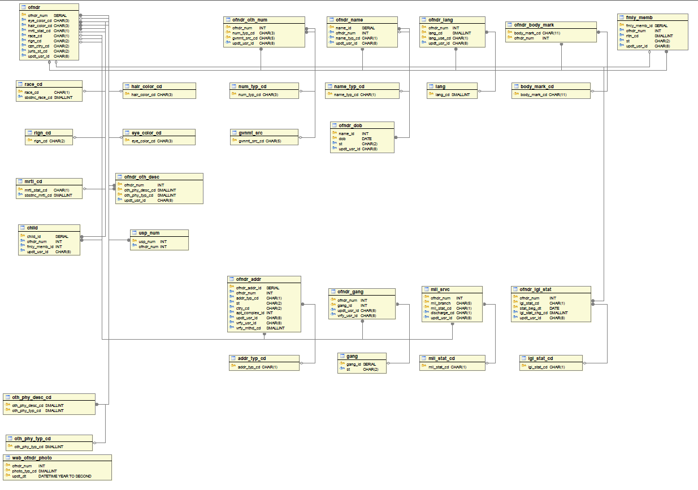

Figure 1: Demographics
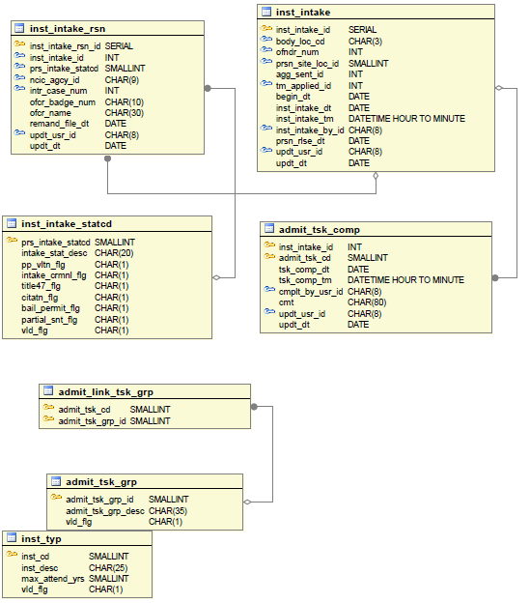

Figure 2: Booking
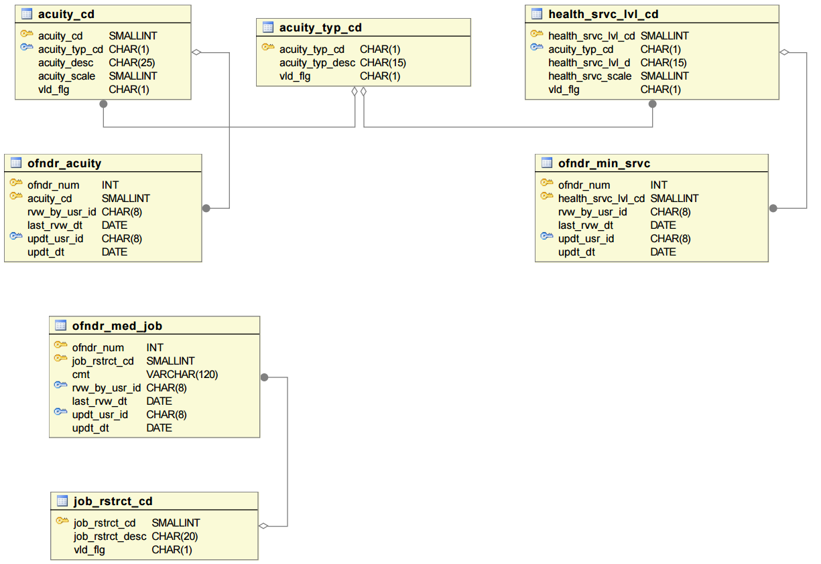

Figure 3: Classification Module - Inmate Medical Location
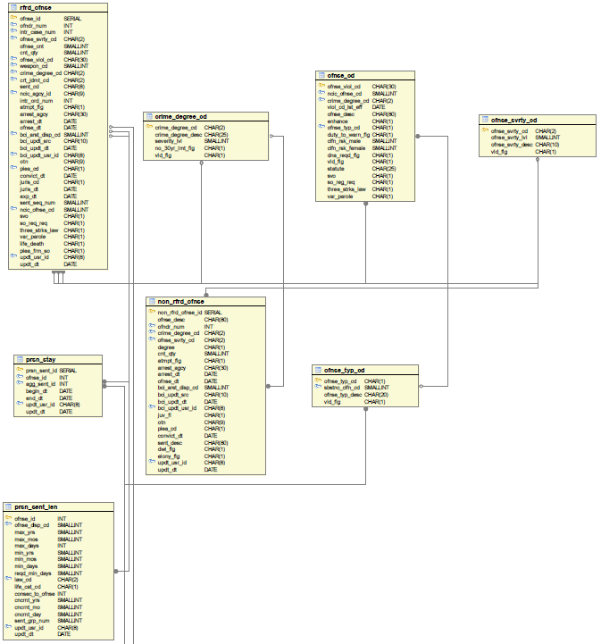

Figure 4: Classification, Image 1 of 4
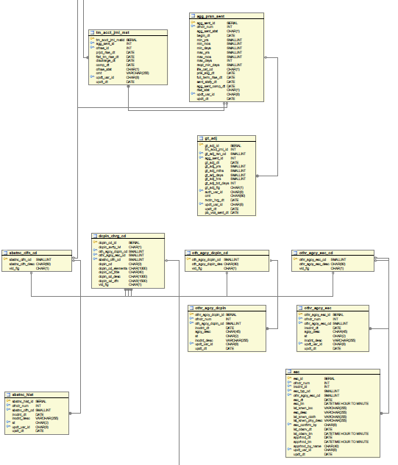

Figure 5: Classification, Image 2 of 4
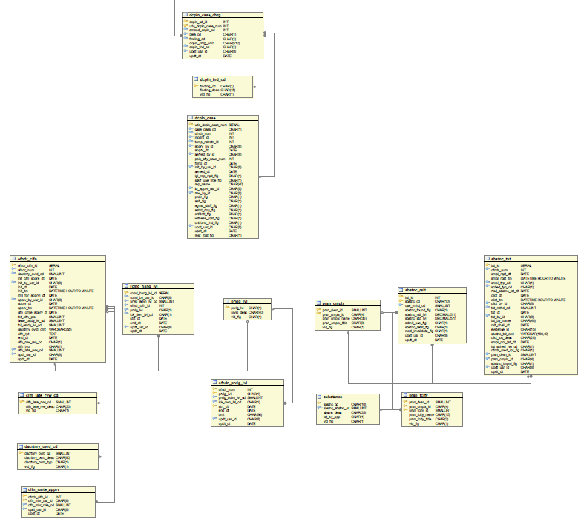

Figure 6: Classification, Image 3 of 4

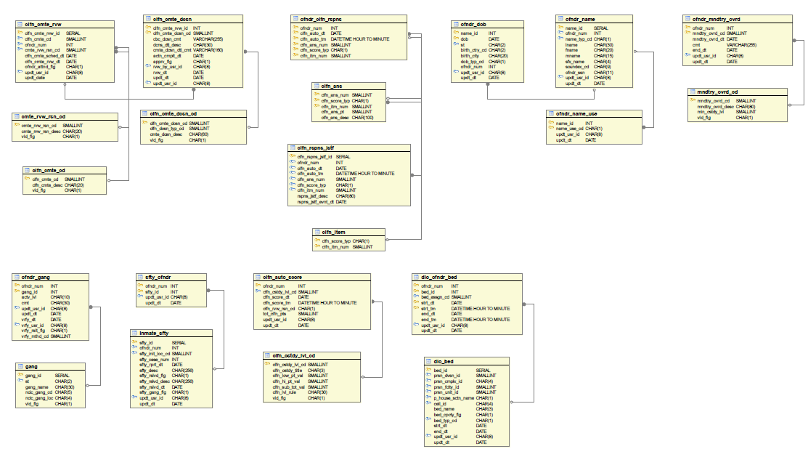
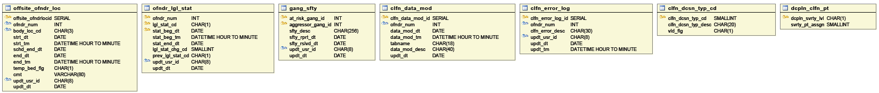

Figure 7: Classification, Image 4 of 4

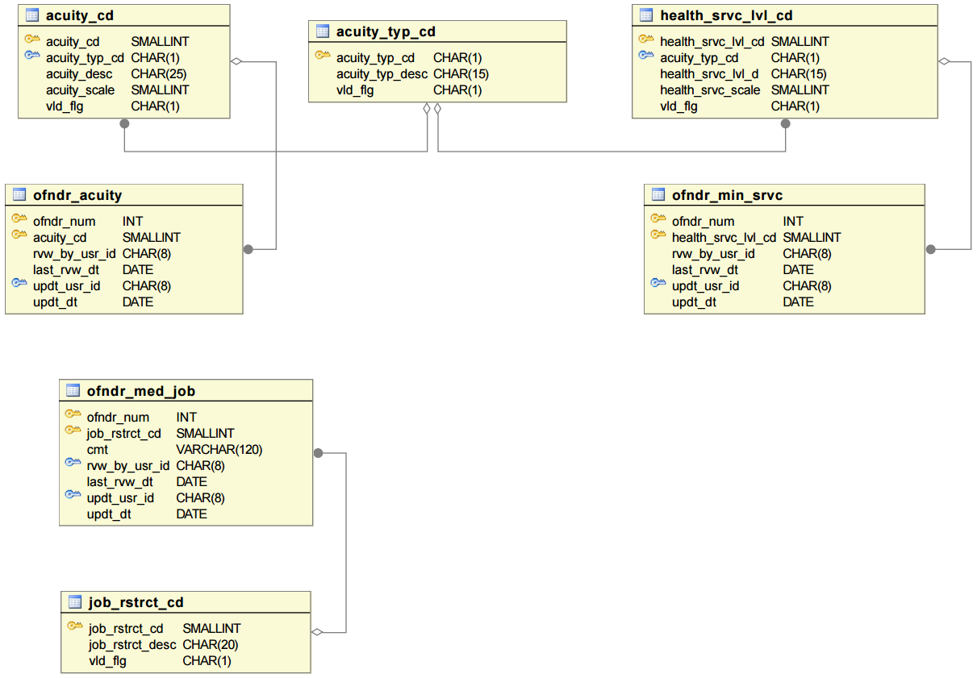

Figure 8: Classification - Inmate Medical Limitation

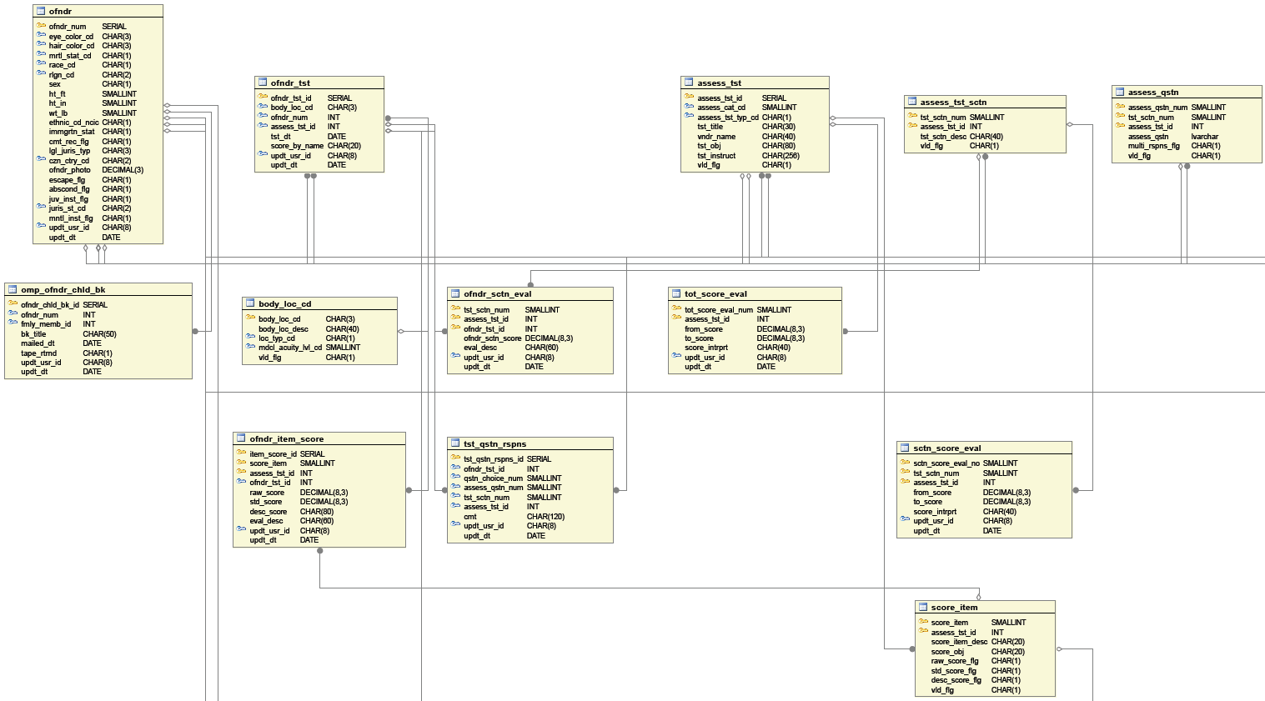

Figure 9: Current OMP Tables, Image 1 of 8
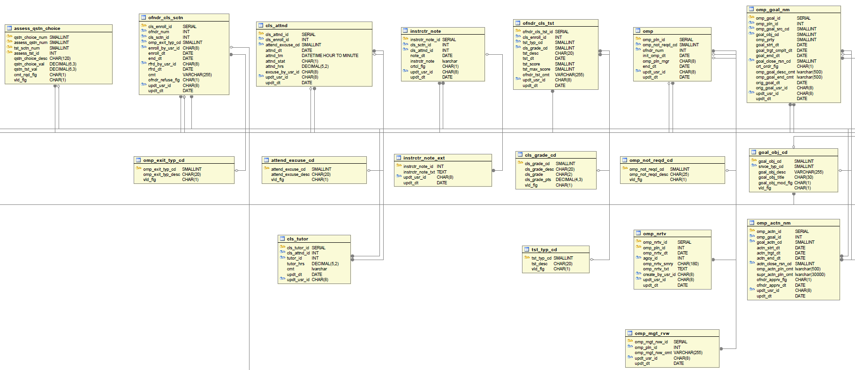

Figure 10: Current OMP Tables, Image 2 of 8

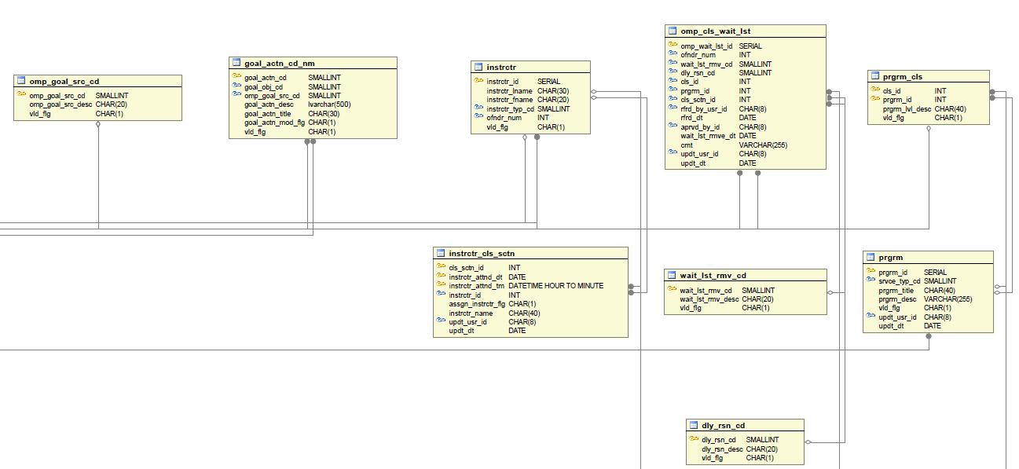

Figure 11: Current OMP Tables, Image 3 of 8

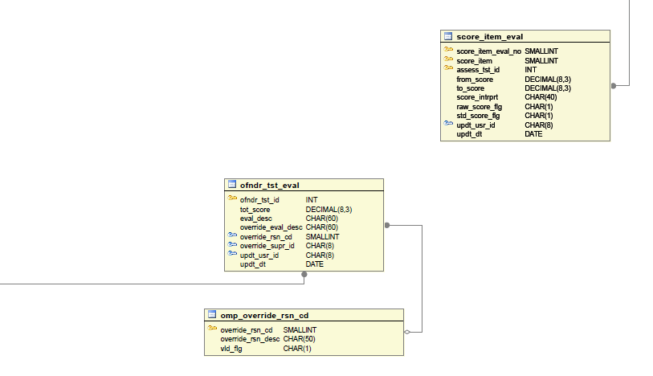

Figure 12: Current OMP Tables, Image 4 of 8

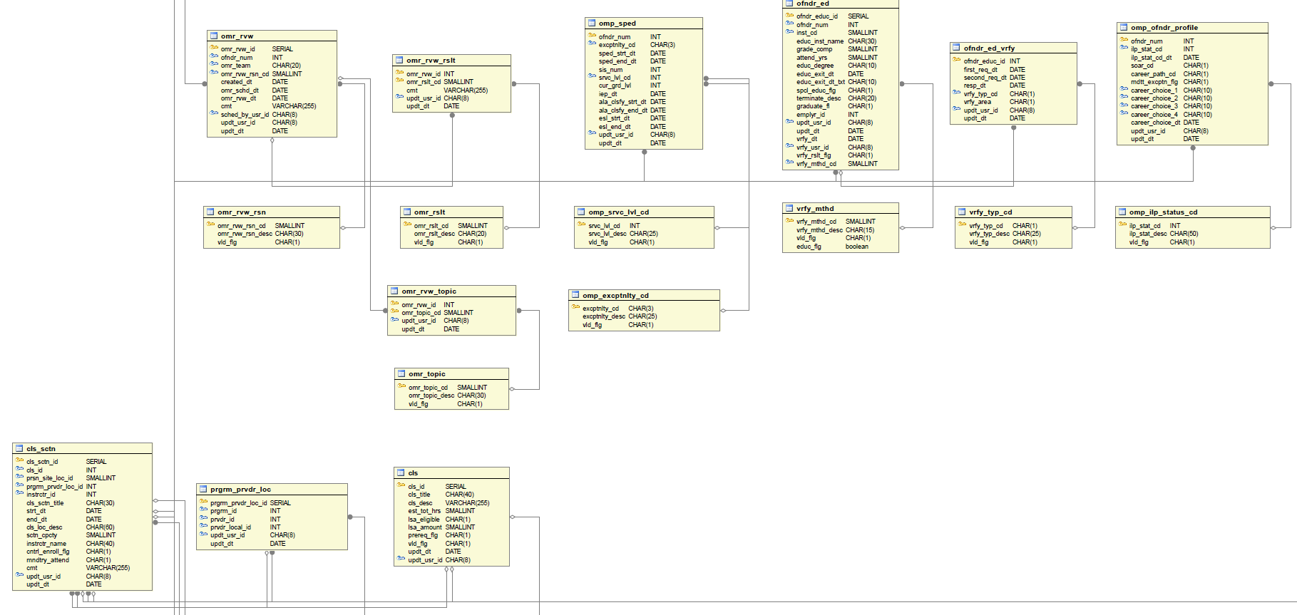

Figure 13: Current OMP Table, Image 5 of 8

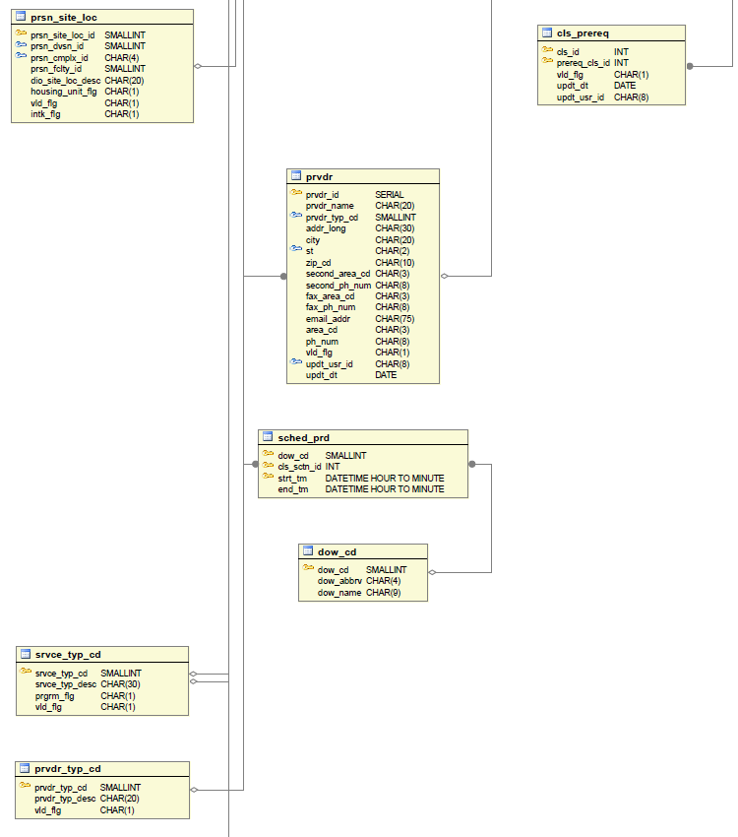

Figure 14: Current OMP Table, Image 6 of 8
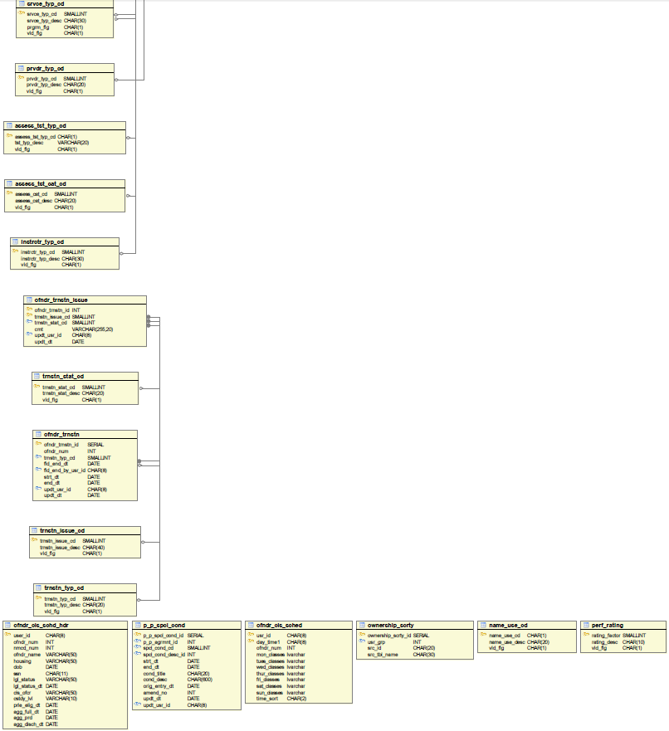

Figure 15: Current OMP Tables, Image 7 of 8

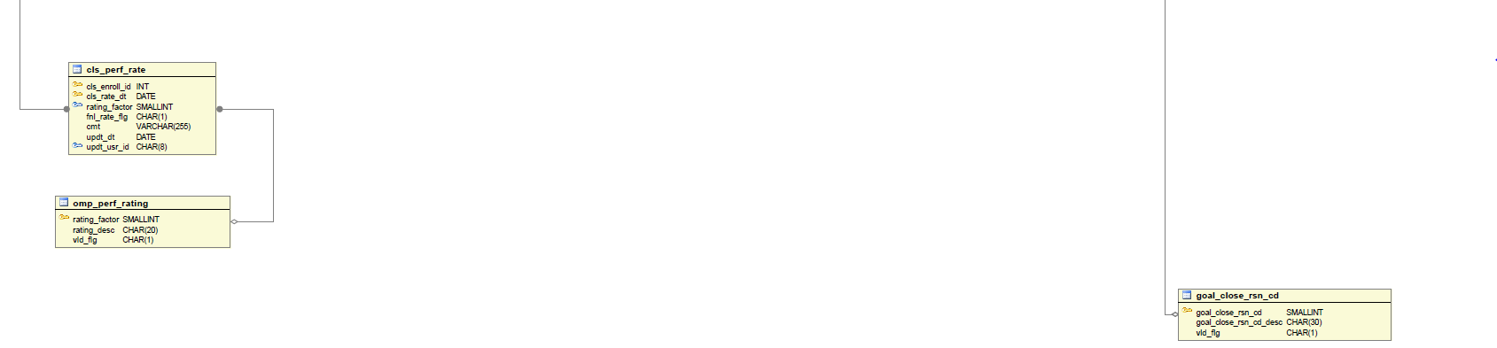

Figure 16: Current OMP Tables, Image 8 of 8

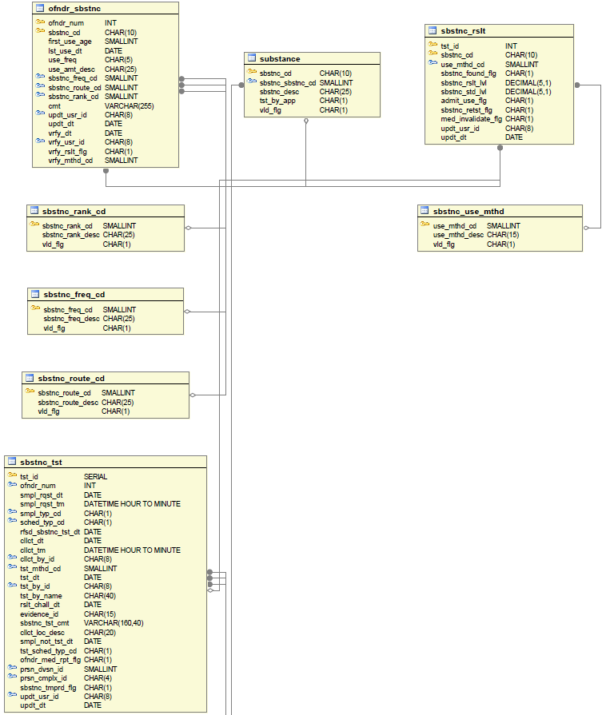

Figure 17: Offender Substance, Image 1 of 3
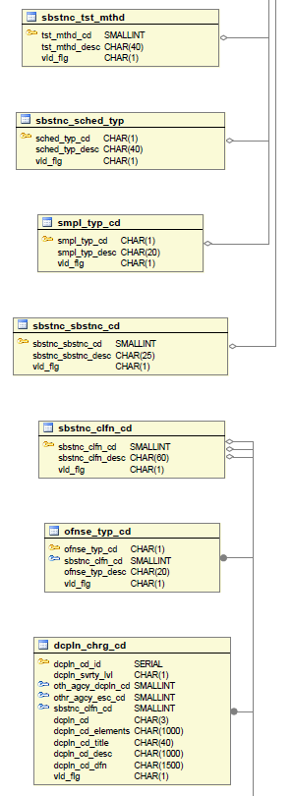

Figure 18: Offender Substance, Image 2 of 3

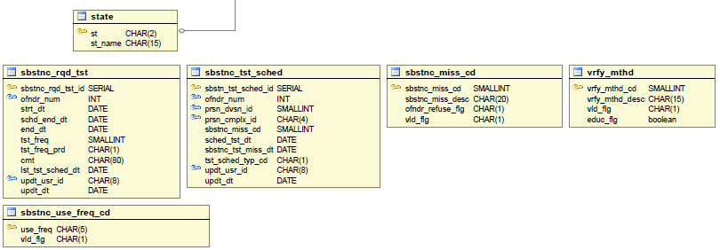

Figure 19: Offender Substance, Image 3 of 3

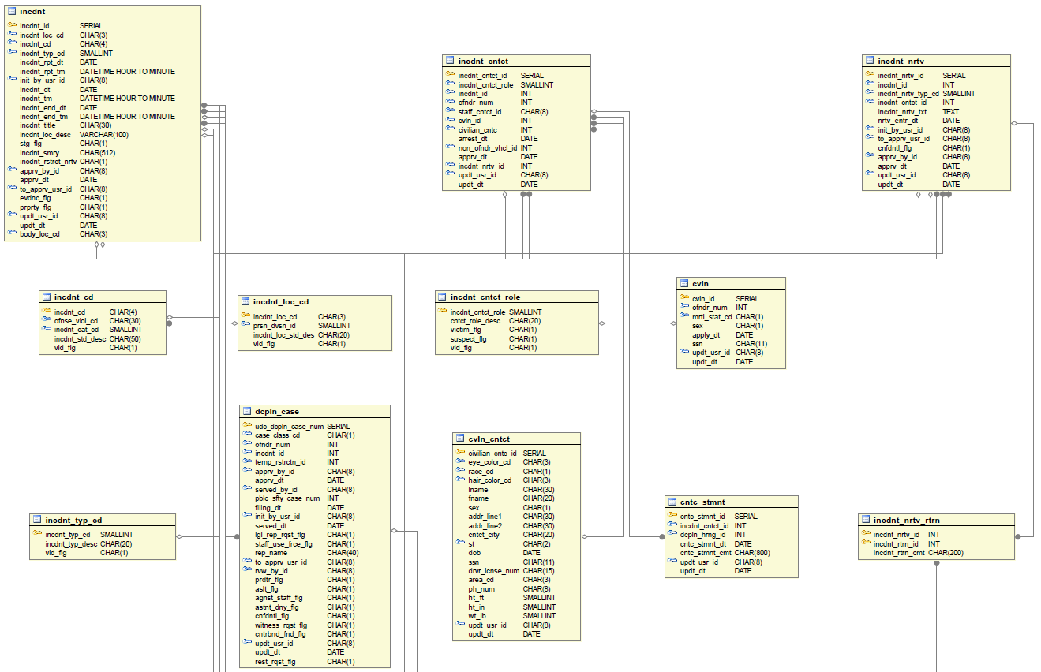

Figure 20: Incident, Image 1 of 2

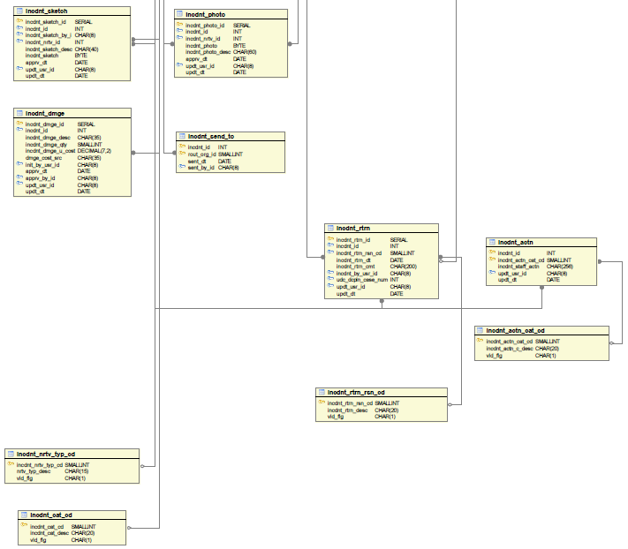

Figure 21: Incident, Image 2 of 2
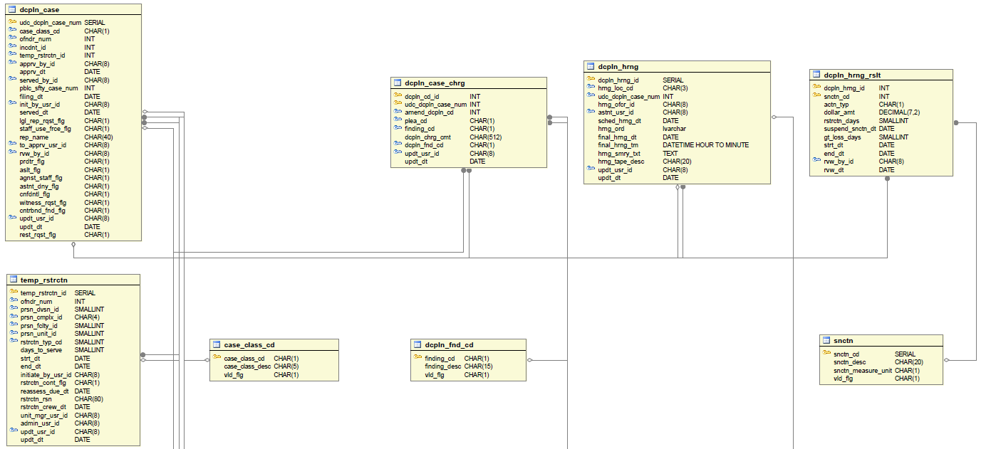

Figure 22: Discipline, Image 1 of 3

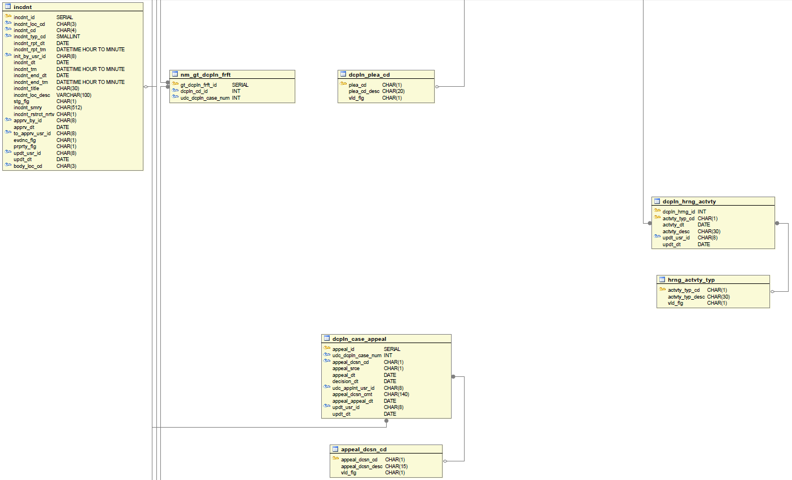

Figure 23: Discipline, Image 2 of 3

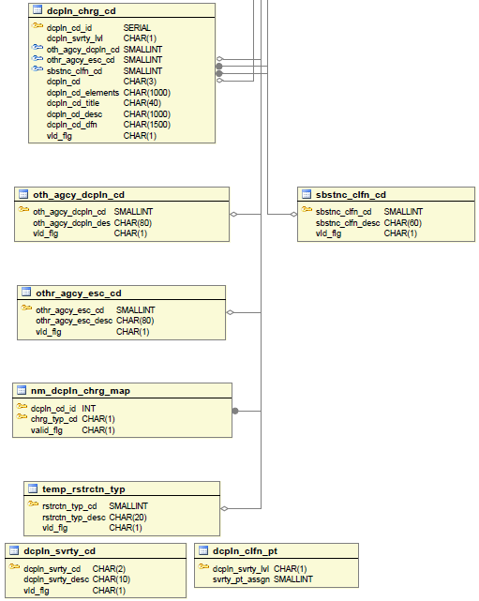

Figure 24: Discipline, Image 3 of 3
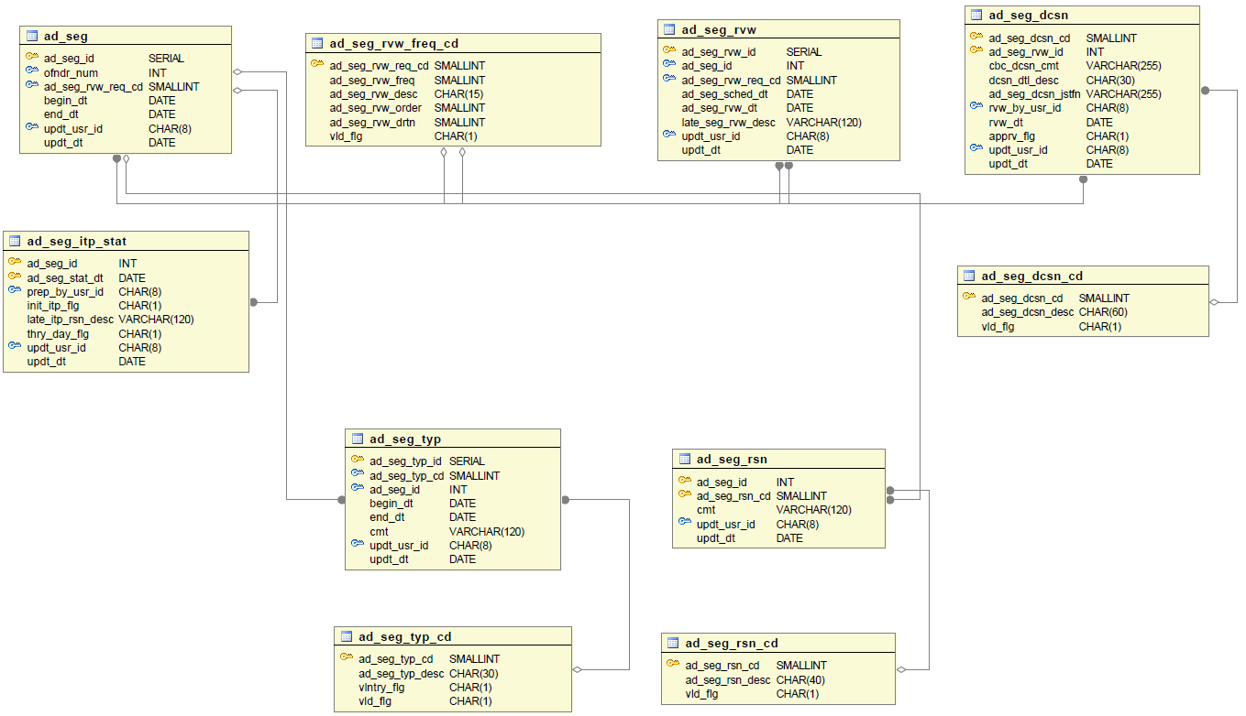

Figure 25: Segregation
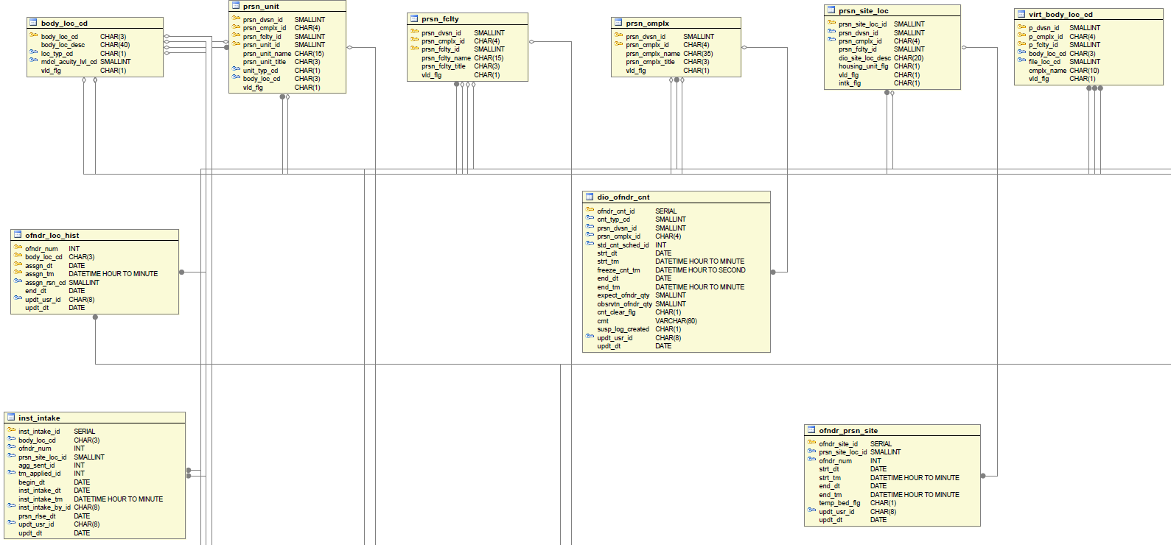

Figure 26: Housing and Movement Module, Image 1 of 7

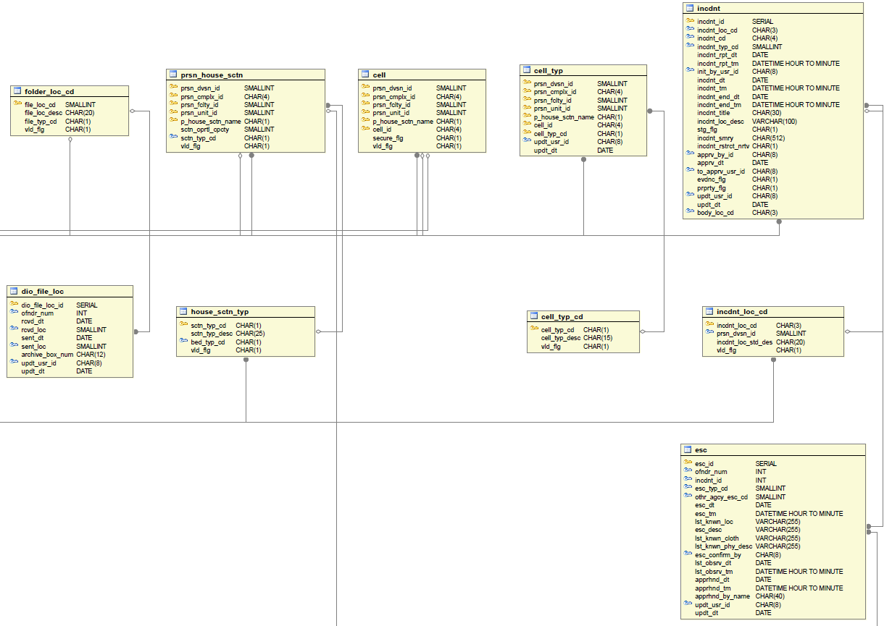

Figure 27: Housing and Movement Module, Image 2 of 7
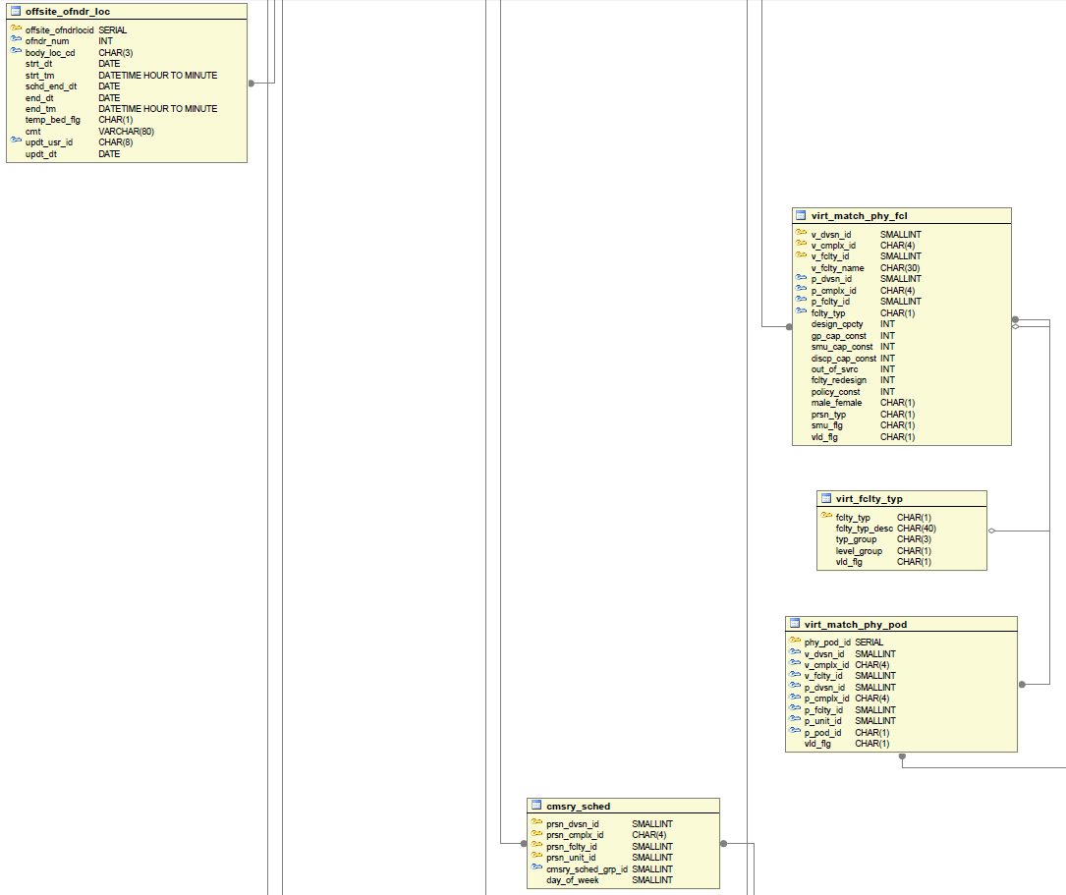

Figure 28: Housing and Movement Module, Image 3 of 7
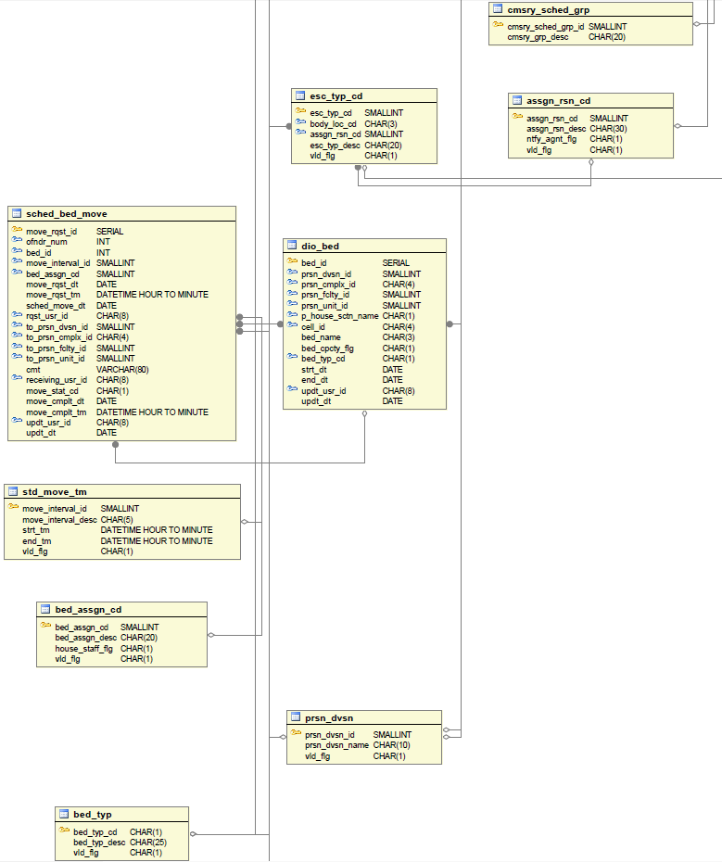

Figure 29: Housing and Movement Module, Image 4 of 7
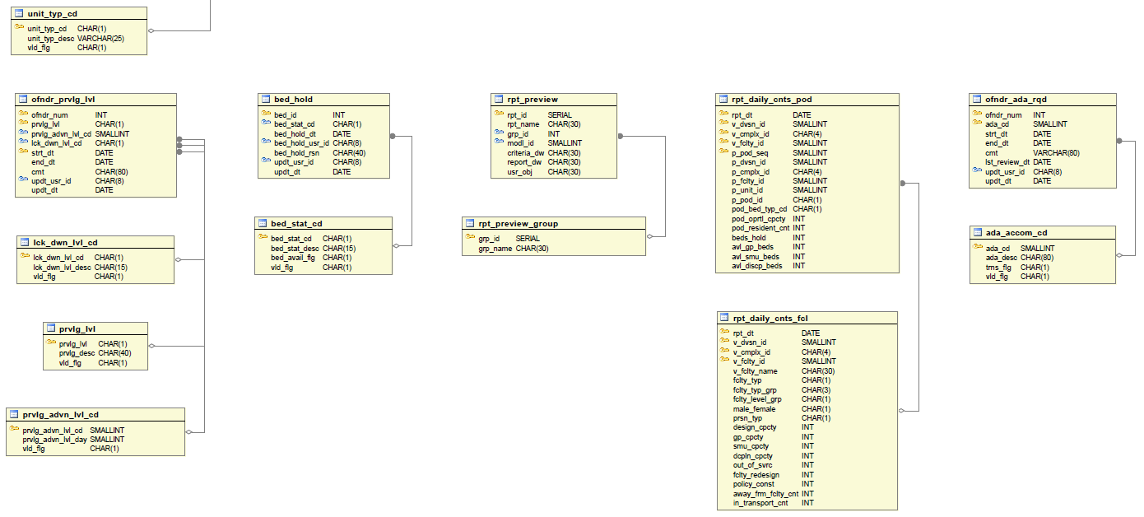

Figure 30: Housing and Movement Module, Image 5 of 7
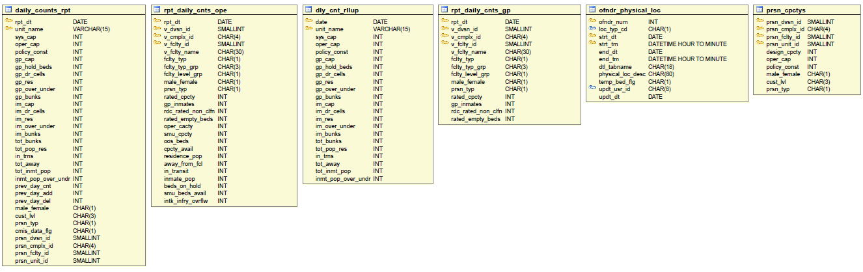
Figure 31: Housing and Movement Module, Image 6 of 7

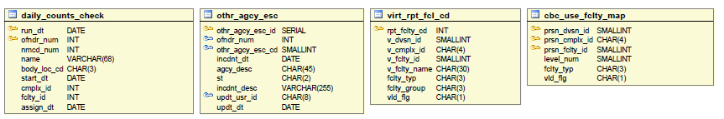

Figure 32: Housing and Movement Module, Image 7 of 7

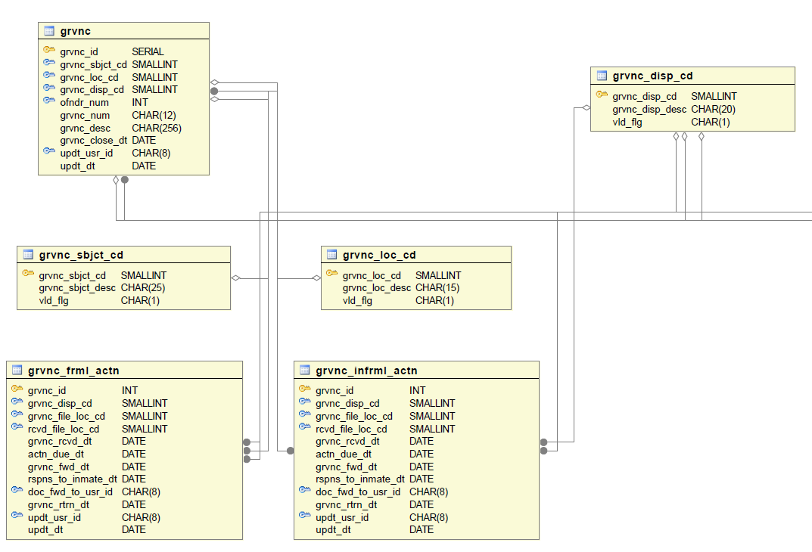
Figure 33: Grievance, Image 1 of 2
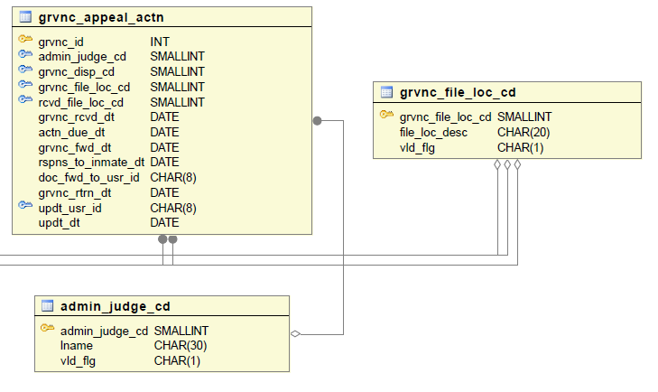
Figure 34: Grievance, Image 2 of 2

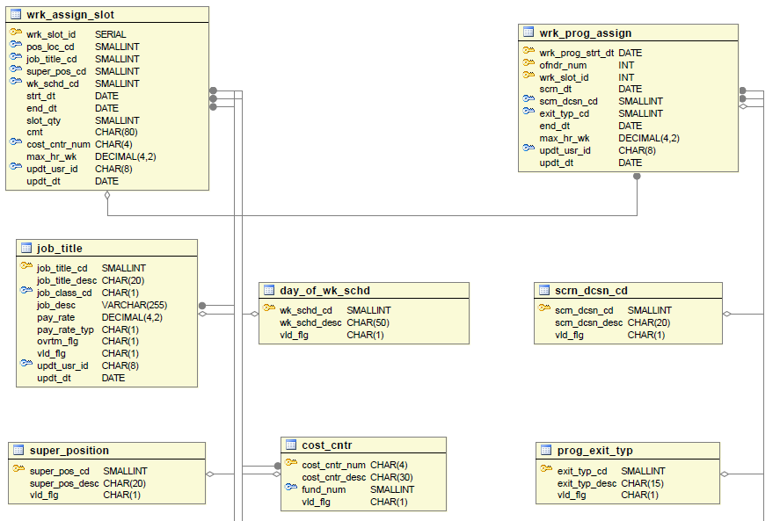
Figure 35: Inmate Work in Prison Program, Image 1 of 2

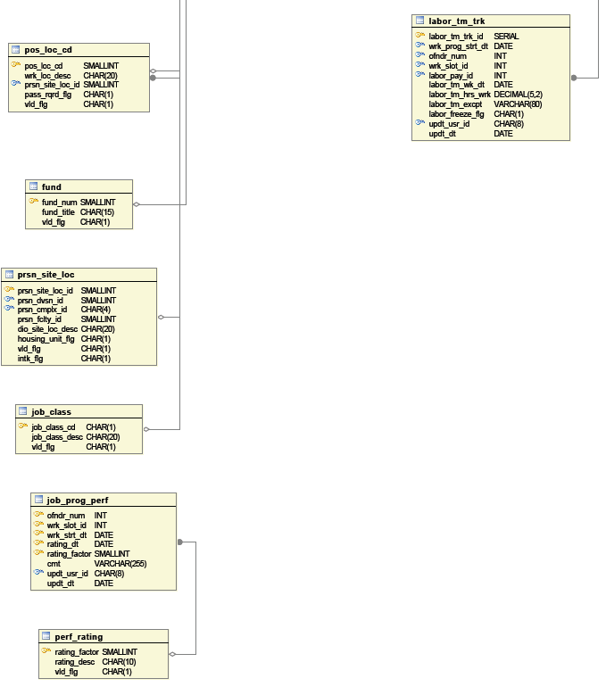

Figure 36: Inmate Work in Prison Program, Image 2 of 2

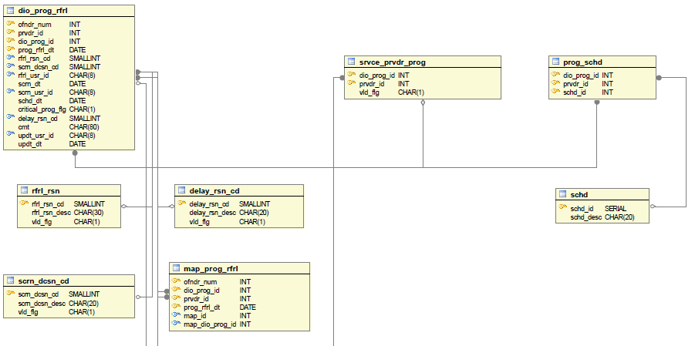

Figure 37: Inmate DIO Program, Image 1 of 3

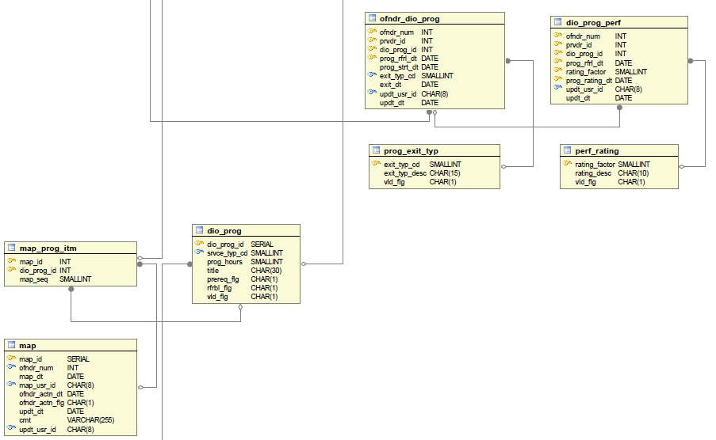

Figure 38: Inmate DIO Program, Image 2 of 3

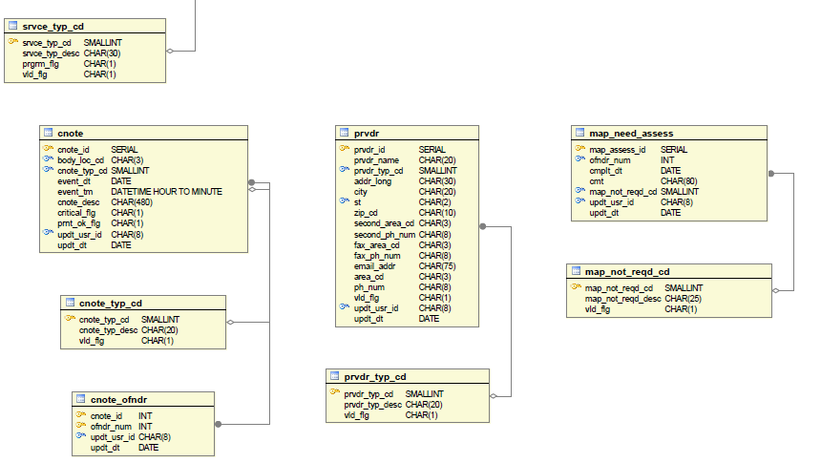

Figure 39: Inmate DIO Program, Image 3 of 3

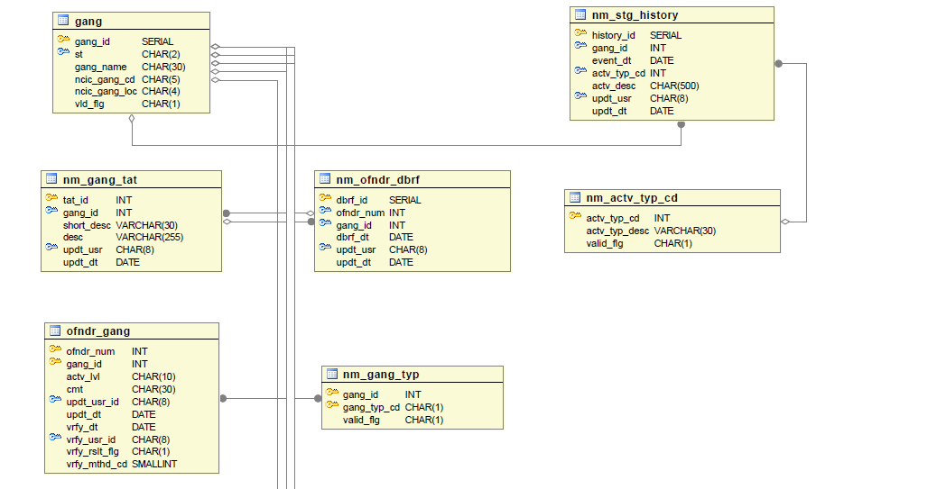

Figure 40: Gang Module, Image 1 of 4

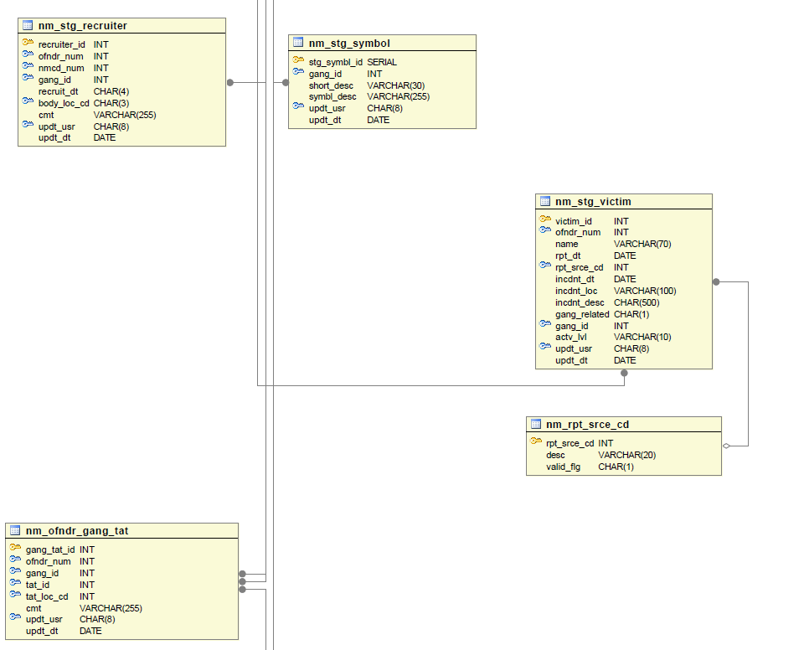

Figure 41: Gang Module, Image 2 of 4
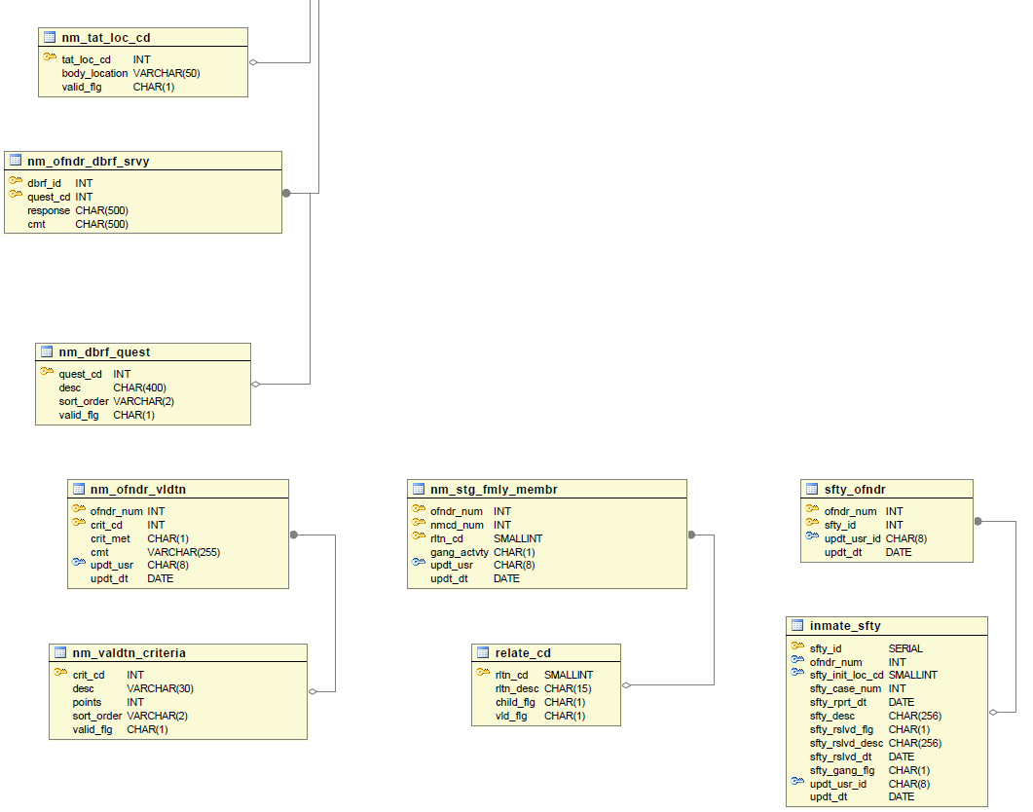
Figure 42: Gang Module, Image 3 of 4

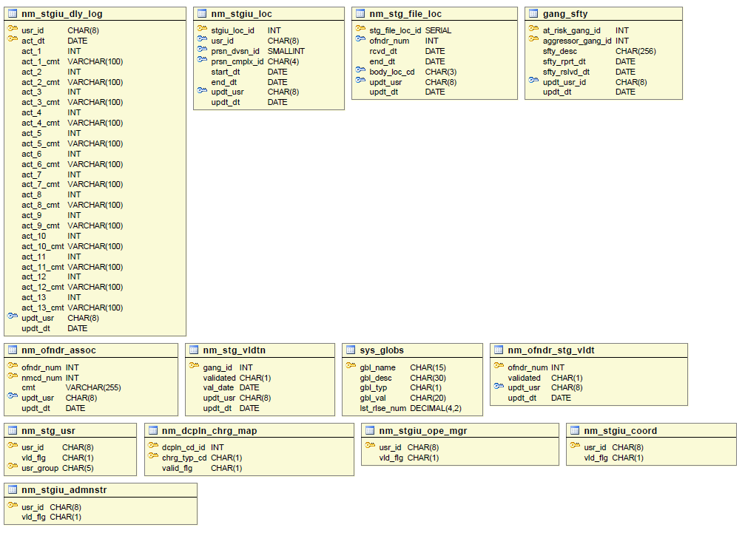

Figure 43: Gang Module, Image 4 of 4

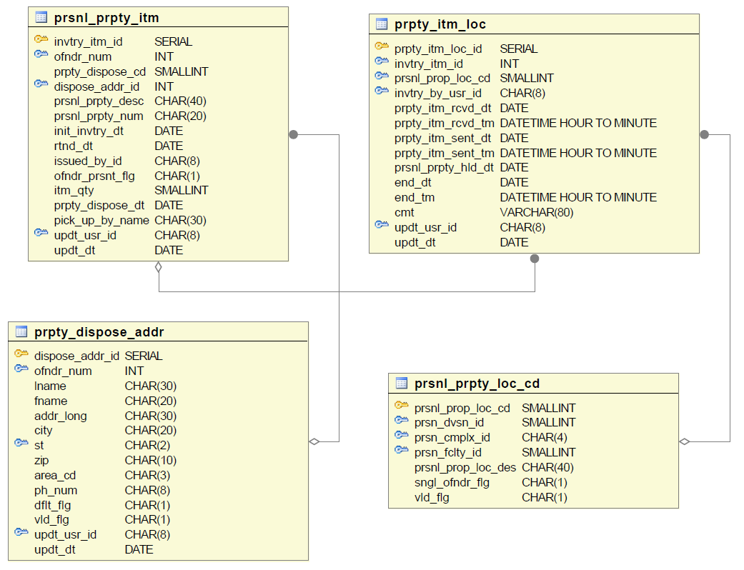

Figure 44: Property

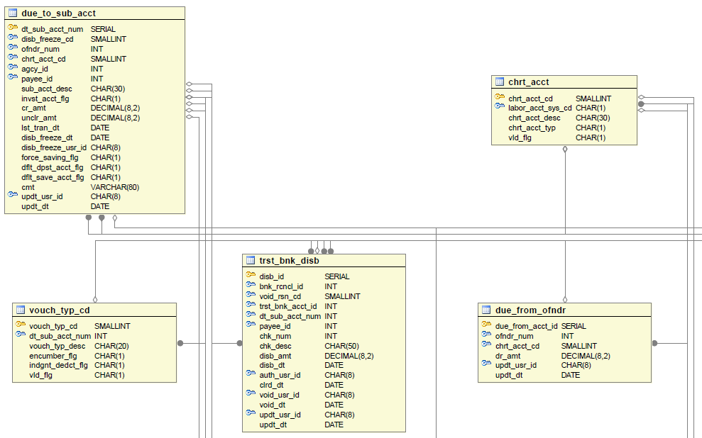

Figure 45: Inmate Trust, Image 1 of 9

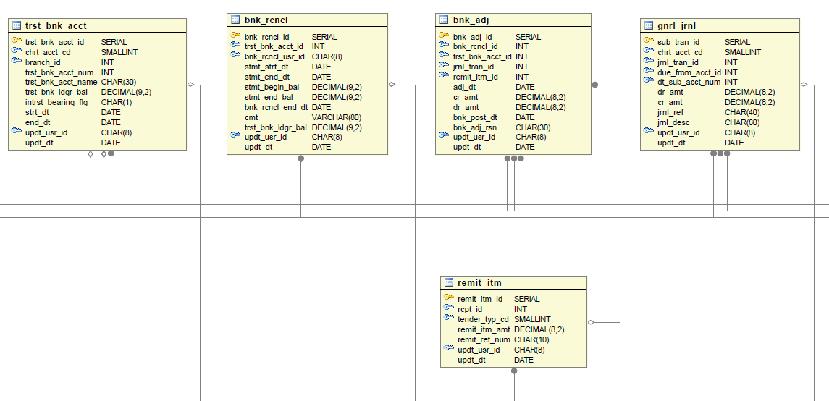

Figure 46: Inmate Trust, Image 2 of 9

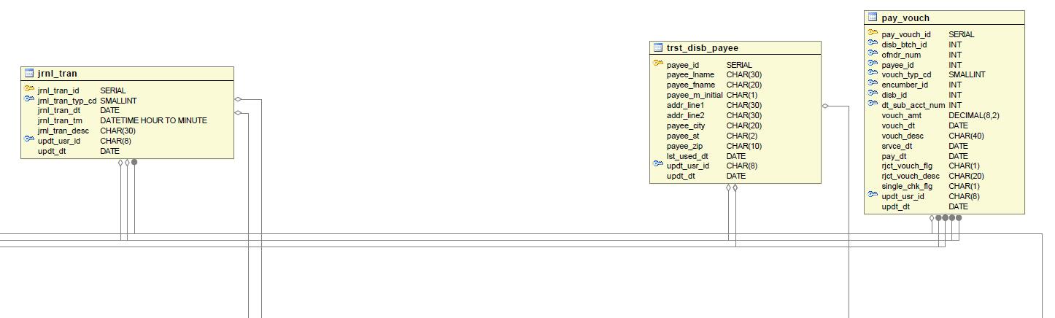

Figure 47: Inmate Trust, Image 3 of 9

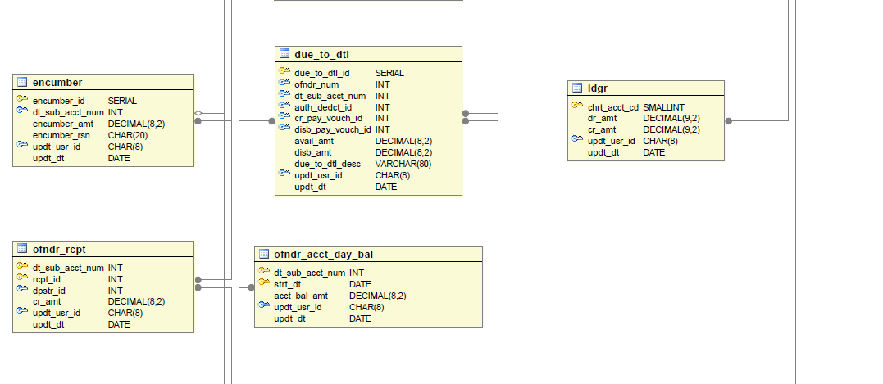

Figure 48: Inmate Trust, Image 4 of 9

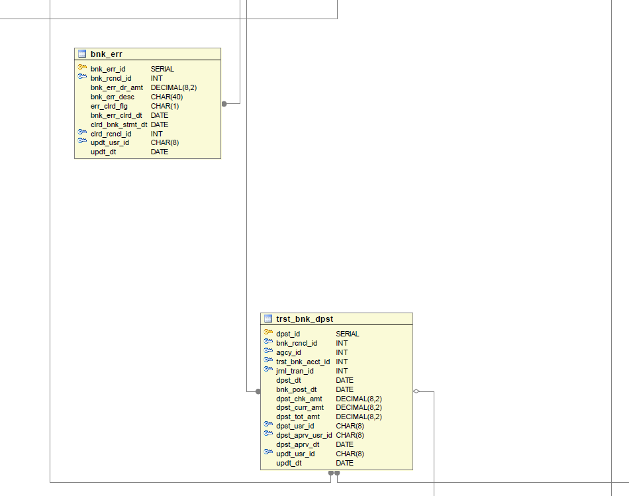

Figure 49: Inmate Trust, Image 5 of 9
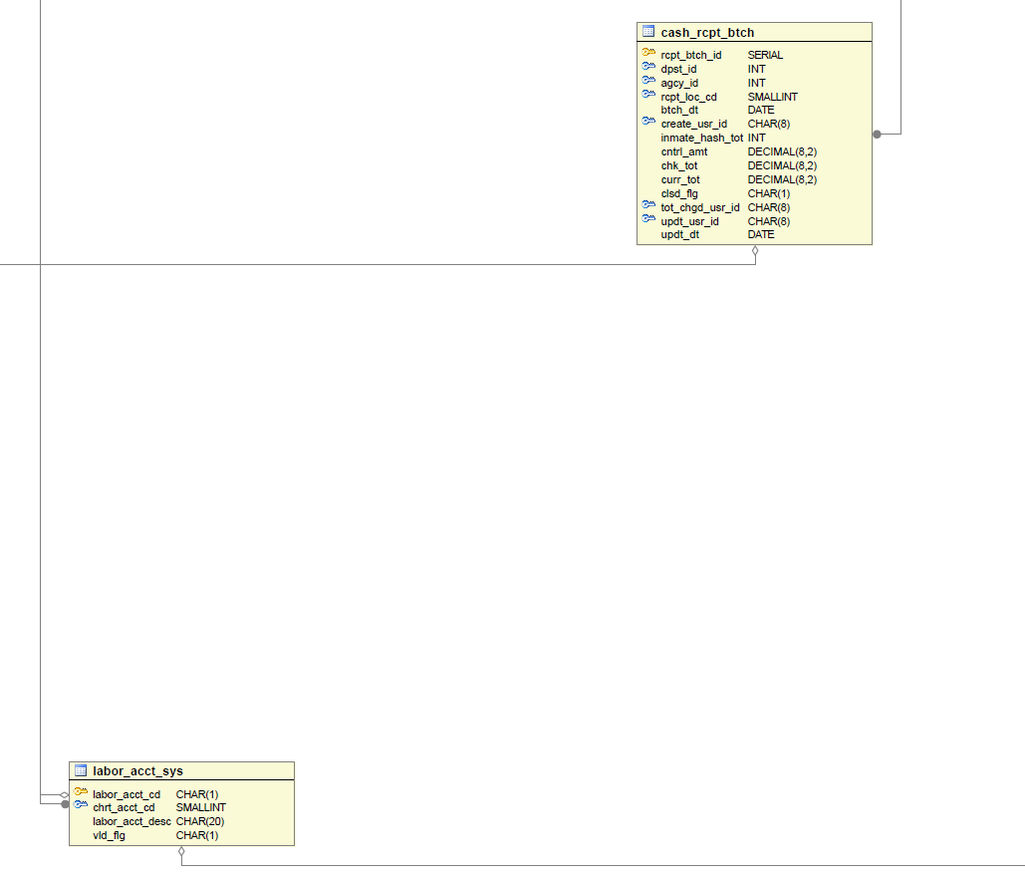

Figure 50: Inmate Trust, Image 6 of 9

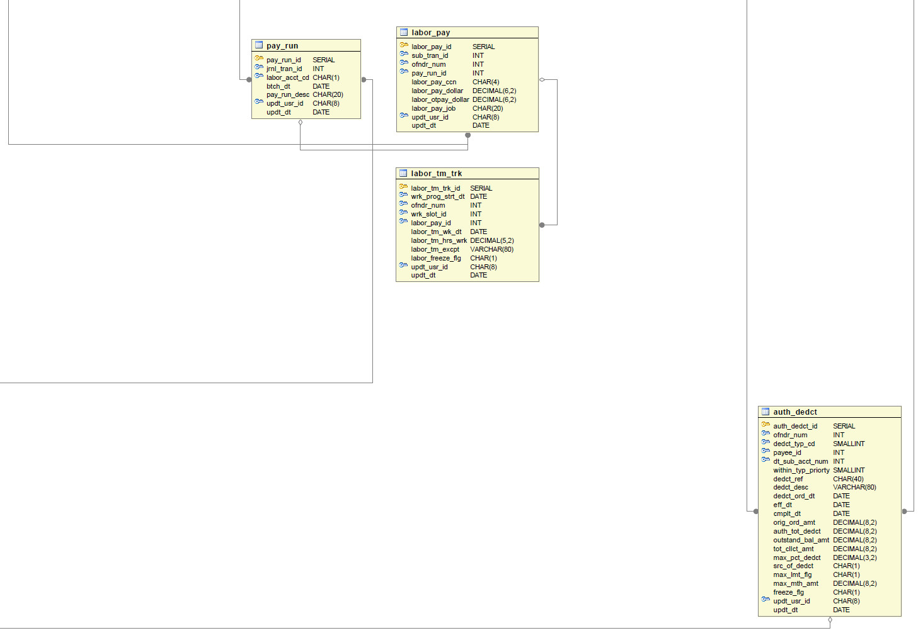

Figure 51: Inmate Trust, Image 7 of 9

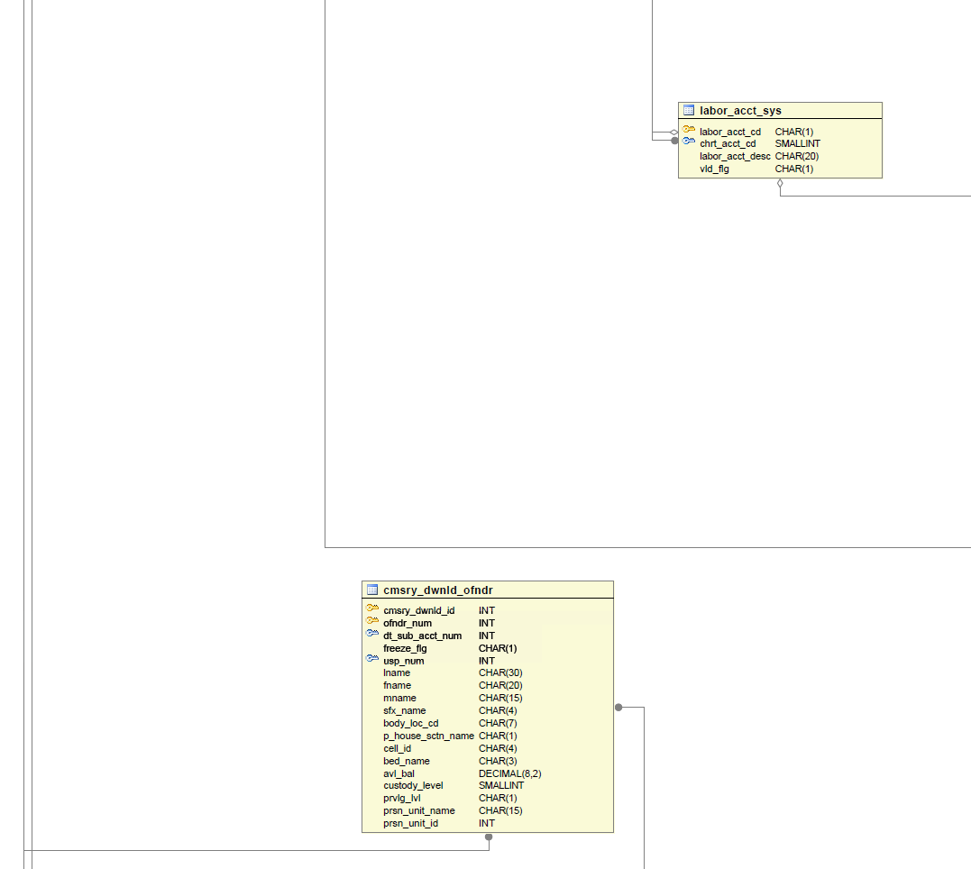

Figure 52: Inmate Trust, Image 8 of 9

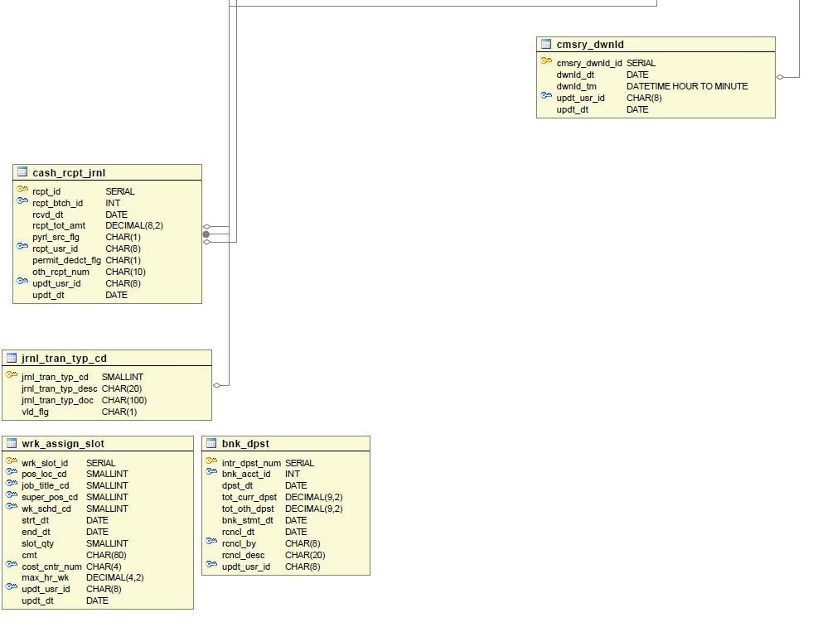

Figure 53: Inmate Trust, Image 9 of 9

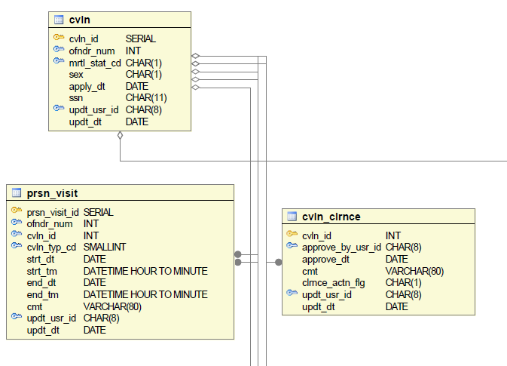

Figure 54: Visitation, Image 1 of 5

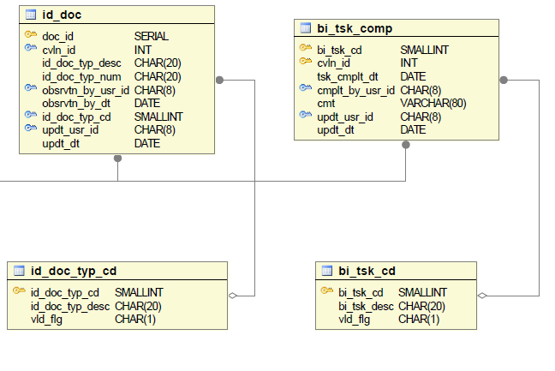

Figure 55: Visitation, Image 2 of 5

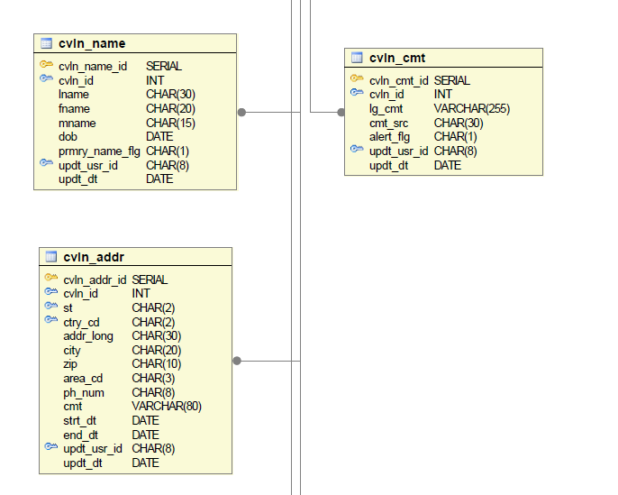

Figure 56: Visitation, Image 3 of 5

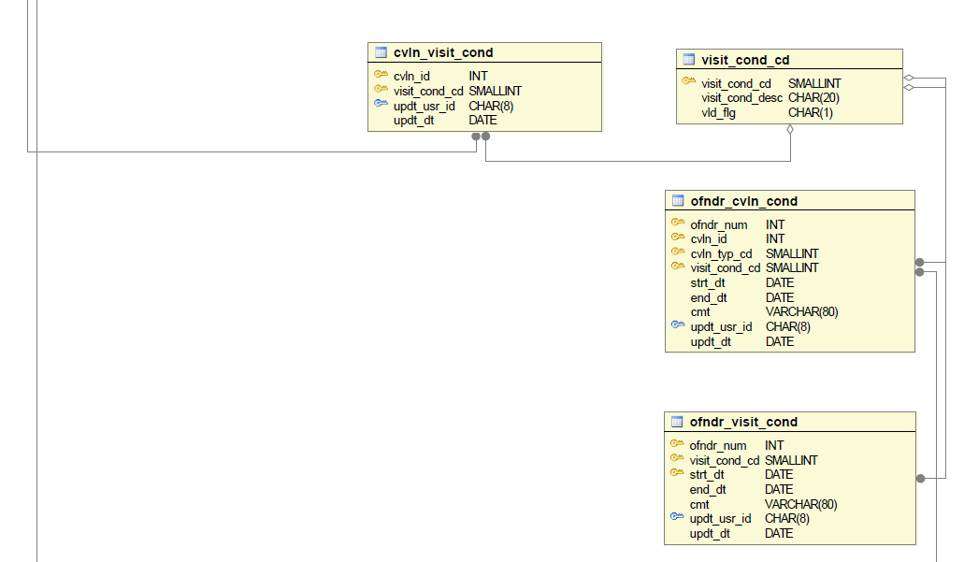

Figure 57: Visitation, Image 4 of 5

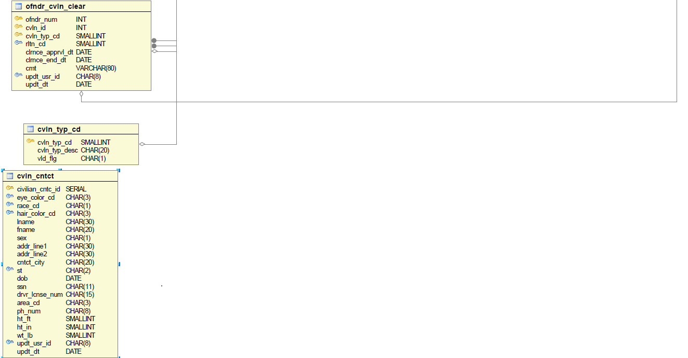

Figure 58: Visitation, Image 5 of 5

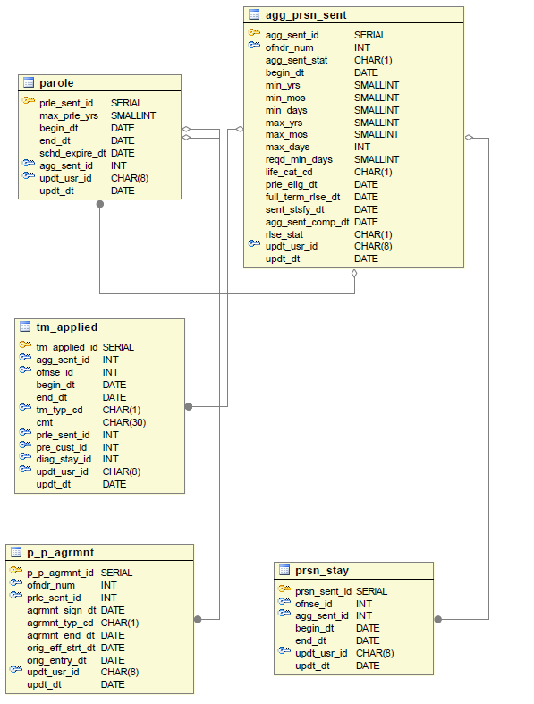

Figure 59: Release and Discharge, Image 1 of 3

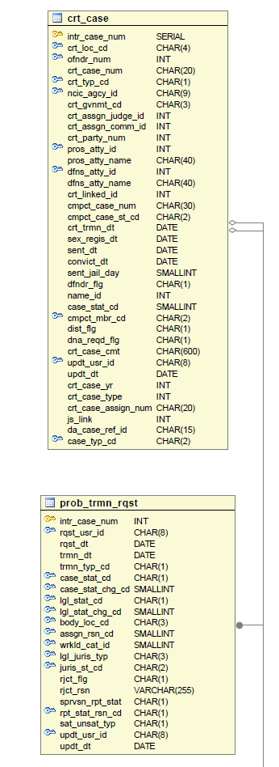

Figure 60: Release and Discharge, Image 2 of 3

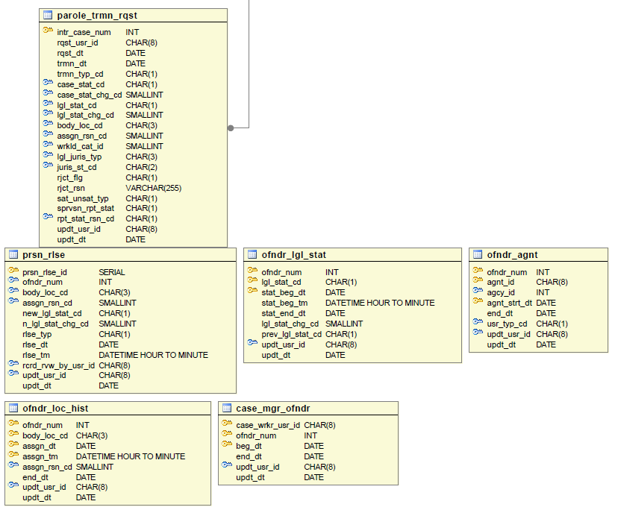

Figure 61: Release and Discharge, Image 3 of 3

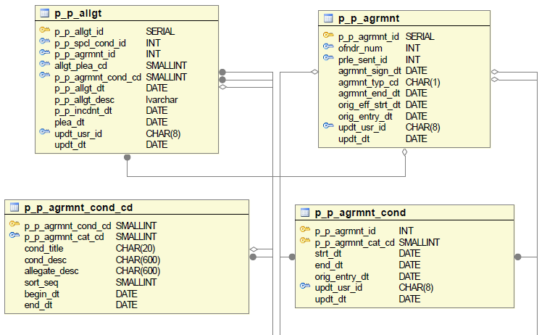

Figure 62: Community Supervision: Agreements and Allegations, Image 1 of 3

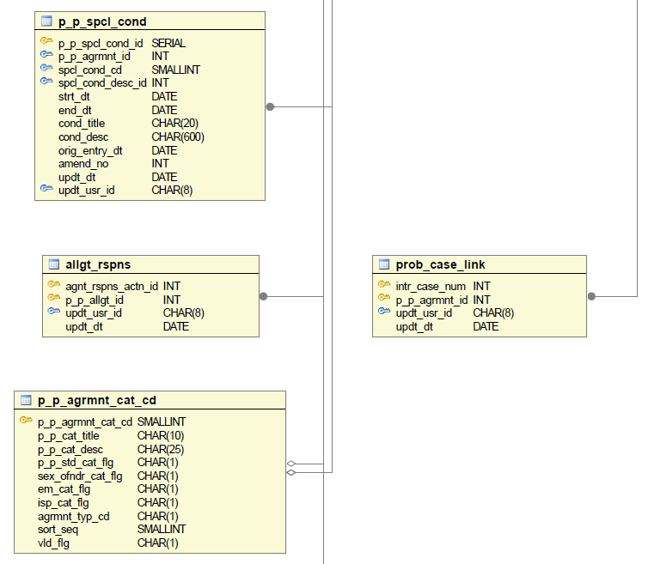

Figure 63: Community Supervision: Agreements and Allegations, Image 2 of 3

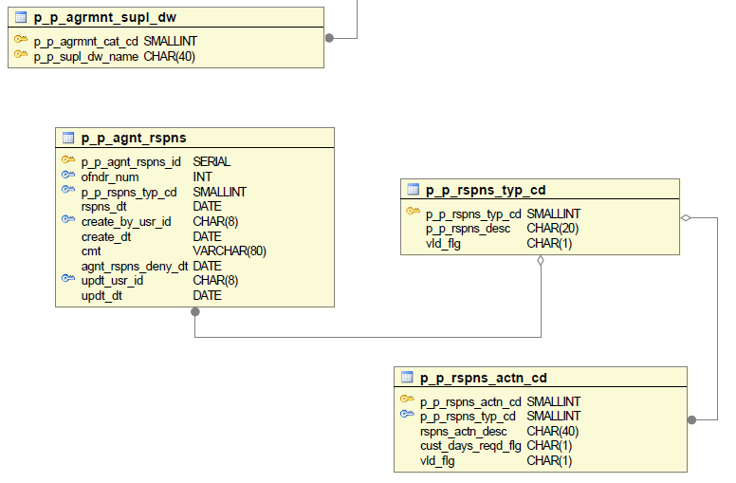

Figure 64: Community Supervision: Agreements and Allegations, Image 3 of 3

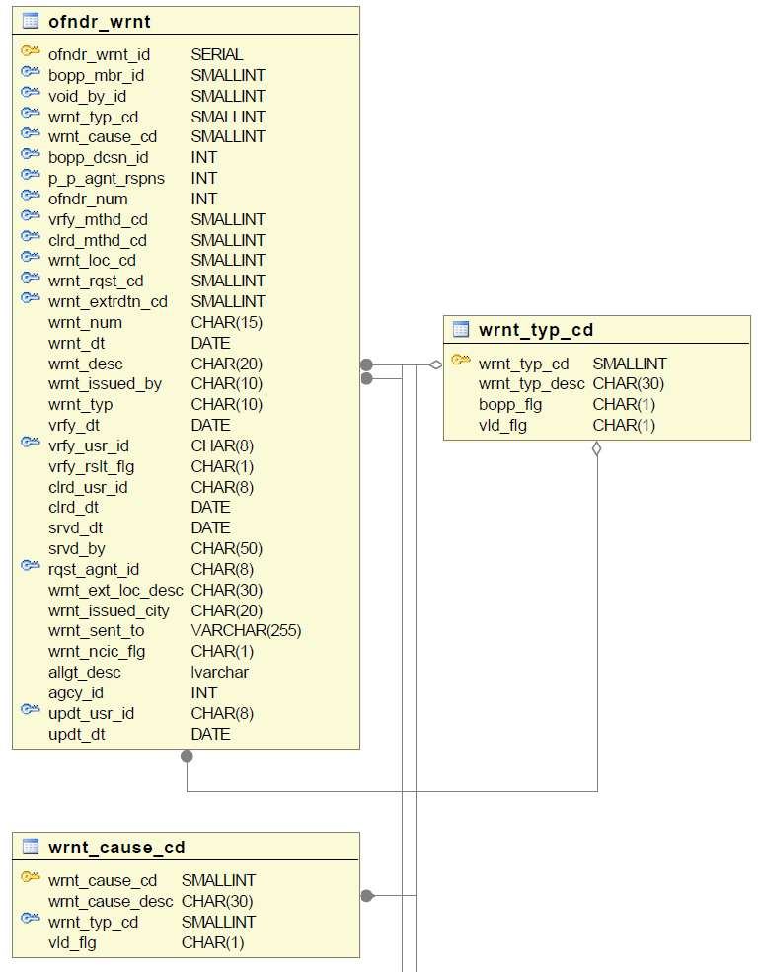

Figure 65: Community Supervision: Caseload Management, Image 1 of 5

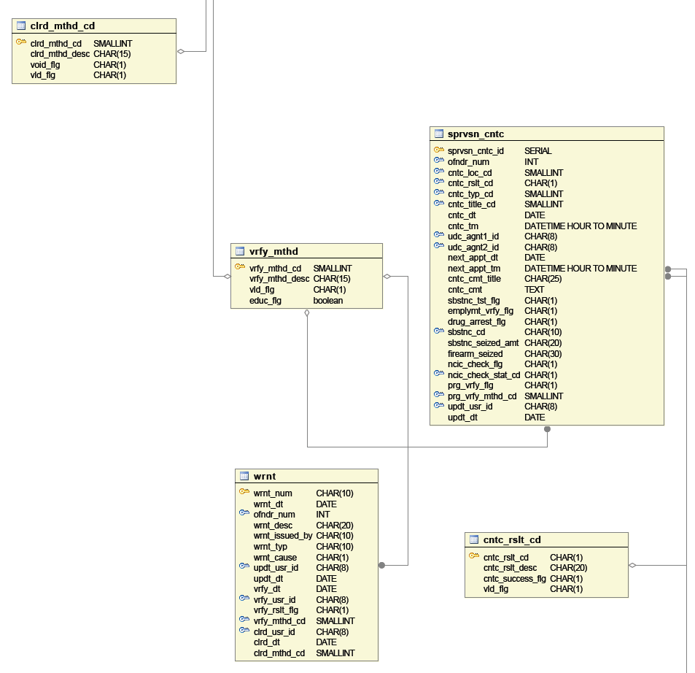

Figure 66: Community Supervision: Caseload Management, Image 2 of 5

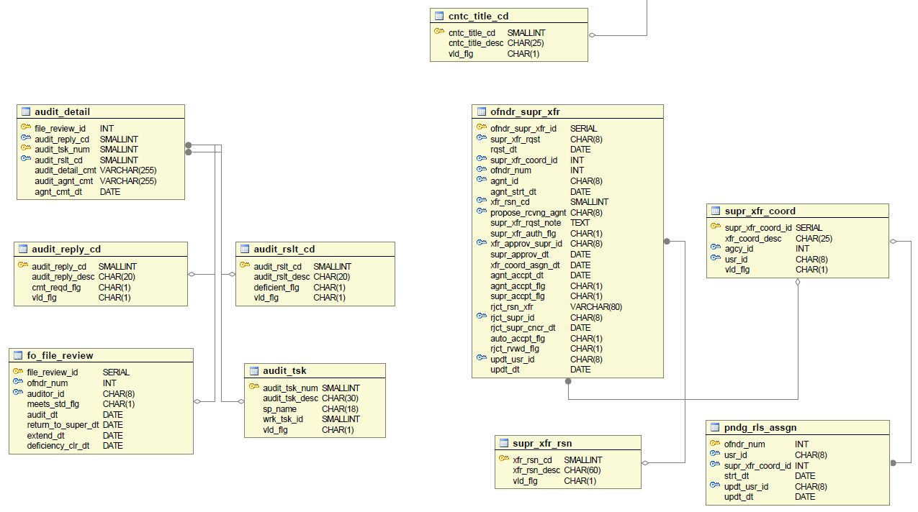

Figure 67: Community Supervision: Caseload Management, Image 3 of 5

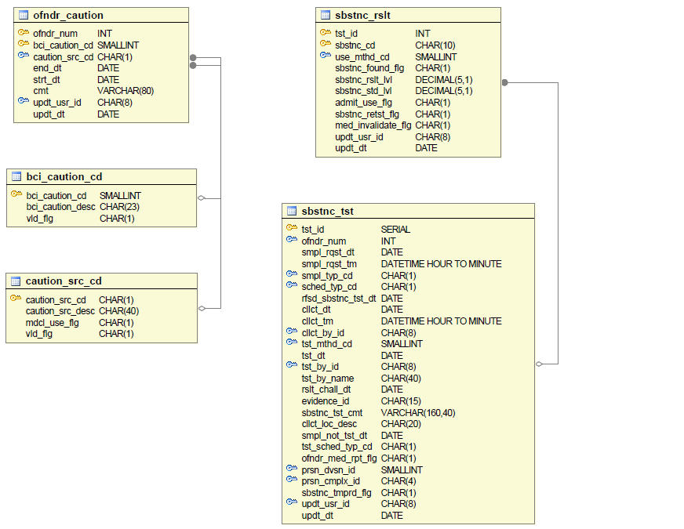

Figure 68: Community Supervision: Caseload Management, Image 4 of 5
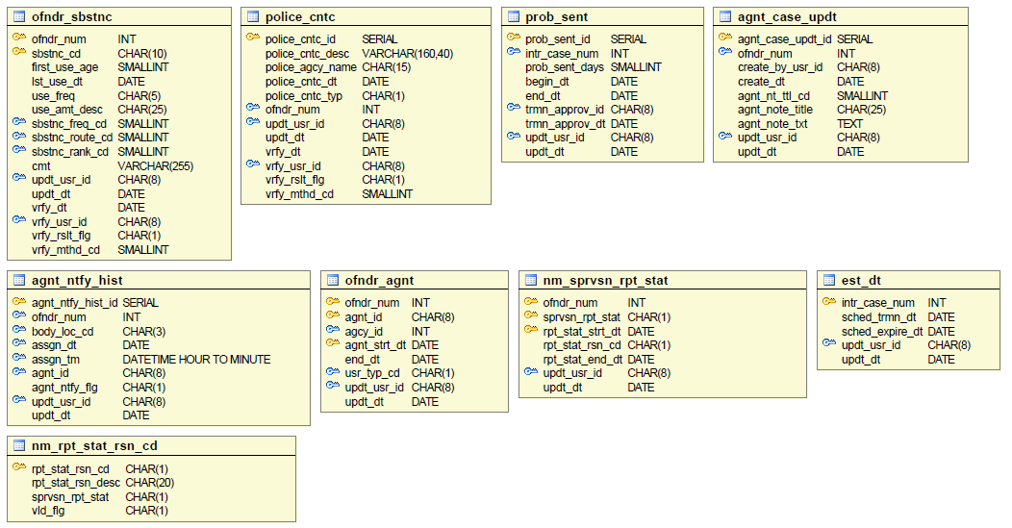

Figure 69: Community Supervision: Caseload Management, Image 5 of 5

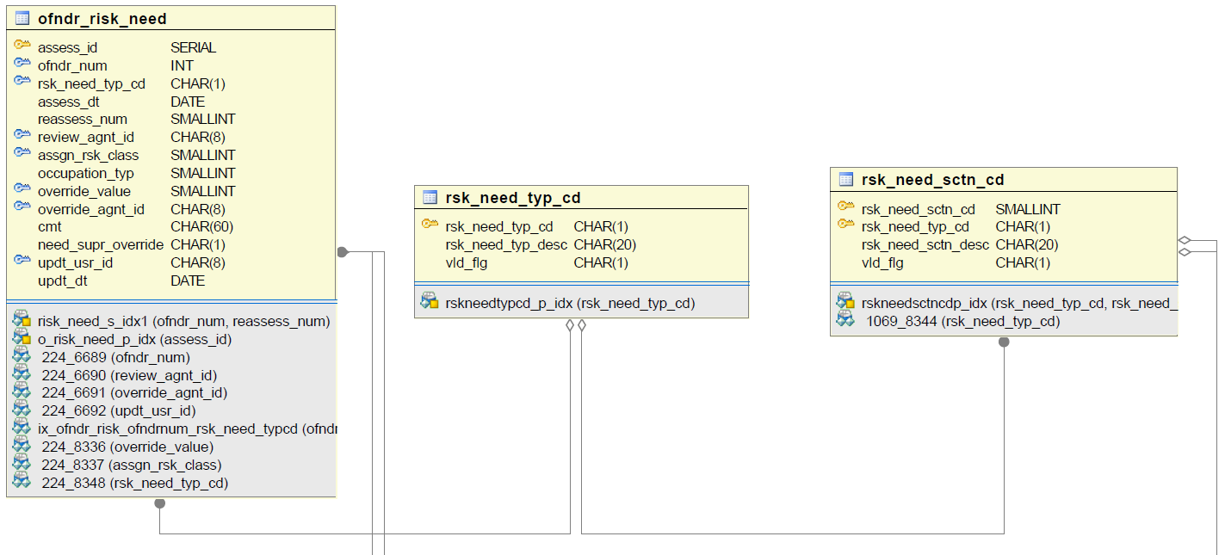

Figure 70: Community Supervision: PPD Risk Instrument, Image 1 of 4

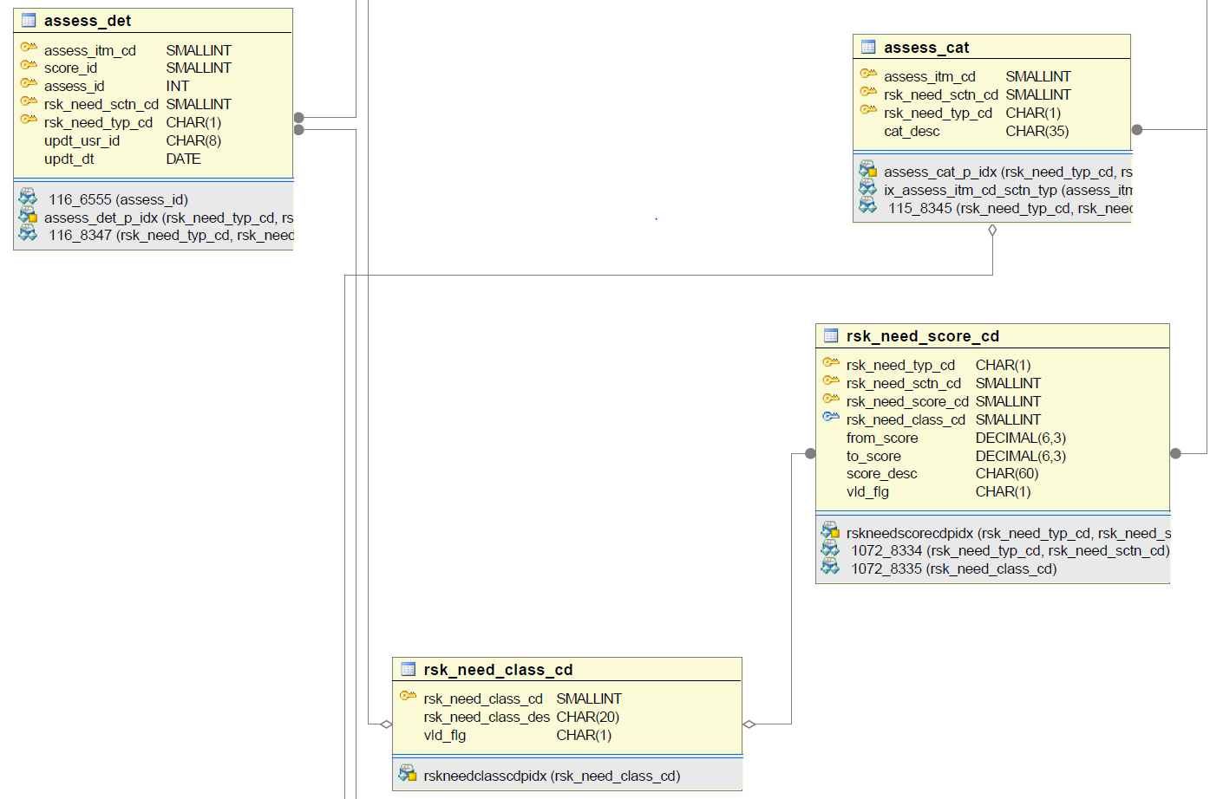

Figure 71: Community Supervision: PPD Risk Instrument, Image 2 of 4

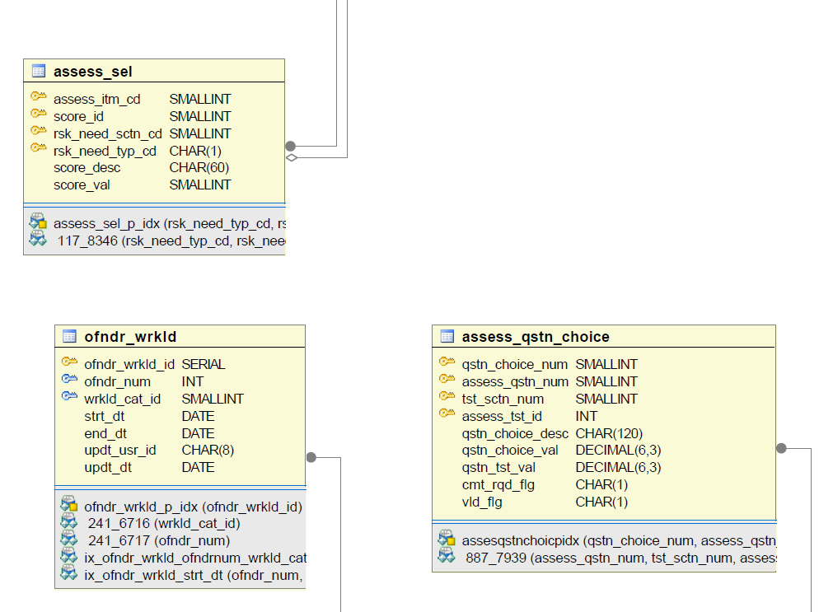

Figure 72: Community Supervision: PPD Risk Instrument, Image 3 of 4

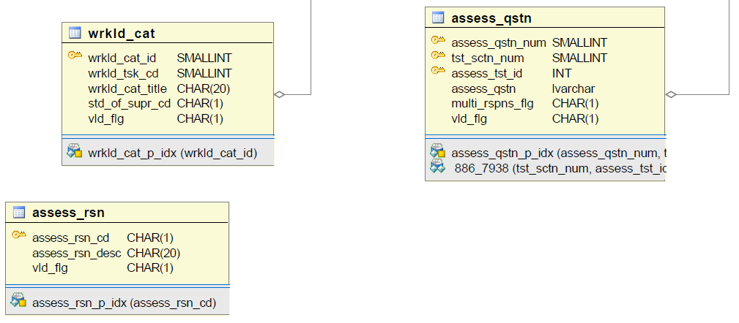

Figure 73: Community Supervision: PPD Risk Instrument, Image 4 of 4

Appendix M: Bidder Questions Form
INSTRUCTIONS FOR USE

PLEASE DO NOT IDENTIFY YOUR NAME, YOUR COMPANY’S NAME, PRODUCT NAMES, OR INTELLECTUAL PROPERTY IN YOUR QUESTIONS.

The following instructions must be followed when submitting questions using the question format on the following page.

- Do not change the format or font. Do not bold your questions or change the color of the font.

- Enter the RFP section number that the question relates to in the “RFP Section” field. If the question is general and not related to a specific RFP section, enter “General” in the “RFP Section” column. Enter the RFP page number in the “RFP page” field.

- Once completed, this form is to be emailed per the instructions in the RFP. The e-mail subject line is to state the RFP number followed by “Questions” (e.g., “RFP #:17-770-2500-5317 Questions”).

Question # | RFP Section | RFP Page # | Question
1
2
3
4
5
6
7
8
9
10
11
12
13
14
15
16
17
18
19
20

